**User Manual for Dike-Groyne Module of FVCOM**

**Step 1: Create an original mesh**

An ordinary triangular mesh should be firstly created, and the structures of dikes and groynes need be specified as node strings in the mesh module of SMS software (version 8.1 or above is recommended). The mesh in SMS is shown in Fig.1.

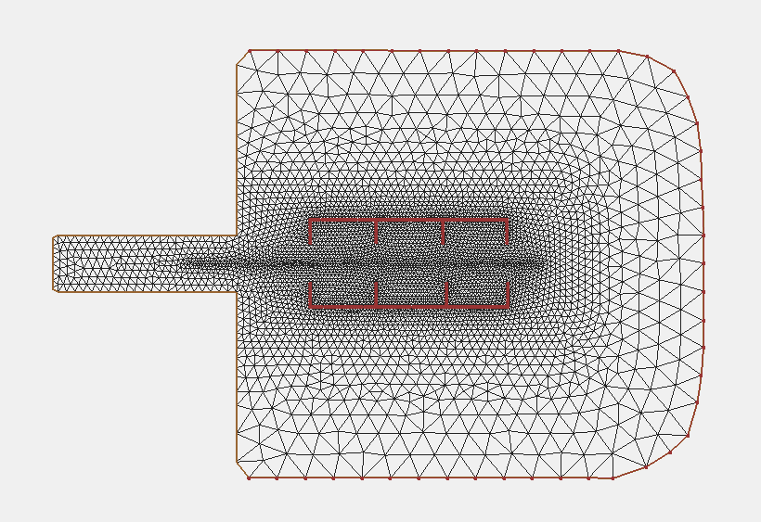

Fig.1 Mesh and dikes node strings of an idealized estuary.

There are two groups of dikes and groynes in this idealized estuary, and they are spatially separated, which then could be allocated into separate CPU domains to increase the computation speed.

The mesh file should be specified as 2dm format, which could be configured under generic model in SMS. The grd format (fort.14) is not supported in this utility. We specified this mesh as *casename_no_dike.2dm*.

**Step 2: Split mesh along dikes and groynes**

The mesh information should be given in the main program of source code in *split_mesh* directory, such as that in Fig.2.

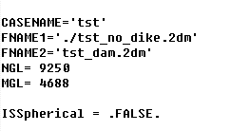

Fig.2 Mesh information specification in virtual_dike_mesh.f90

Then, the node information for the dikes and groynes should be given in *casename_ns.dat* in *step2_split_mesh* directory. The original node string information in 2dm-formated mesh file is shown as Fig.3.

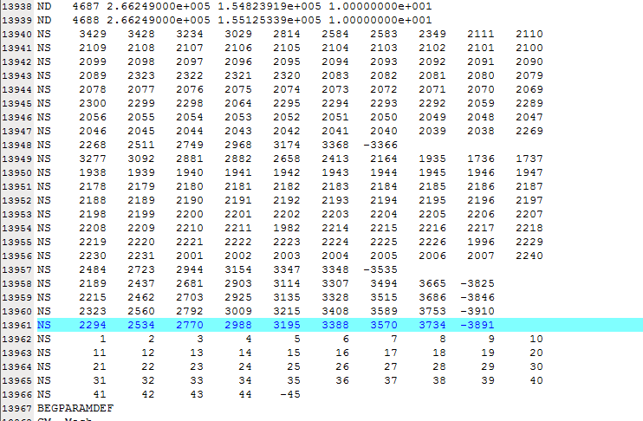

Fig.3 Original format for the node strings in SMS 2dm-format mesh file.

The node strings for dikes and groynes are included from line 13940 to line 13961. The node string from line 13962-13966 indicates the open boundary in this idealized estuary.

Copy these node string lines to *casename_ns.dat*, and replace the blanks with zero. The final format of casename_ns.dat is shown as Fig.4.

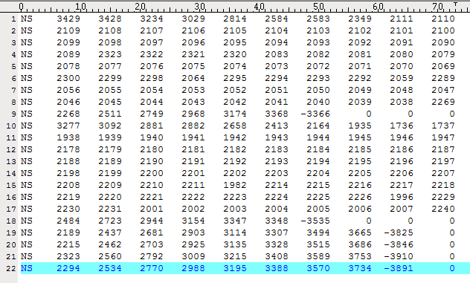

Fig.4 Final format of casename_ns.dat

Compile the source code in *split_mesh*, and link the executable *./xsplit* in *step2_split_mesh* directory, and run this program to split this mesh along the dikes and groynes. Some temporary files will be produced, and the final result for this step is *casename_dike.2dm*.

The dikes and groynes in *casename_dike.2dm* is shown in Fig.5, indicating inserted solid coastline along the dikes and groynes.

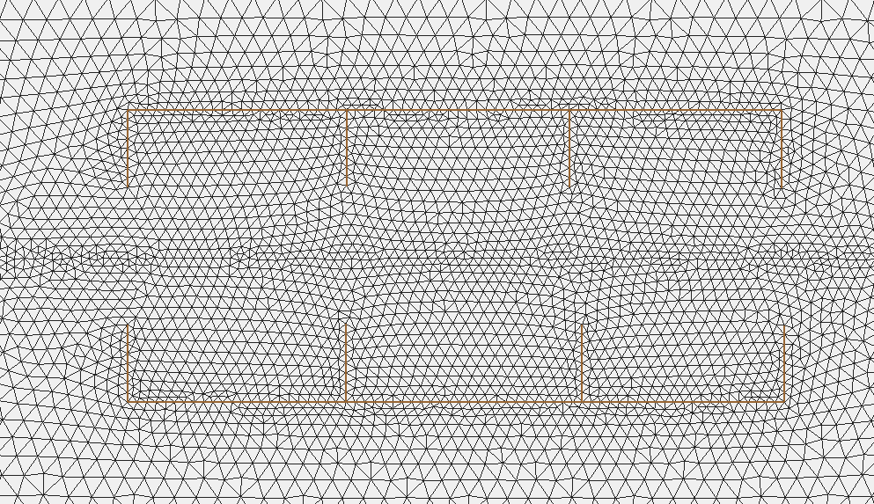

Fig.5 The boundaries for dikes and groynes after mesh splitting.

**Step 3: Renumber the mesh and generate the input file**

Copy the node string information and other mesh information in *casename_no_dike.2dm* (Fig.3) to *casename_dike.2dm*.

Select the open boundary node string, and renumber the whole mesh with new node numbers and cell numbers.

Save the mesh into *casename_dike_renumbered.2dm*.

Copy or link the *casename_dike_renumbered.2dm* to *step3_generate_files* directory.

Copy the node string information in *casename_dike_renumbered.2dm* to *casename_ns_after_renumber.dat* file.

Insert a new column after ‘NS’ column in *casename_ns_after_renumber.dat* file to specify the domain marks. The file format for *casename_ns_after_renumber.dat* file is shown in Fig.6.

**It should be noted** all spatially connected dikes/groynes should be allocated in one CPU domain. To increase the computation speed under parallel environment, these nodes and cells of dikes and groynes should be allocated as many CPUs as possible if they are spatially separated.

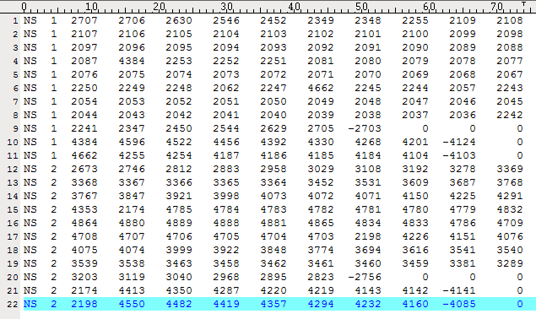

Fig.6 File format of *casename_ns_after_renumber.dat*.

Specify the mesh information in *generate_thin_dam_inputs.f90* as Fig.7.

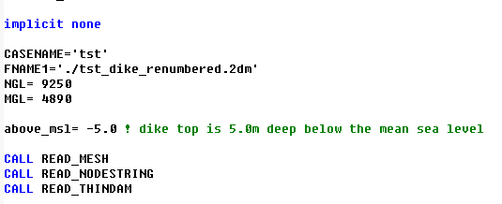

Fig.7 Mesh specification in *generate_thin_dam_inputs.f90*.

The variable *above_msl* indicates the elevation of dike/groyne top above the mean sea level. In this experiment example, the dike/groyne height is 5m, which means the dike top is located in the middle of water column (uniform 10m-depth bathymetry).

Besides of this uniform value of *above_msl*, some special configuration of dike/groyne height can be given in this utility, such as *casename_ns_adding.dat*, *casename_ns_submerged.dat* and *casename_ns_linear_groyne.dat*. For this idealized experiment, these files could be left blank.

The final input files for dikes and groynes will be generated into *casename_dam_cell.dat* and *casename_dam_node.dat*.

**Step 4: Run the dike-groyne model**

Copy or link the *casename_dam_cell.dat* and *casename_dam_node.dat* to *step4_final_model/input* directory.

Create the *casename_grd.dat*, *casename_dep.dat* and *casename_cor.dat* according to *casename_dike_renumbered.2dm*. Copy them into *input* directory.

Run the model with

*./fvcom –casename=tst* for serial computation, or

*mpiexec –n 10 ./fvcom –casename=tst* for parallel running.

User can check the domain specification with Pseudocolor plotting of variable *partition* in model result *tst_0001.nc* as shown in Fig.8. The software VisIt is recommended.

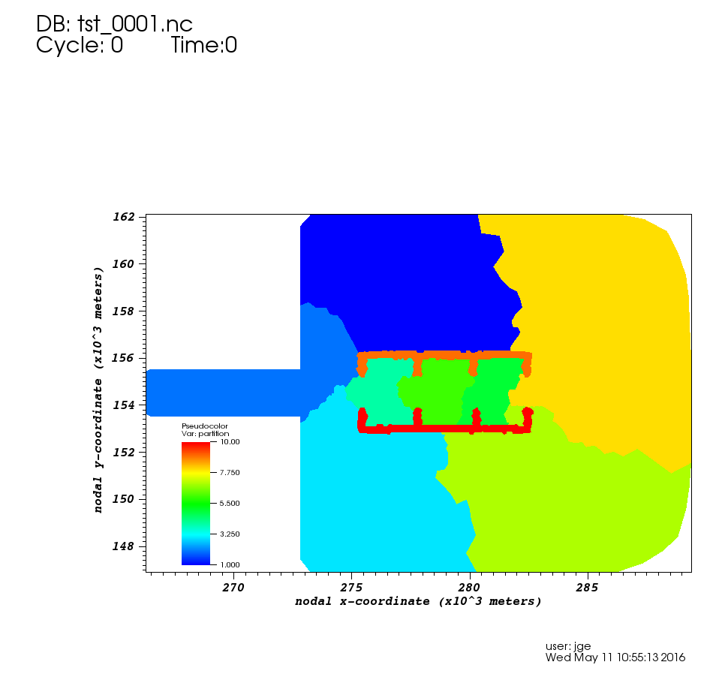

Fig.8 Domain decomposition with dike-groyne module in FVCOM.

The model details could be referred to:

Ge, J., Chen, C., Qi, J., Ding, P., & Beardsley, R. C. (2012). A dike-groyne algorithm in a terrain-following coordinate ocean model (FVCOM): Development, validation and application. *Ocean Modelling*, 47(C), 26–40. doi:10.1016/j.ocemod.2012.01.006

Chen C., R. C. Beardsley, G. Cowles, J. Qi, Z. Lai,G. Gao, D. Stuebe, Q. Xu, P. Xue, J. Ge, S. Hu, R. Ji, R Tian, H. Huang, L. Wu, H. Lin, Y. Sun and L. Zhao, (2013). An Unstructured Grid, Finite-Volume Community Ocean Model FVCOM User Manual, SMAST/UMASSD-13-0701

Regarding any questions and suggestions about the dike-groyne module, users can contact with:

Dr. Changsheng Chen ([c1chen@umass.edu](mailto:c1chen@umass.edu)) at School of Marine Science and Technology, University of Massachusetts-Dartmouth,

Dr. Jianzhong Ge ([jzge@sklec.ecnu.edu.cn](mailto:jzge@sklec.ecnu.edu.cn) ) at State Key Laboratory of Estuarine and Coastal Research, East China Normal University.