mysql> show databases;

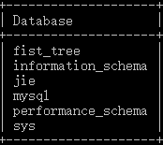

create table shopping_wang(id int(5) auto_increment primary key,name varchar(5));

Query OK, 0 rows affected (0.16 sec)

mysql> alter table shopping_wang add xihao varchar(4);

mysql> alter table shopping_wang add zhekou varchar(4);

mysql> alter table shopping_wang add shuangshiyiyuanwang varchar(4);

mysql> alter table shopping_wang add money varchar(4);

mysql> desc shopping_wang;

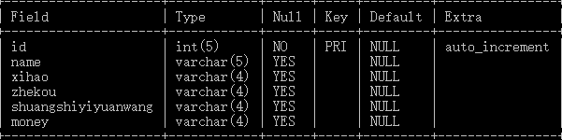mysql> insert into shopping_wang(id,name,xihao,zhekou,shuangshiyiyuanwang,money)values(1,'dlxzq','66.6','77.7','66.5','99.3');

mysql> select * from shopping_wang;

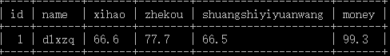

mysql> insert into shopping_wang(id,name,xihao,zhekou,shuangshiyiyuanwang,money)values(2,'qwerr','56.3','56.5','58.3','78.6');

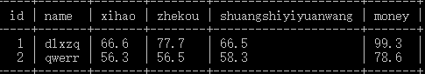

mysql> insert into shopping_wang(id,name,xihao,zhekou,shuangshiyiyuanwang,money)values(3,'dfghj','56.3','45.6','58.9','45.6'),(4,'cvbnm','45.6','45.8','86.4','58.4');

mysql> select * from shopping_wang;

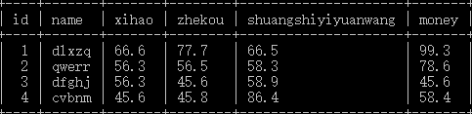

mysql> update shopping_wang set shuangshiyiyuanwang="60" where id=4;

mysql> select * from shopping_wang;

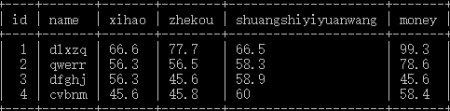

mysql> delete from shopping_wang where name='dfghj';

mysql> select * from shopping_wang;

