**mysql> show databases;**

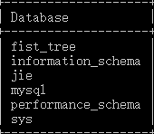

mysql> use jie;

mysql> show tables;

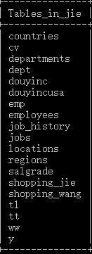

mysql> create table my(id int auto_increment primary key,name varchar(3) not null);

mysql> alter table my add shoucang varchar(2);

mysql> alter table my add huazhaungpin varchar(2);

mysql> alter table my add piaoliangdeyifu varchar(2);

mysql> alter table my add pen varchar(2);

mysql> desc my;



mysql> insert into my(id,name,shoucang,huazhaungpin,piaoliangdeyifu,pen)

-> values(1,'yui',12,13,14,25);

mysql> select * from my;



mysql> select distinct piaoliangdeyifu from my;

