mysql> show tables;

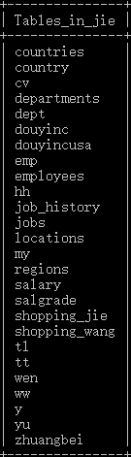

mysql> select * from zhuangbei;

mysql> desc zhuangbei;

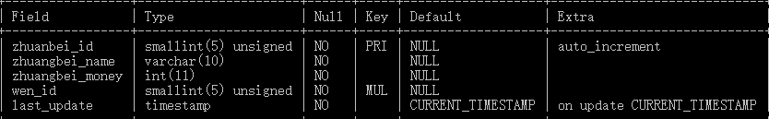

mysql> desc wen;

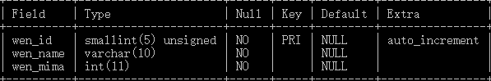

mysql> select md5("wen_mima");

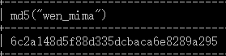

mysql> desc wen;

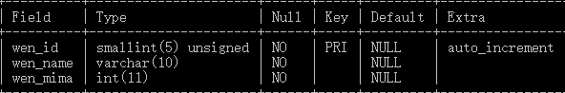

mysql> insert into wen(

-> wen_name,wen_mima) values(

-> 'yy',012345),('uu',678945),('hh',789456);

mysql> select * from wen;

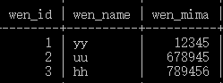

mysql> desc zhuangbei;

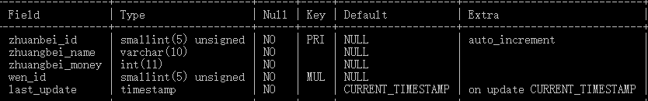

mysql> insert into zhuangbei(

-> zhuangbei_name,zhuangbei_money,wen_id) values('wwwwww',25,1),('jjjjjj',36,2),('bbbbbb',58,3);

mysql> select * from zhuangbei;

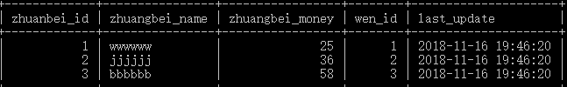

mysql> update wen set wen_id=2 where wen_id=2;

mysql> select * from zhuangbei;

