mysql> use jie;

mysql> create table dianying(id int(12) auto_increment primary key,name varchar(20) not null,year int(4),director varchar(20) not null,grade int(3));

mysql> desc dianying;

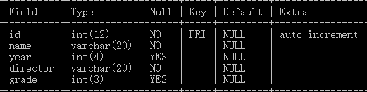

mysql> insert into dianying (id,name,year,director,grade) values(1,'goulaidewomen','2018','liuruoying','8.1'),(2,'xinlizui','2017','zhengnan','8.3');

mysql> select * from dianying;

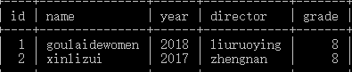

mysql> select director from dianying where director like"liu%";

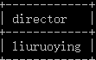

mysql> select name from dianying where name like"xin%";

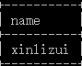

mysql> select * from dianying where (year=2017);

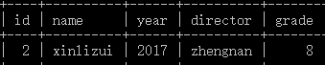

mysql> select * from dianying where (grade=8);

