mysql> show databases;
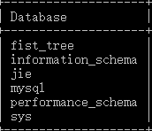
mysql> show tables;

mysql> select * from departments;
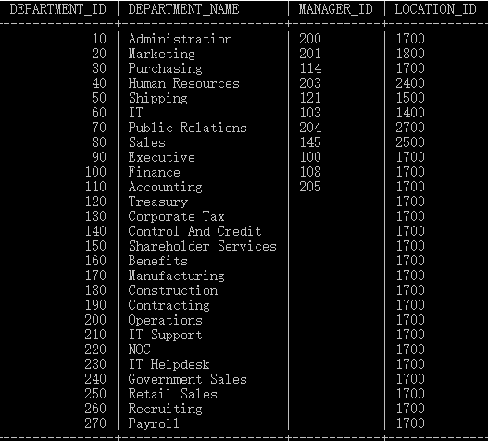
mysql> select distinct DEPARTMENT_NAME from departments;

mysql> select *from departments where ( LOCATION_ID>=1700);
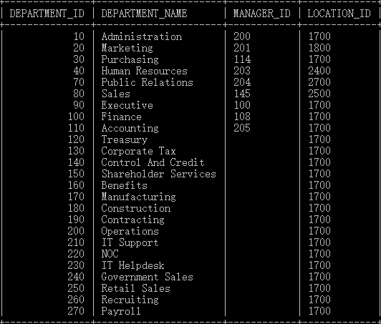
mysql> select * from departments order by MANAGER_ID;
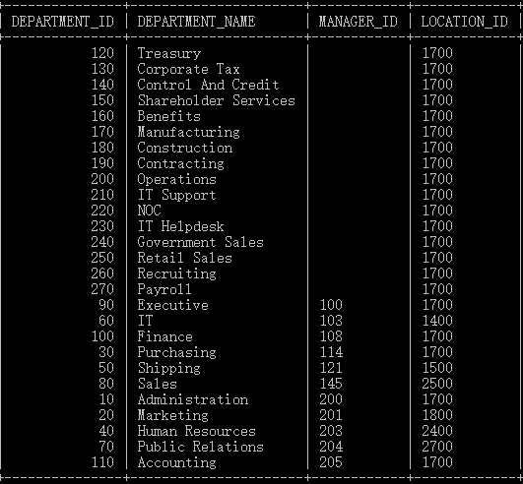
mysql> select * from departments order by MANAGER_ID desc;
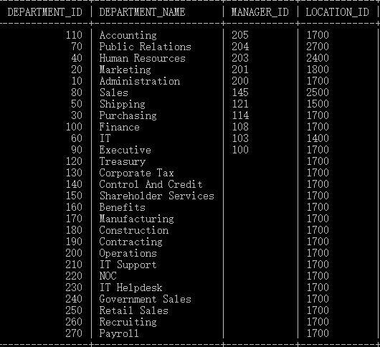
mysql> select * from departments where MANAGER_ID>120 order by MANAGER_ID desc limit 4,2;

mysql> select * from departments where MANAGER_ID>120 order by MANAGER_ID desc limit 3;
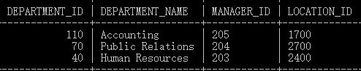
mysql> select sum(MANAGER_ID) from departments;

mysql> select sum( DEPARTMENT_ID),sum( MANAGER_ID) from departments;
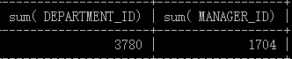
mysql> select DEPARTMENT_ID,sum( DEPARTMENT_ID) from departments group by DEPARTMENT_ID;
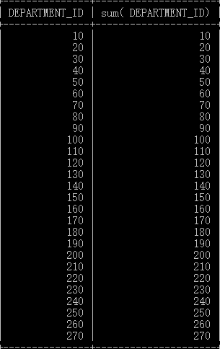
mysql> select max( DEPARTMENT_ID) from departments;
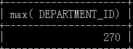
mysql> select min( DEPARTMENT_ID) from departments;
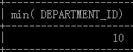
mysql> select DEPARTMENT_ID,count( DEPARTMENT_ID) from departments group by DEPARTMENT_ID;
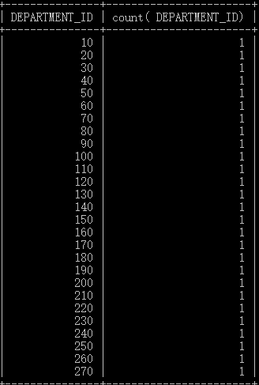
mysql> select * from jobs right join job_history on jobs. JOB_ID=job_history. JOB_ID;
