Design Day Booklet Project Page Template

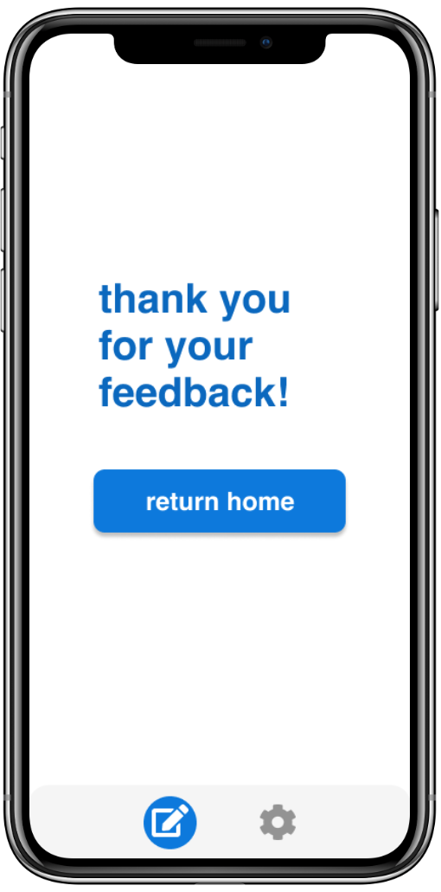

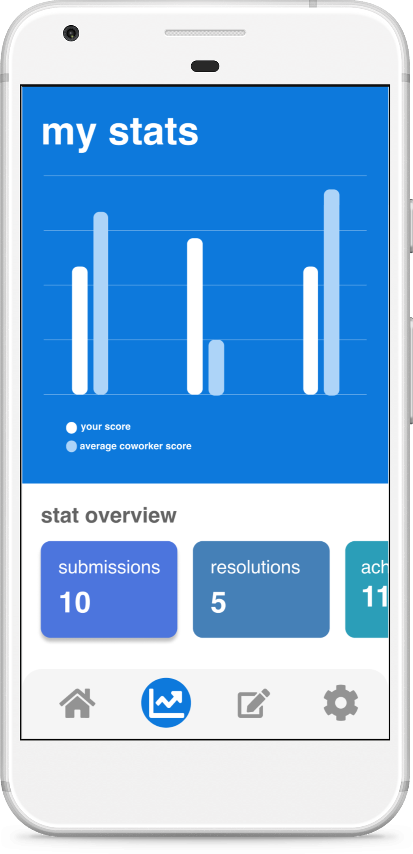

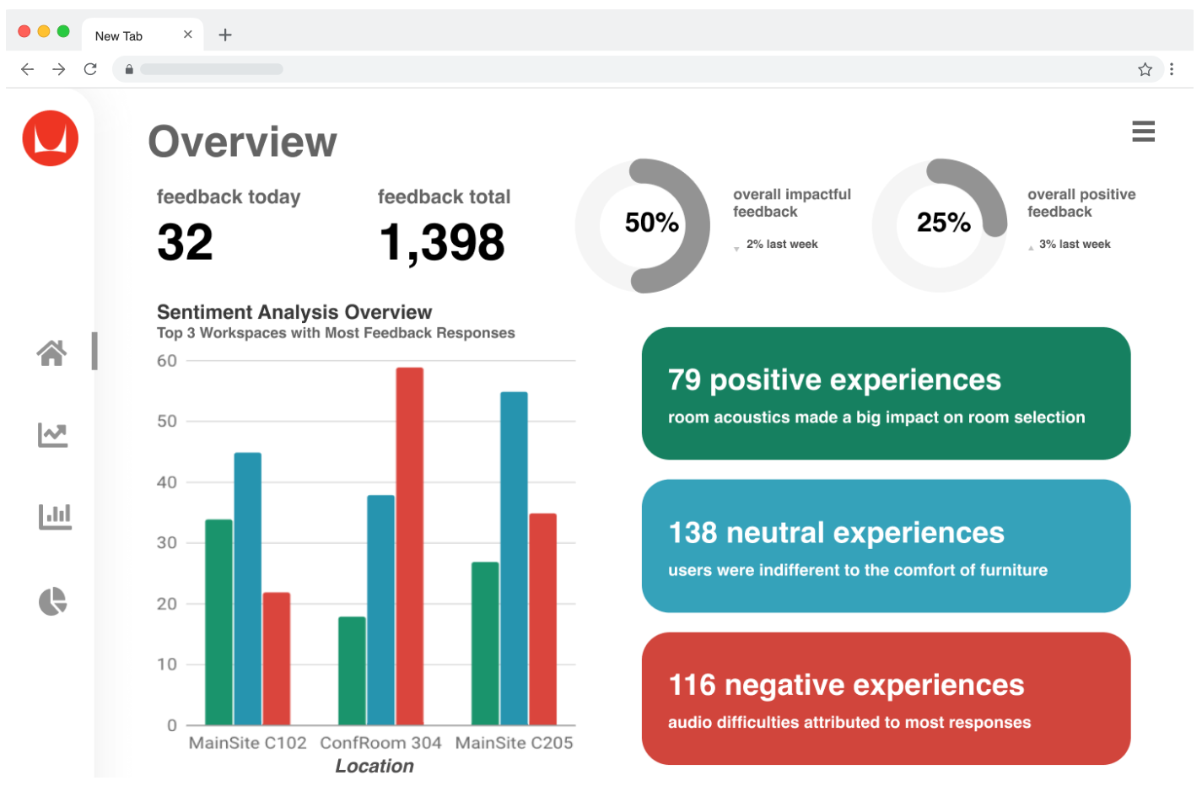

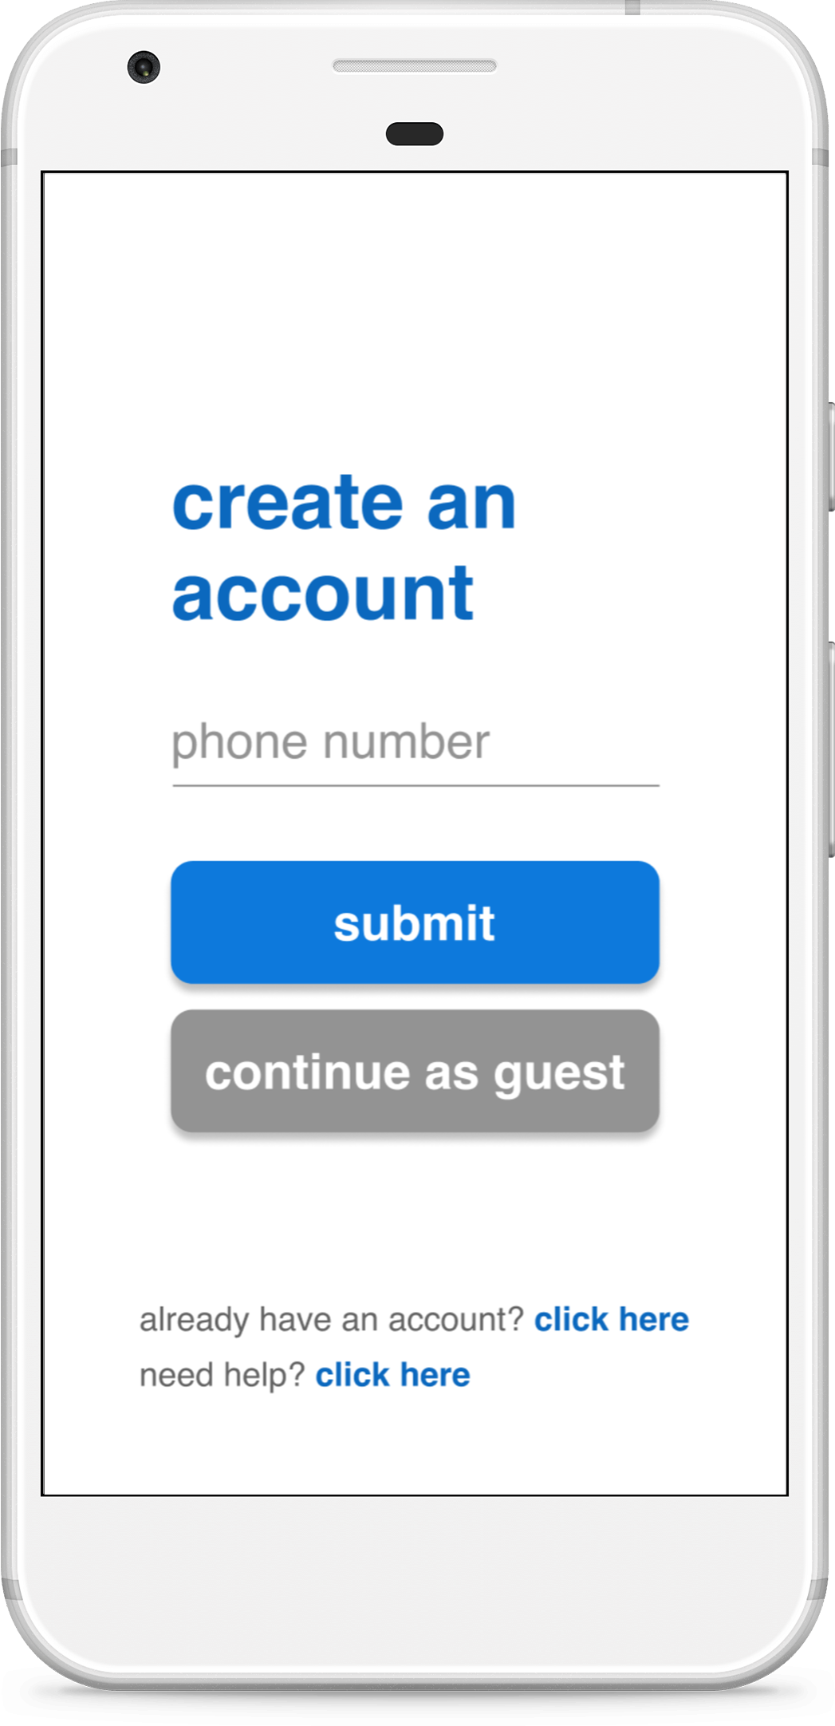

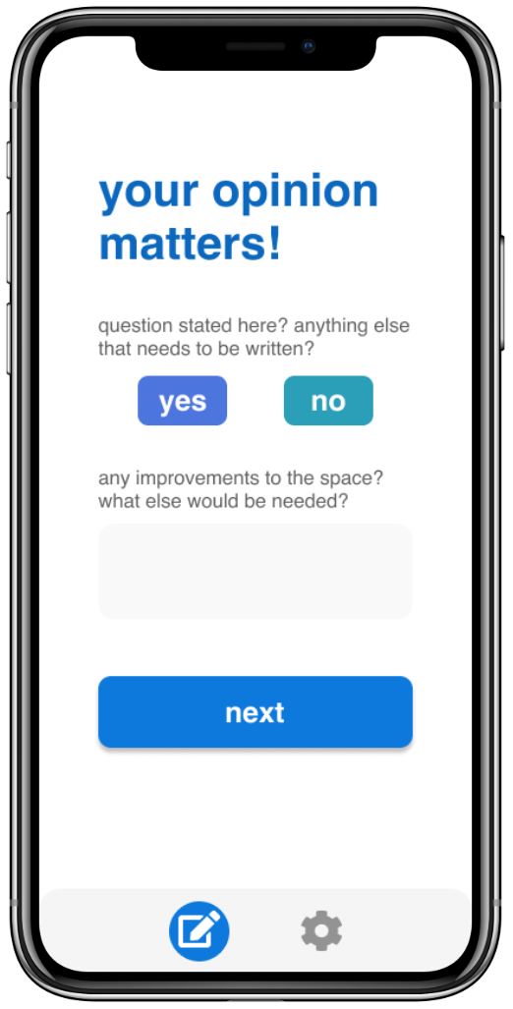

PAGE N + 11



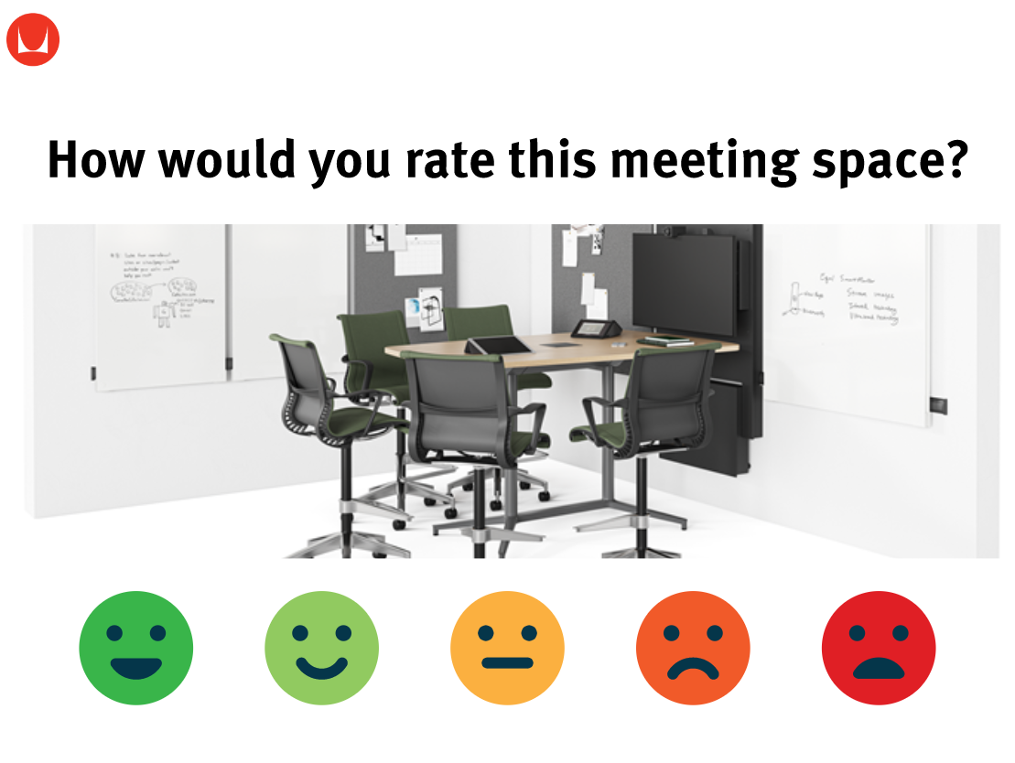

Herman Miller

Project Sponsors

Mark Buikema

Zeeland, Michigan

Missy Groothuis

Zeeland, Michigan

Tom Holcomb

Zeeland, Michigan

Michigan State University

Team Members (left to right)

Sophia Frankel

Grand Rapids, Michigan

Jake Baum

Grand Rapids, Michigan

Lynn Dai

Nanjing, China

John Nguyen-Tran

Holt, Michigan

Marla Mae Defensor

Manila, Phillipines

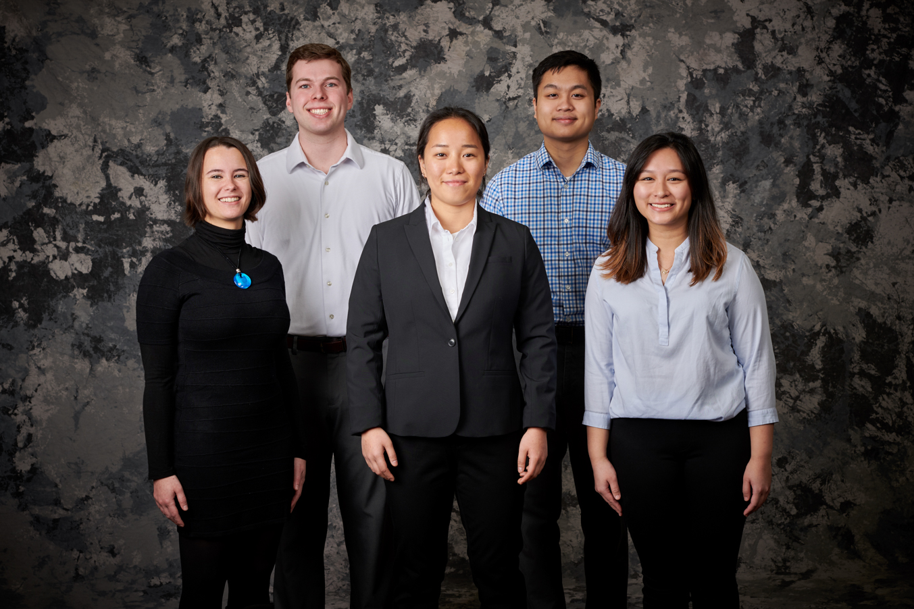

Herman Miller, a 100+ year old furniture company from Zeeland, Michigan, is known for its history of design innovation. Herman Miller cares about the workspace designs and whether the designs are worth the investment. Herman Miller conducts broad surveys to gain feedback on office space quality and has sensor solutions to measure the utilization of workspace areas.

Sensor solutions, however, do not provide adequate information regarding the employees’ sentiment towards the specific workspace.

Based around our mobile application, users are able to use workspace kiosk stations and their mobile devices to input sentiment about specific workspace. Our sentiment analytics web platform derives quick data insights from workspace kiosk stations and users’ mobile devices.

The mobile application allows the user to login using their company code and user identification, or as a guest. The users are able to access their reward page if they create accounts. The Beacon is able to send a notification with sentiment question about a specific workspace. The kiosk station at open workspace location allows user to choose their sentiment level regarding the specific workspace.

The data collected from the mobile application is being displayed through the analytics web platform, which is only accessible for Herman Miller, as this gives a better understanding of how to accommodate workspace needs.

The iOS and Android mobile application use Amazon Web Services(AWS), including relational database service, natural language processing, API Gateways, as backend to collect and analyze data. Estimote Proximity Beacon is used as workspace user location detection. The Google Charts API is used as data displaying aid. React is used for building analytics web platform.

Engineering Building, 1300 Hallway | First Floor 8:00 a.m. - Noon / Computer Science CSE498

Herman Miller

Measuring Workspace Impact on Employee Experience