基于Pygame的贪吃蛇的设计与实现
1.程序简介（300-500字）
（1）所用技术：
Import导入Pygame,内置类库random。调用pygame内置api的display.set_mode可以非常方便地初始化窗口,time.Clock().tick(t)提供定时渲染的功能。Pygame提供了sprite精灵类 和sprite.Group精灵组类，使用它可以快速简便地更新模块几时渲染。Pygame的中文显示，需要额外调用pygame.font.Font("./simhei.ttf", 18)，参数为中文字体包，也可以直接用pygame.font.Sys()引用系统自带的中文字体包。
（2）开发环境及硬件支撑：
开发环境：cpu：i5 双核 操作系统：Mac python：3.5
pip包：pygame
（3）功能特征描述：
1. 启动页点击绿色块开始游戏
2. 游戏页面，绿色代表我方贪吃蛇，可左右移动，上下移动，但是不能移出屏幕。
3. 游戏页面，红色代表食物。
4. 红色食物随机位置出现。
5. 贪吃蛇触及食物即可将食物食之，食的越多分数越高。
6. 贪吃蛇若碰到屏幕边缘和本身身体，游戏结束退出。

2.程序截图（1-5张）：
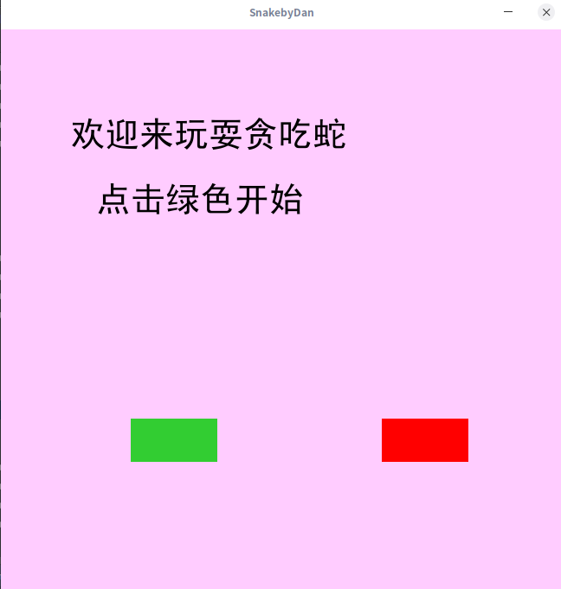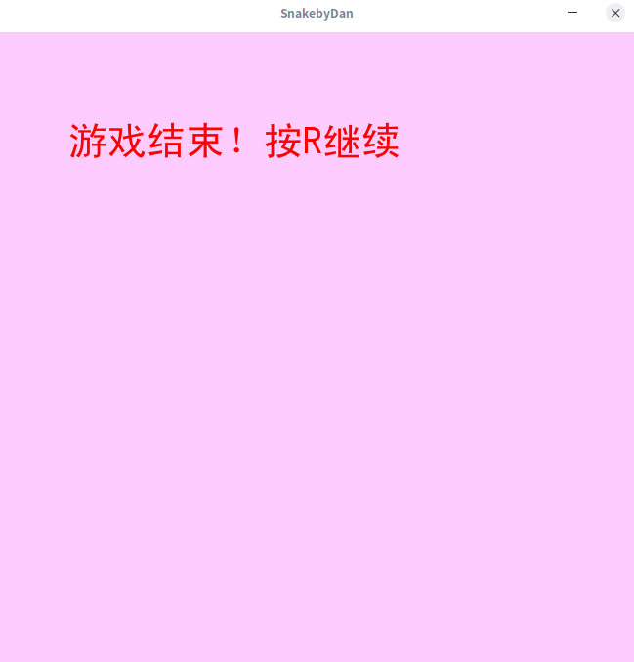

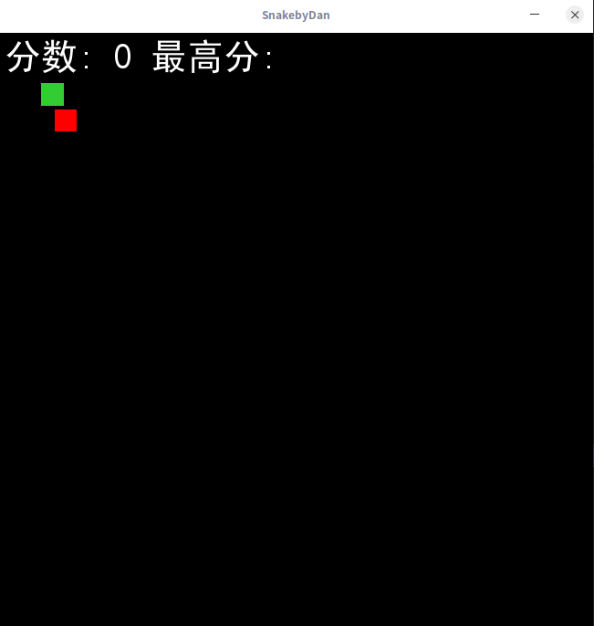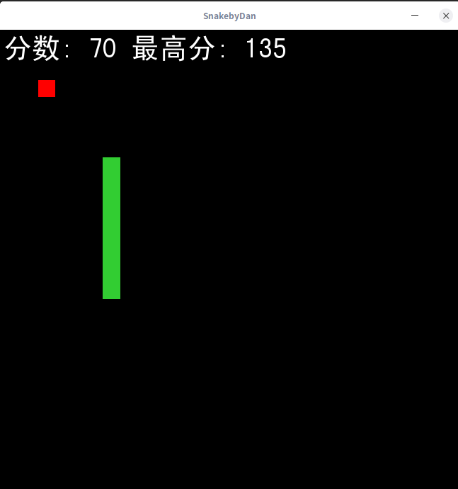

3.程序代码：
（1）文件名：plane_main.py
#--coding:utf-8--
import pygame
import random

#colors
black = (0, 0, 0)
white = (255, 255, 255)
red = (255, 0, 0)
lime_green = (50, 205, 50)
other_green = (0, 250, 154)
pink = (255,204,255)
bright_red = (255,153,153)

pygame.mixer.pre_init(44100,16,2,4096)

pygame.init()

width = 100
height = 100
x = 150
y = 170

screenwidth = (650)
screenheight = (650)
screen = pygame.display.set_mode((screenwidth, screenheight))

pygame.display.set_caption("Snake")
pygame.display.update()
clock = pygame.time.Clock()
# font = pygame.font.SysFont("simhei", 40)
font = pygame.font.Font("./simhei.ttf", 40)

def text_screen(text, color, x, y):
screen_text = font.render(text, True, color)
screen.blit(screen_text, [x, y])

# pygame.mixer.music.load("snek.wav")
# pygame.mixer.music.play(-1)

def plot_snake(screen, color, snke_list, snake_size):
for x,y in snke_list:
pygame.draw.rect(screen, lime_green, [x, y, snake_size, snake_size])

def start_screen():
exitgame = False
while not exitgame:
screen.fill(pink)

mouse = pygame.mouse.get_pos()
click = pygame.mouse.get_pressed()
click2 = pygame.mouse.get_pressed()

if 150+100 > mouse[0] > 150 and 450+50 > mouse[1] > 450:
pygame.draw.rect(screen, other_green,(150,450,100,50))
if click[0] == 1:
pygame.mixer.music.stop()
gameloop()
else:
pygame.draw.rect(screen, lime_green,(150,450,100,50))

pygame.draw.rect(screen, red,(440,450,100,50))
if click2[0] == 1:
pygame.quit()

text_screen("欢迎来玩耍贪吃蛇", black, 80, 100)
text_screen("点击绿色开始", black, 110, 175)
for event in pygame.event.get():
if event.type == pygame.QUIT:
exitgame = True

pygame.display.update()
clock.tick(45)

#game loop#
def gameloop():
exitgame = False
gameover = False
snake_x = 45
snake_y = 55
snake_size = 25
velocity_x = 0
velocity_y = 0
snke_list = []
snke_length = 1
fps = 60
food_x = random.randint(20, screenwidth/2)
food_y = random.randint(20, screenheight/2)
score = 0
init_velocity = 5
food_x = random.randint(20, screenwidth/2)
food_y = random.randint(20, screenheight/2)
food_size = 24
with open("Highscore.txt", "r") as f:
Highscore = f.read()

while not exitgame:
if gameover:
with open("Highscore.txt", "w") as f:
f.write(str(Highscore))
screen.fill(pink)
text_screen("游戏结束！按R继续", red, 70, 90)

for event in pygame.event.get():
if event.type == pygame.QUIT:
exitgame = True

if event.type == pygame.KEYDOWN:
if event.key == pygame.K_r:
pygame.mixer.music.stop()
gameloop()

else:

for event in pygame.event.get():
if event.type == pygame.QUIT:
exitgame = True

if event.type == pygame.KEYDOWN:
if event.key == pygame.K_RIGHT:
velocity_x = init_velocity
velocity_y = 0

if event.key == pygame.K_LEFT:
velocity_x = - init_velocity
velocity_y = 0

if event.key == pygame.K_UP:
velocity_y = - init_velocity
velocity_x = 0

if event.key == pygame.K_DOWN:
velocity_y = init_velocity
velocity_x = 0

if event.key == pygame.K_q:
score+=24

snake_x = snake_x + velocity_x
snake_y = snake_y + velocity_y

if abs(snake_x - food_x)<20 and abs(snake_y - food_y)<20:
score +=10
pygame.mixer.music.load("8bitpickup.wav")
pygame.mixer.music.play()
food_x = random.randint(20, screenwidth/2)
food_y = random.randint(20, screenheight/2)
snke_length +=5
if score>int(Highscore):
Highscore = score

screen.fill(black)
text_screen("分数: "+ str(score) + " 最高分: "+str(Highscore), white, 5, 5)
pygame.draw.rect(screen, red, [food_x, food_y, food_size, food_size])

head = []
head.append(snake_x)
head.append(snake_y)
snke_list.append(head)

if len(snke_list)>snke_length:
del snke_list[0]

if head in snke_list[:-1]:
gameover = True
# pygame.mixer.music.load("Gameover.mp3")
pygame.mixer.music.play()

if snake_x<0 or snake_x>screenwidth or snake_y<0 or snake_y>screenheight:
gameover = True
# pygame.mixer.music.load("Gameover.mp3")
pygame.mixer.music.play()

plot_snake(screen, black, snke_list, snake_size)
clock.tick(fps)

pygame.display.update()
pygame.init()

pygame.quit()

start_screen()

