**MAIN(GITHUB)**

GitHub is a web-based [Git](https://en.wikipedia.org/wiki/Git_(software)) repository [hosting service](https://en.wikipedia.org/wiki/Hosting_service). It offers all of the [distributed revision control](https://en.wikipedia.org/wiki/Distributed_revision_control) and [source code management](https://en.wikipedia.org/wiki/Source_code_management)(SCM) functionality of [Git](https://en.wikipedia.org/wiki/Git_(software)) as well as adding its own features. Unlike Git, which is strictly a [command-line](https://en.wikipedia.org/wiki/Command-line) tool, GitHub provides a [Web-based graphical interface](https://en.wikipedia.org/wiki/Web_application) and desktop as well as mobile integration.

The best feature about GitHub is a person could access another person’s file and make changes to it. An example would be if my friend wants me to make changes to a project in Visual Studio, he can put his files on GitHub and I am able to take his files and make changes to it. Thus, I will make a short demo on how GitHub works.

Firstly, you and your friend would need to sign up as a GitHub user, then make a public repository so other people can make changes to that particular repository. Then, after adding one another, they can make changes to each other’s files

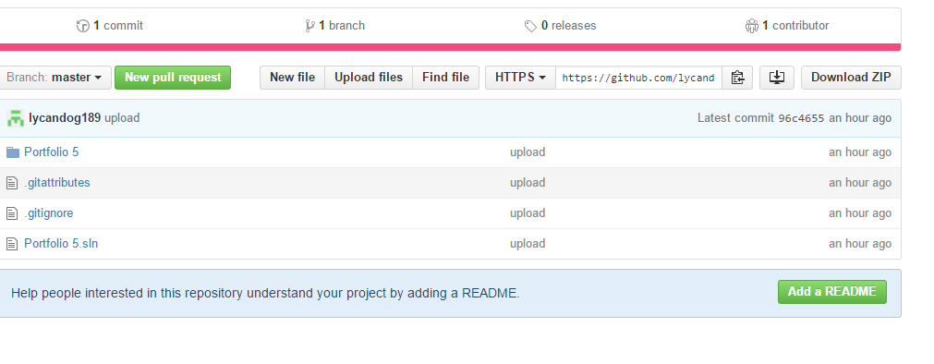

First, I accessed lycandog189’s repository, then I copied the github link in able to make changes to his Portfolio 5 file

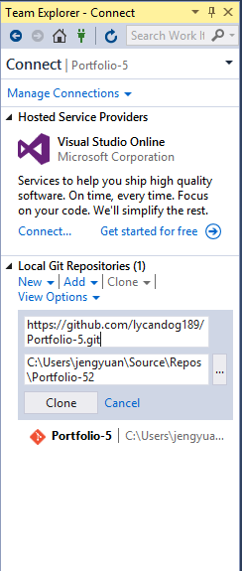

I pasted the link in the link box which is found in Visual Studio, then I clicked the clone button to connect to lycandog189’s github Portfolio 5. Then I waited for the cloning to be completed

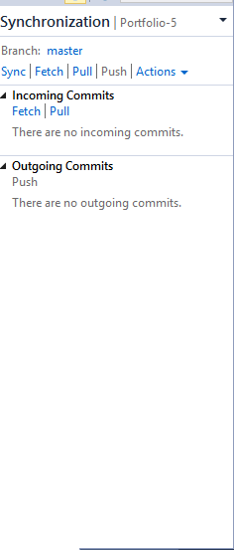

After that, I pulled the Portfolio 5 file from lycandog’s repository to make changes to his current project.

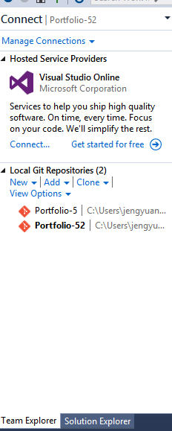

Lycandog’s Portfolio 5 is now in my visual studio.

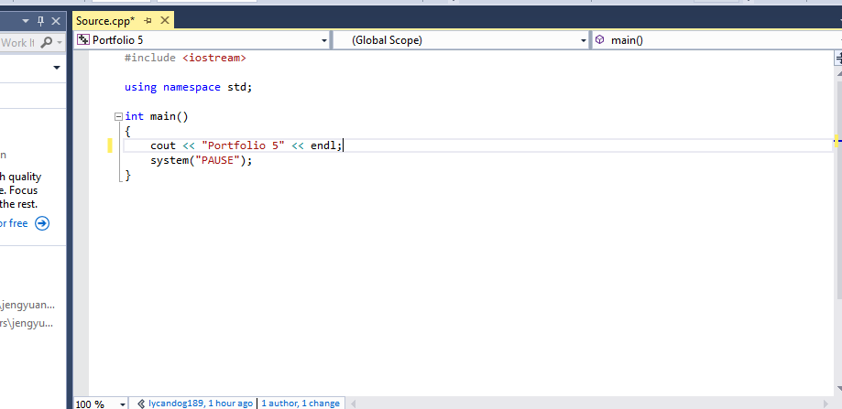

This is his current file without making changes yet

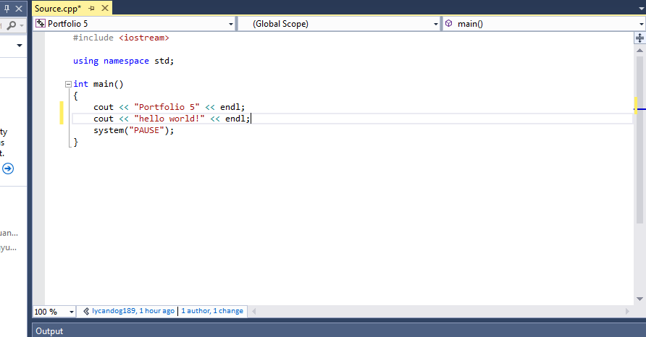

I added a line called cout << “hello world! << endl; to see if there will be changes later.

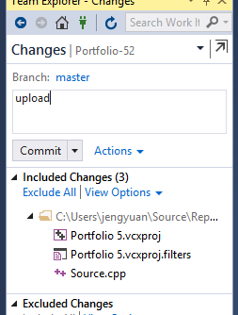

After adding that line, I put a name called upload(can be any name at all) and click commit which will commit any changes done.

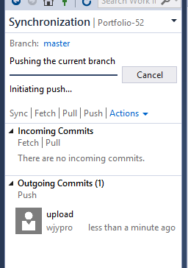

Then I click the push button which sends the changes I made back to lycandog’s github.

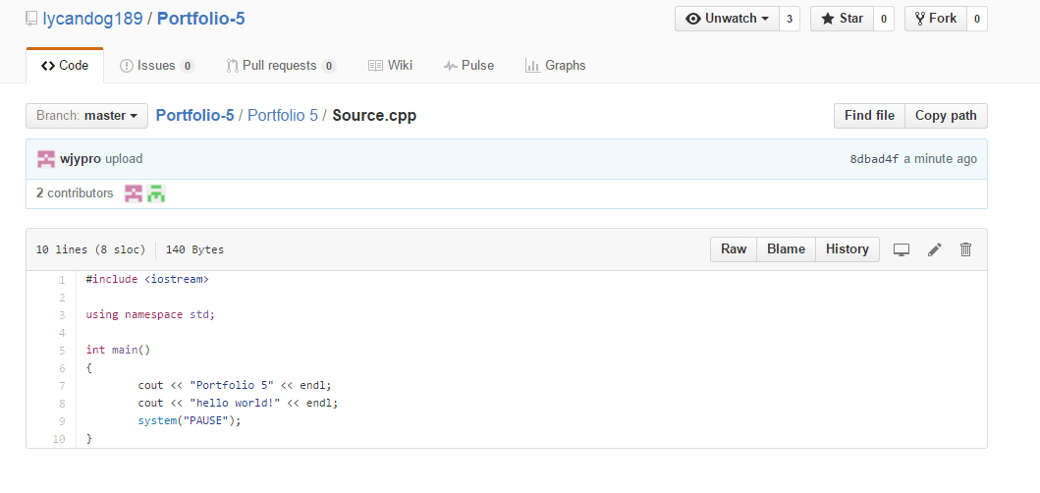

After opening his github, the line (cout << “hello world!” << endl;) is added, thus changes are made to his Portfolio 5 file.