Available online at www.sciencedirect.com



**ScienceDirect**

Procedia Computer Science 166 (2020) 206–212

3rd International Conference on Mechatronics and Intelligent Robotics (ICMIR-2019)

Research and Application of Template Engine for Web Back-end Based on MyBatis-Plus

Yao Zhang Li1 , Sheng Gao1,* , Jing Pan2, Bi Feng Guo1, Pei Feng Xie*1*

*1Faculty of Mathematics and Computer Science, Guangdong Ocean University*

*2Faculty of Management, Guangdong Ocean University*

**Abstract**

In web development, it takes much time to code for back-end including business logic and interface integration, which is machanized and high-repeated. In order to address the problem in back-end web coding, this paper analyzes the advantages and disadvantages of SSM(Spring, SpringMVC and MyBatis) framework and development pattern of the original and end separation. By integrating the template engine in PHP web development, we achieve the technology of code generation for back-end of web, which benefits for artificial intelligence of web coding and saves the time on software engineering.

© 2020 The Authors. Published by Elsevier B.V.

This is an open access article under the CC BY-NC-ND license (http://creativecommons.org/licenses/by-nc-nd/4.0/)

Peer-review under responsibility of the scientific committee of the 3rd International Conference on Mechatronics and Intelligent Robotics, ICMIR-2019.

**Keywords***:*Back-end Development, Code Generation, Template Engine

1. **Introduction**

**1.1Background of Software and Web**

With the development of information technology, the use of software crowds into people's life including in entertainment and office work. Differing from hardware, software is made of a series of computer data and instruction list[1]. Software is not only the program in the computer, files are also the parts of software. Software

* Corresponding Author. Tel.+(86) 13924401222 *E-mail: minix@139.com

1877-0509 © 2020 The Authors. Published by Elsevier B.V.

This is an open access article under the CC BY-NC-ND license (http://creativecommons.org/licenses/by-nc-nd/4.0/) Peer-review under responsibility of the scientific committee of the 3rd International Conference on Mechatronics and Intelligent Robotics, ICMIR-2019.

10.1016/j.procs.2020.02.052

|  |  |
| --- | --- |
| *Yao Zhang Li et al. / Procedia Computer Science 166 (2020) 206–212* | 207 |

includes operating software and application software. As we know, android and ios operating system are the popular operating software. Web is a kind of application software existing in the operating software.

***1.2 Literature Review***

Application development, program development, phone application development[2] and web development[3] are included in software development. This paper introduces the development of web service(which is called back-end development) based on the Java Web. In the development of the web, design patterns include MVC(Model, View and Controller) pattern, Web Form, Web Page and so on, but the most popular pattern used by developers is MVC pattern[4]. Some scholars think that MVC pattern has the advantage of low coupling and the data in this project is highly uniform[5]. However, others think that it makes the coding redundant and the assessed data inefficient[6]. Based on the MVC pattern, the development pattern is a kind of pattern with the separation of front-end and back-end. Using this pattern[7], the professionals will be responsible for the different parts of web development and the development is divided into front-end and back-end interacted with interfaces[8]. At present, the most popular technical framework is SSM(Spring, SpringMVC and MyBatis)[9-11] framework and it is widely used in last few years. Differing from SSH(Spring, Struts and Hibernate) framework, it handles requests and responses better and is suitable for RESTful coding style and MVC pattern[12]. Nevertheless, this development pattern has a disadvantage that the interfaces for each Model have the same functional interface, causing so many high-repeated codes in the project and it wastes the developers much time. In the development of PHP[13], this problem is handled by Template Engine. Because of the differences between Java and PHP, less Java developers generate codes with template engine[14]. This technology does deal with the problem effectively.

1. **Operation Mechanism of Web Development**
2. **1 MVC *Pattern***

MVC Pattern is an interactive interface structure design pattern presented in the 1980s and it is also an effective design pattern. The MVC design pattern emphasizes that developers design their software in a modular fashion based on users’ input, data model and information display. It divides an application software into the following three parts.

Model is the business logic of application software including date and model. Model is the core functionality of the application and it encapsulates the data and problem solving process. User calls the Model by calling Controller so that the Model can provide data for Views to reduce the code redundancy.

View is the part of the application software that handles the display of data, which displays different information. View is an interface seen and interacted by users. For the View, data and problem soling process are ignored, from which users can send service requests to the Model by calling the Controller to update the View.

Controller is the part of the application software which handles interactions. Controller converts the inputted information such as mouse and keyboard into service request for Model and View, and it responses the changes of Model to the View. And users only interact with software by Controller.

One set of View and Controllers make up a user interface and a Model can have many Views. If user change the Model through Controller, Controller will spread this change to all Views, so as to achieve the unity of the display.

**2.2 *Development* Pattern of End Separation**

Web Page is one of the early design pattern, which requires the developers to be skilled at the whole development process. It also makes the developers know all technology about the web development, resulting the ambiguous duties among the developers. Consequently, developers need to be skilled at the codes in chaos of web project that is hard to be maintained.

Obviously, MVC pattern changes a lot. The most distinct improvement of it is end Separation development pattern, which means that project development are divided into two parts: front-end development and back-end development.

208 *Yao Zhang Li et al. / Procedia Computer Science 166 (2020) 206–212*

In this development pattern, front-end engineers pay more attention to page expression, user experience, compatibility, etc and back -end engineers are more concerned with high performance, security and business logic. Obviously, compared with the original development pattern like Web Form and Web Page, such a development pattern doesn’t reduce the technical requirements for the developers but higher standards.

**2.3 SSM *Framework***

Spring is an open source java framework. It is a framework developed to reduce the complexity of enterprise project development. The core functions of Spring are IOC(Inversion of Control) and AOP (Aspect-Oriented Programming). Because of these two core functions, almost any Java application can benefit from it. And Spring is a lightweight and low-intrusive open source framework that makes it compatible with other frameworks.

SpringMVC is a sub-project of Spring with the same low-invasive features as Spring. It is the framework that back-end development and front-end development are completely separated. Namely, almost any View can be used. Besides, Spring makes components of java web are better managed in SpringMVC.

Mybatis is an open source Project iBatis of Apache, which was later migrated to google code and renamed MyBatis. MyBatis encapsulates almost all JDBC operations and extends the functionality of parameter settings and return result sets. By parsing the configuration files and the corresponding mapping files, the original JDBC function is extended, making the simple interaction between the application and the databases.

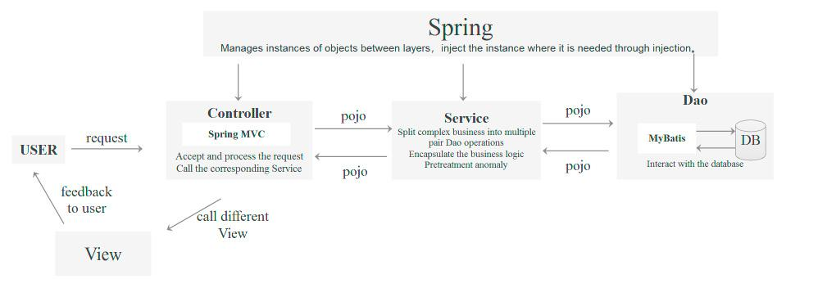

Figure 1 SSM Working Pattern Diagram

With SSM framework, the back-end development is divided into three layers. They are Layer Controller, Layer Service and Layer DAO. Layer Controller is used for processing relevant requests, calling relevant service to complete the business logic and selecting the corresponding view as the feedback to the users. The Service layer encapsulates the business logic, calling Layer Dao and pre-processing the exceptions. MyBatis integrates Layer Service to operate the database to as Layer DAO, persisting the data.

**2*.4 Problem Analysis***

In general, the process of back-end development in SSM framework is database design, entity class design, Layer DAO development, Layer Service development, Layer Controller development, integration with front -end and project completion. In this way, although the coupling between the front-end and back-end is reduced and the code maintainability is high, there remain some problems shown as follows.

High code repeatability. In this development pattern, almost every operation of the table in the database has CRUD (Create, Retrieve, Update and Delete). Regardless of Layer DAO, Layer Service or Layer Controller, the code repeatability there is high. Moreover, as the underlying development of back-end, the development cycle of this stage can’t be shortened. This kind of development make developers busy coding instead of taking more complex business logic into account.

Long cycle for project development. For enterprise projects, there may be hundreds of tables in the database. It takes a long time to develop the CRUD, which delays the business logic development, causing large cycle development of the project.

|  |  |
| --- | --- |
| *Yao Zhang Li et al. / Procedia Computer Science 166 (2020) 206–212* | 209 |

1. **Research Method and Solutions**

***3.1 Research Method***

With the problems above, it is not difficult to find that the writing of such code is simple but a kind of mechanical labor. So the main solution is to shorten the development cycle of the code for simple CRUD and improve the efficiency of coding.

As the same problem, another programming language PHP, has a very effective solution and that is the template engine. The corresponding technology is also used for Java but this is not a regular development method for Java due to the difference between the two languages.

***3.2 Case Analysis***

For the template engine for PHP is different from what is used by Java, the PHP template engine is missed in this paper. Java's template engine is mostly used in JSP (Java Server Pages). Currently there are only two popular template engines: FreeMaker and Velocity. And the programming languages for these two template engines are simple.

After considering the framework to the relevant engine, we found an open source framework called MyBatis-Plus. This framework is an enhancement to MyBatis which improves the functionality of MyBatis but doesn’t change the original structure of MyBatis. Through the extended function of this framework, we can generate the code of Layer DAO, Layer Service and Layer Controller by template engine.

***3.3 Case Refactoring***

Most importantly, this is an open source framework. Many people share the use cases of the framework and official documents are on the official website. What we need to work is coding the start-up class and the template.

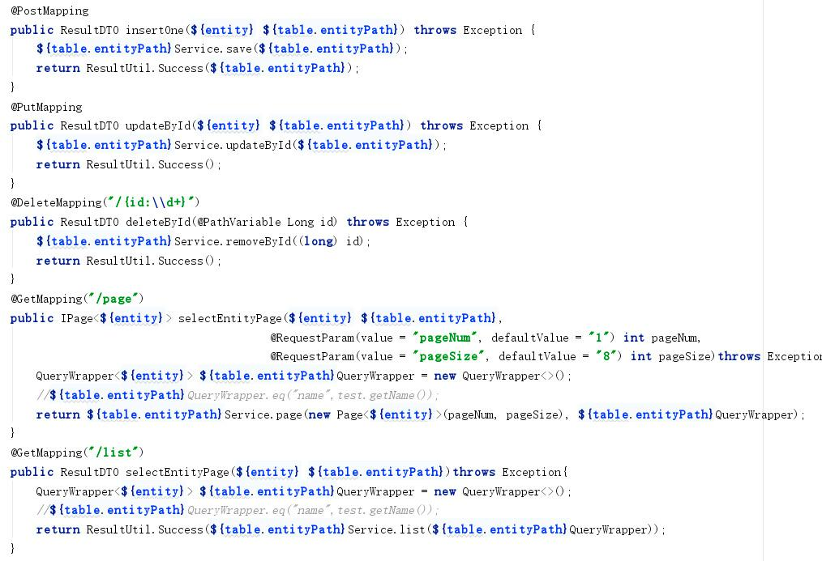

Figure 2 Controller layer template

For the start-up class, there are more than 20 attribute configurations in the start-up class. we choose the most important properties for configuration, while other properties are configured by default to keep the development simple. In this case, we finally modify the properties and successfully created them where developers only need to modify the configuration of the database connection related connections.

210 *Yao Zhang Li et al. / Procedia Computer Science 166 (2020) 206–212*

For the template of MyBatis-Plus, the generated Layer Service and Layer DAO use the template from MyBatis-Plus. We only need to code the template of the Layer Controller which only has five interface functions.

From Figure.2, we can see the template of the Layer Controller. After the code generation, the corresponding class will be generated by this template. There are five functions in the class including inserting an entity, updating an entity by id, deleting an entity by id and selecting entities for page respectively.

1. **Application**

***4.1 Database Design***

With the development environment of JDK8, Spring Boot2.0, Maven3.6 and MySQL5.7, here is a classic case of database that solving the problem of user information management and the corresponding table of database is established as shown in Table.1.

Table.1 Student Table

|  |  |  |  |  |  |
| --- | --- | --- | --- | --- | --- |
| Column Name | Data Type | Lengt | Not | Primary | Annotation |
|  |  | h | Null | Key |  |
| id | int | 11 | Ture | Ture | User ID |
|  |  |  |  |  |  |
| userName | varchar | 255 | Ture | Ture | User Name |
|  |  |  |  |  |  |
| password | varchar | 255 | Ture | Ture | UserPassword |
|  |  |  |  |  |  |

***4.2 Creating Dependence***

Table.2 dependence table

|  |  |  |
| --- | --- | --- |
| groudId | artifactId | version |
| com.baomidou | mybatis-plus-generator | 3.0.7.1 |
|  |  |  |
| com.baomidou | mybatis-plus | 3.0.7.1 |
| org.apache.velocity | velocity-engine-core | 2.0 |
| mysql | mysql-connector-java | 8.0.15 |
|  |  |  |

From Table.2, there are four dependences for the project. The first two dependences are the jar package of MyBatis-Plus. The third dependence is the jar package of template engine. The last one is the connection between Java and database.

After creating the information table and the dependence, we then code the start-up class. And there is a start-up class in the CodeGenerator of the generator package in which there is a main function and configures the data source, template file path and output file path. Place the template under the path specified by the configuration. Finally, run the main function to complete the code generation.

Table.3 original file table

|  |  |
| --- | --- |
| Package | File |
|  |  |
| java.per.example.demo.generator | CodeGenerator.java |
|  |  |
| resource.templatesMybatis | Controller.java.vm |
|  |  |

|  |  |
| --- | --- |
| *Yao Zhang Li et al. / Procedia Computer Science 166 (2020) 206–212* | 211 |

The changes of the project after ran the main function is as follows. From Table.3, original environment of case project is listed and from Table.4, the generated java files are divided into three parts. The part of Layer DAO is the files in the “java.per.example.demo.mapper”, “java.per.example.demo.entity” and “resource.mapper”. The part of Layer Service is the files in the “java.per.example.demo.service” and “java.per.example.demo.service.impl”. The package “java.per.example.demo.controller” is belong to the Layer Controller.

Table.4 new file table

|  |  |
| --- | --- |
| Package | File |
| java.per.example.demo.contr | UserController.java |
| oller |  |
| java.per.example.demo.entity | User.java |
| java.per.example.demo.mapp | UserMapper.java |
| er |  |
| java.per.example.demo.servi | UserServiceImpl.java |
| ce.impl |  |
| java.per.example.demo.servi | UserService.java |
| ce |  |
| resource.mapper | UserMapper.xml |
|  |  |

1. **Evaluation and Future Work**

By using MyBatis-Plus and developing template, code generated is created. With this generator, the code repeatability is reduced and the cycle of development is shortened in back-end development. This code generator can generate interfaces of back-end development, which is beneficial for the artificial intelligent of code generation. However, there are some disadvantages. It can’t deal with the problem of different coding style of different developers. Besides, the generated interfaces just only for CRUD and some special requirement of interface like granting can’t be generated.

In the research above, MyBatis-Plus is indispensable for this technology. So we intend to reduce the dependence of technology on MyBatis-Plus and separate this technology from MyBatis-Plus. As for future work, we will collect the cases of developers and analyze their code writing habits. After we refer to Spring's working model, coding habits can be analyzed by deep learning and neural network algorithm, which is beneficial to artificial intelligence of code generation.

1. **Acknowledgments**

This research is supported and funded by the following projects. Guangdong Province Innovative Entrepreneurship Training Project for College Students (201810566090), Guangdong Ocean University Innovative Entrepreneurship Training Project(CXXL2018171) and Guangdong Ocean University Innovative Team for College Students(CXTD2019003).

1. **References**
2. Steele J, To N. The Android Developer's Cookbook: Building Applications with the Android SDK[M]. 2010.
3. Armstrong, Eric. The Java Web services tutorial =[M]. Higher Education Press, 2003.
4. Wang Y , Guo C , Song L . Architecture of e-commerce systems based on j2ee and mvc pattern[C]// International Conference on Management of E-commerce & E-government. IEEE, 2009.
5. Ding Y H , Liu C H , Tang Y X . MVC Pattern Based on JAVA[J]. Applied Mechanics and Materials, 2012, 198-199:537-541.
6. Han H , Lu J , Lu X . Virtual Interface Machine[J]. ACM SIGSOFT Software Engineering Notes, 2002, 27(3):88-92.
7. Lara J A , Lizcano D , María Aurora Martínez, et al. Developing front-end Web 2.0 technologies to access services, content and things in the future Internet[J]. Future Generation Computer Systems, 2013, 29(5):1184–1195.

212 *Yao Zhang Li et al. / Procedia Computer Science 166 (2020) 206–212*

1. Yunrui Q . Front-End and Back-End Separation for Warehouse Management System[C]// 2018 11th International Conference on Intelligent Computation Technology and Automation (ICICTA). IEEE Computer Society, 2018.
2. Mitchell J G . An overview of the spring system[C]// Compcon Spring 94, Digest of Papers. IEEE, 2002.
3. Mak G , Long J , Rubio D . Spring @MVC[J]. 2010.
4. Vaidyanath K . Java Persistence with MyBatis 3 - A Practical Guide to Mybatis, a Simple Yet Powerful Java Persistence Framework[J]. 2013.
5. Bai Y. Developing Java Web Services to Access Databases[M]// Practical Database Programming with Java. 2011.
6. Zhang D , Wei Z , Yang Y . Research on Lightweight MVC Framework Based on Spring MVC and Mybatis[C]// Proceedings of the 2013 Sixth International Symposium on Computational Intelligence and Design - Volume 01. IEEE, 2013.
7. Amanatidis T , Chatzigeorgiou A . Studying the evolution of PHP web applications.[J]. Information & Software Technology, 2016, 72(4):48-67.
8. Nakaike T , Kondoh G , Nakamura H , et al. JSP splitting for improving execution performance[C]// International Symposium on Applications & the Internet. IEEE, 2004.