**Abstract**

The goal of this lab was to work with Cortex M3 core peripherals and the CMSIS standard using the pre-defined header file (lpc 17xx.h). The systick timer was to be used for both polling and interrupt.

**Procedure**

*Part A: LED Blink with systick polling*

A SysTick_Handler interrupt program was created that would determine if 1 second had passed.

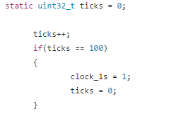

Where clock_1s was a global value used by the infinite while loop in main.

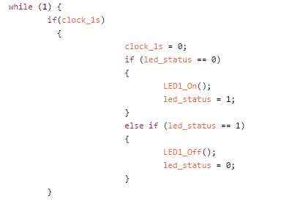

*Part B: Led Blink with systick interrupt*

The SysTick interrupt directly controlled the led pins.

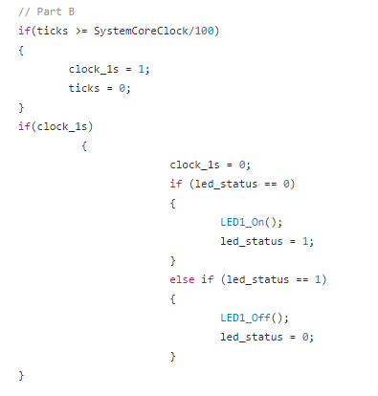

The SysTick was defined using:

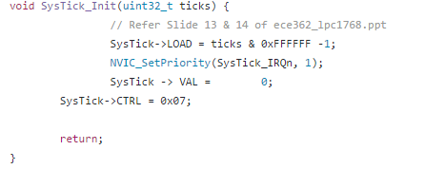

*Part C: LED Blink with CMSIS SysTick initialization*

The same steps were taken as in part B, however the SysTick timer was initialized using SysTick_Config(SystemCoreClock / 100);.

**Results**

**Conclusion**

The lab performed as expected, with both the interrupt and polling methods with the user-defined SysTick initialization file creating the correct delay can causing the LED to blink. The CMSIS standard SysTick_Config also initialized correctly and was successful in creating the desired delay for the LED blink.