Router tracer following text descriptions
Team members: Mihai Daniel
GitHub repository: https://github.com/lowlyN/TProj
Project’s short description (max 50 words):
Route tracer following text descriptions, it has to detect locations/ places from given plaintext and building a map route. If no city is given, it’ll also choose a city based on every location found (the highest city rank wins).
Architecture (schema):
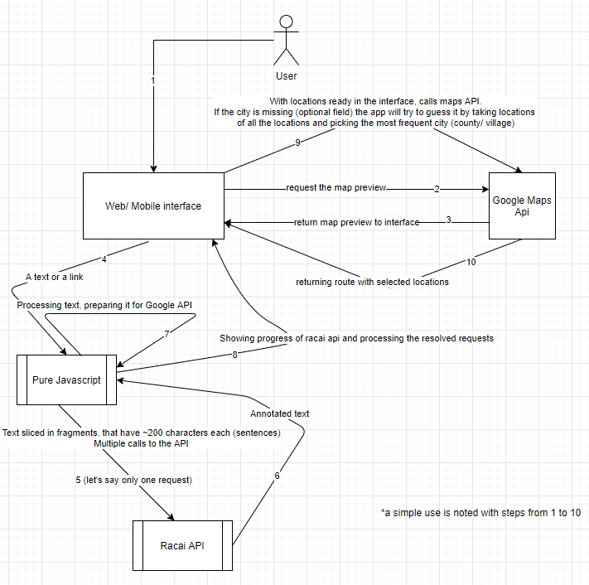

Project’s details (no. max. words no. imposed), including:
- Motivation: Checking out natural language processing in Romanian and working with geolocation tools
- Challenges: Lack of knowledge about Romanian parts of speech. Guessing the location(village/ county) based only on the places names due to the fact of implementation
- State of the art: Reading about NLP in general, thinking of methods and parts of speech to ignore in processing
- Short description of each module in the architecture, including methods to be used, programming language, additional resources (if any), input/output formats, etc.
The processing part has been written in javascript vanilla, including the API calls. I’ve used html/ css for the web interface and java with android studio for the application I made for it.
There are two big methods, and ~15 little ones, one that is taking the input from the user and check if it’s link or not. If the input text is a method, a request will be made to that URL and the plaintext will be taken from the webpage’s body tag, then it’ll be processed in a way that’s readable, without any html tags, emojis or any special characters and if it’s a bigger text (more than 200 characters) it’ll be sliced in how many parts are needed and the other method will be called.
The second one is taking care of the API calls and after it has the results, it’ll cut some of the useless parts of speech, that are most probably not locations or places
- Description of the integration of different modules: problems foreseen, if any (incompatibility of programming languages, input/output format changes, etc.).
Checking the county/ village or every location before the actual API call was a bit tricky. I needed to wait 1-2 seconds before using the results because they were not ready. It took me some time making the methods for the maps API calls and finding a proper order for them in which every method would have the arguments ready when needed.

Project management (no. max. words no. imposed):
- Detailed deadlines and milestones (for each subtask of each module, but also for the inclusion of all modules in the final system). Deadlines are actual dates.
Every week something new, closer to the final result
- Qualitative measures for the evaluation of the project (e.g. no. of annotations, no. of sentences processed, etc.). These measures will be used to assess the projects.
I’ve annotated all the code

