⭐ Relationships in Entity Framework Core
In a relational database, tables are connected through foreign keys.
In EF Core, the same connections are called entity relationships.
EF Core supports three major types of relationships:
- One-to-One (1:1)
- One-to-Many (1:N)
- Many-to-Many (M:N)

1️⃣ One-to-Many Relationship (MOST COMMON)
➡️ Example: One Category → Many Products
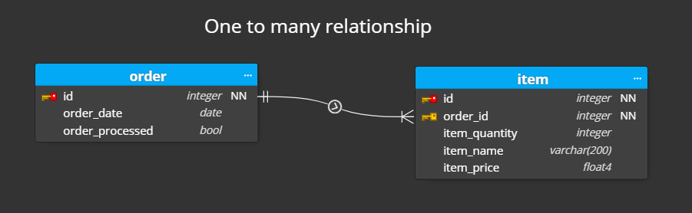
✔ Concept
- One parent entity has multiple child entities
- Child entity contains the foreign key
✔ Example Classes
public class Category
{
public int Id { get; set; }
public string Name { get; set; }

// Navigation Property
public ICollection<Product> Products { get; set; } = new List<Product>();
}

public class Product
{
public int Id { get; set; }
public string Name { get; set; }

// Foreign Key
public int CategoryId { get; set; }

// Navigation Property
public Category Category { get; set; }
}
✔ Fluent API
modelBuilder.Entity<Product>()
.HasOne(p => p.Category)
.WithMany(c => c.Products)
.HasForeignKey(p => p.CategoryId);

2️⃣ One-to-One Relationship (1:1)
➡️ Example: User → UserProfile
✔ Concept
- One entity has exactly one related entity
- One of the tables must contain the foreign key with a unique constraint
✔ Example Classes
public class User
{
public int Id { get; set; }
public string Username { get; set; }

public UserProfile Profile { get; set; }
}

public class UserProfile
{
public int Id { get; set; }

// Foreign Key (also Primary Key)
public int UserId { get; set; }

public string Address { get; set; }

public User User { get; set; }
}
✔ Fluent API
modelBuilder.Entity<User>()
.HasOne(u => u.Profile)
.WithOne(p => p.User)
.HasForeignKey<UserProfile>(p => p.UserId);

3️⃣ Many-to-Many Relationship (M:N)
➡️ Example: Students ↔ Courses
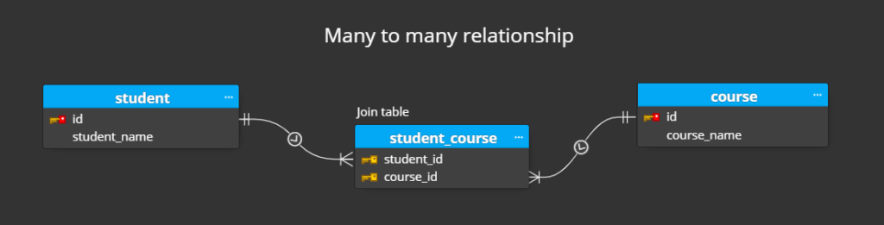
✔ Concept
- One entity can have many of another entity and vice versa
- EF Core automatically creates the join table from EF Core 5+
✔ Example Classes
public class Student
{
public int Id { get; set; }
public string Name { get; set; }

public ICollection<Course> Courses { get; set; } = new List<Course>();
}

public class Course
{
public int Id { get; set; }
public string Title { get; set; }

public ICollection<Student> Students { get; set; } = new List<Student>();
}
✔ Fluent API (Optional – EF Core can configure automatically)
modelBuilder.Entity<Student>()
.HasMany(s => s.Courses)
.WithMany(c => c.Students)
.UsingEntity(j => j.ToTable("StudentCourses"));

⭐ Navigation Properties
Navigation properties create object-level relationships:
Type | Navigation Example
Reference | Product.Category
Collection | Category.Products

⭐ Foreign Keys (FK) in EF Core
Explicit FK
public int CategoryId { get; set; }
Shadow FK
EF Core creates the FK even if you don’t define it.

⭐ Relationship Conventions (What EF Core detects automatically)
One-to-many detection:
- If class A has collection of B → EF Core assumes one-to-many
One-to-one detection:
- If both sides have reference navigation → EF tries to configure 1:1
Many-to-many detection:
- If both sides are collections → EF creates join table automatically

⭐ Cascading Behaviors
When deleting a parent entity:
Cascade Type | Effect
Cascade | Child rows deleted
Restrict | Prevent deletion if children exist
SetNull | FK becomes null
NoAction | Database decides
Example:
modelBuilder.Entity<Category>()
.HasMany(c => c.Products)
.WithOne(p => p.Category)
.OnDelete(DeleteBehavior.Cascade);

⭐ When to Use Each Relationship Type
Relationship | Use Case
One-to-One | Additional details table (User ↔ Profile)
One-to-Many | Parent–child models (Category → Products)
Many-to-Many | Linking entities (Students ↔ Courses)

