Below is a real, clean, well-structured ASP.NET Core Web API project that demonstrates Separation of Concerns (SoC) using:
- Controllers → Request/Response only
- Services → Business logic
- Repositories → Data access
- DTOs → Data transfer
- Models → Domain entities
I’ll show full folder structure + complete working code for each layer.

📁 Project Structure (Shows Separation of Concerns Clearly)
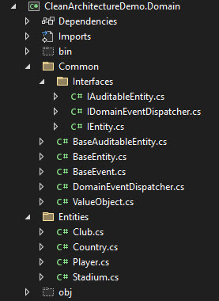
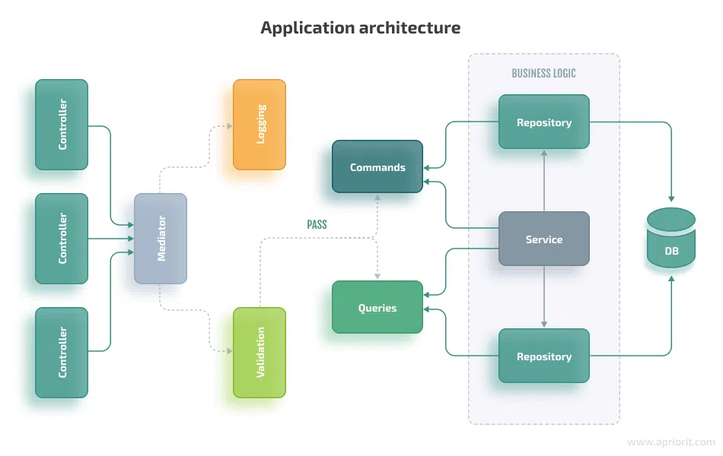
MyApp/
│
├── Controllers/
│ └── ProductsController.cs
│
├── Services/
│ ├── Interfaces/
│ │ └── IProductService.cs
│ └── ProductService.cs
│
├── Repositories/
│ ├── Interfaces/
│ │ └── IProductRepository.cs
│ └── ProductRepository.cs
│
├── Models/
│ └── Product.cs
│
├── DTOs/
│ └── ProductDto.cs
│
└── Program.cs
This structure is PERFECT for understanding Separation of Concerns.

🧱 1. Model (Domain Entity) — Only Data Structure
Models/Product.cs
namespace MyApp.Models
{
public class Product
{
public int Id { get; set; }
public string Name { get; set; }
public decimal Price { get; set; }
}
}
✔ Contains only domain data
❌ No business logic
❌ No database code

📦 2. DTO (Data Transfer Object) — for API input/output
DTOs/ProductDto.cs
namespace MyApp.DTOs
{
public class ProductDto
{
public string Name { get; set; }
public decimal Price { get; set; }
}
}
✔ Avoids exposing internal domain model
✔ Good for validation

🗄 3. Repository Interface — Defines Data Access Contract
Repositories/Interfaces/IProductRepository.cs
using MyApp.Models;

namespace MyApp.Repositories.Interfaces
{
public interface IProductRepository
{
IEnumerable<Product> GetAll();
Product Get(int id);
void Add(Product product);
void Delete(int id);
}
}
✔ Defines what operations are supported
❌ Does NOT care how data is stored
(DB could be SQL, in-memory, MongoDB, etc.)

🗄 4. Repository Implementation — Actual Data Access Logic
Repositories/ProductRepository.cs
using MyApp.Models;
using MyApp.Repositories.Interfaces;

namespace MyApp.Repositories
{
public class ProductRepository : IProductRepository
{
private readonly List<Product> _products = new();

public IEnumerable<Product> GetAll() => _products;

public Product Get(int id) => _products.FirstOrDefault(x => x.Id == id);

public void Add(Product product)
{
product.Id = _products.Count + 1;
_products.Add(product);
}

public void Delete(int id)
{
var product = Get(id);
if (product != null)
_products.Remove(product);
}
}
}
✔ Only handles storage
✔ No business rules
✔ No controller logic

🧠 5. Service Interface — Defines Business Logic Contract
Services/Interfaces/IProductService.cs
using MyApp.DTOs;
using MyApp.Models;

namespace MyApp.Services.Interfaces
{
public interface IProductService
{
IEnumerable<Product> GetAllProducts();
Product GetProduct(int id);
void CreateProduct(ProductDto dto);
void RemoveProduct(int id);
}
}

⚙️ 6. Service Implementation — Contains Business Logic
Services/ProductService.cs
using MyApp.DTOs;
using MyApp.Models;
using MyApp.Repositories.Interfaces;
using MyApp.Services.Interfaces;

namespace MyApp.Services
{
public class ProductService : IProductService
{
private readonly IProductRepository _repo;

public ProductService(IProductRepository repo)
{
_repo = repo;
}

public IEnumerable<Product> GetAllProducts() => _repo.GetAll();

public Product GetProduct(int id) => _repo.Get(id);

public void CreateProduct(ProductDto dto)
{
if (dto.Price <= 0)
throw new Exception("Price must be greater than zero.");

var product = new Product
{
Name = dto.Name,
Price = dto.Price
};

_repo.Add(product);
}

public void RemoveProduct(int id)
{
_repo.Delete(id);
}
}
}
✔ Handles validation
✔ Handles business rules
✔ Does NOT know about HTTP
✔ Does NOT know about controllers

🧭 7. Controller (API Endpoint) — Handles HTTP Only
Controllers/ProductsController.cs
using Microsoft.AspNetCore.Mvc;
using MyApp.DTOs;
using MyApp.Services.Interfaces;

namespace MyApp.Controllers
{
[ApiController]
[Route("api/[controller]")]
public class ProductsController : ControllerBase
{
private readonly IProductService _service;

public ProductsController(IProductService service)
{
_service = service;
}

[HttpGet]
public IActionResult GetAll()
{
return Ok(_service.GetAllProducts());
}

[HttpGet("{id}")]
public IActionResult Get(int id)
{
var product = _service.GetProduct(id);
if (product == null)
return NotFound();

return Ok(product);
}

[HttpPost]
public IActionResult Create(ProductDto dto)
{
_service.CreateProduct(dto);
return Ok("Product created");
}

[HttpDelete("{id}")]
public IActionResult Delete(int id)
{
_service.RemoveProduct(id);
return Ok("Product deleted");
}
}
}
✔ Controls HTTP
✔ No business logic
✔ No database operations

⚡ 8. Register Services & Repositories in DI
Program.cs
var builder = WebApplication.CreateBuilder(args);

builder.Services.AddControllers();

// Dependency Injection
builder.Services.AddScoped<IProductRepository, ProductRepository>();
builder.Services.AddScoped<IProductService, ProductService>();

var app = builder.Build();

app.MapControllers();
app.Run();

🎯 How This Project Demonstrates SoC
Concern | Layer
HTTP processing | Controller
Business logic | Service
Data access | Repository
Domain model | Model
External communication | DTO
Each part focuses on ONE responsibility → Perfect example of Separation of Concerns.

