data communication between Angular components

1. Why Component Communication Is Needed
Angular applications are built as component trees. Each component:
- Has its own template
- Maintains isolated state
- Should follow separation of concerns
Because of this isolation, components cannot directly access each other’s data. Angular therefore provides well-defined communication mechanisms depending on the relationship between components.

2. Types of Component Relationships
Component communication is chosen based on hierarchy and scope.

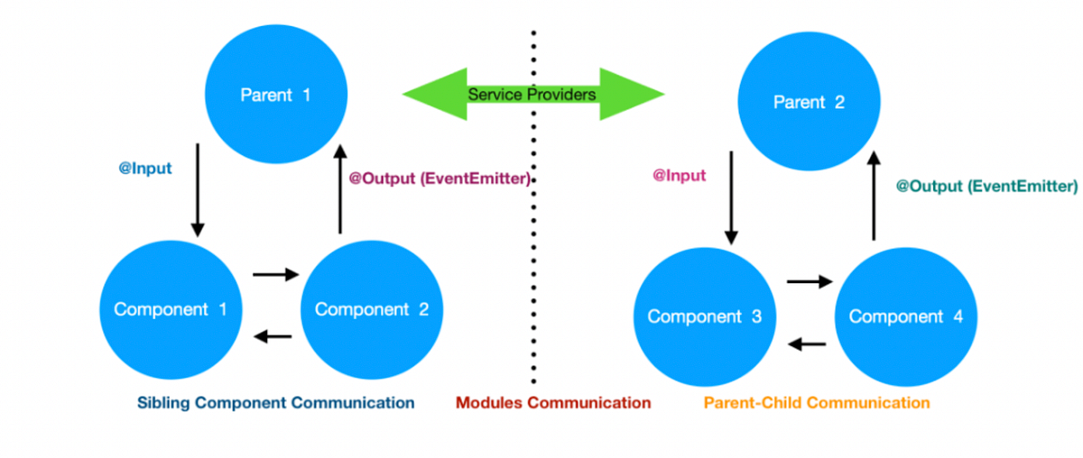

Relationship | Typical Use Case
Parent → Child | Pass data/configuration
Child → Parent | Emit events/actions
Sibling → Sibling | Share state indirectly
Unrelated Components | Global/shared state
Route-based | Navigation & context passing

3. Parent → Child Communication (@Input)
Purpose
Used when the parent owns the data and passes it downward.
Mechanism
- Parent binds a value
- Child receives it via @Input()
Example
Parent Component
<app-user-profile [username]="loggedInUser"></app-user-profile>
Child Component
@Input() username!: string;
Key Characteristics
- One-way data flow
- Child must not modify parent state
- Most common and recommended approach

4. Child → Parent Communication (@Output + EventEmitter)
Purpose
Used when the child triggers an action and notifies the parent.
Mechanism
- Child emits an event
- Parent listens and reacts
Example
Child Component
@Output() save = new EventEmitter<string>();

onSave() {
this.save.emit('User Saved');
}
Parent Component
<app-editor (save)="onSaveHandler($event)"></app-editor>
Key Characteristics
- Event-driven
- No tight coupling
- Parent controls the logic

5. Parent Accessing Child (@ViewChild)
Purpose
Used when the parent needs to:
- Call a child method
- Access child properties
Mechanism
- Parent gets a reference to the child instance
Example
@ViewChild(ChildComponent) child!: ChildComponent;

ngAfterViewInit() {
this.child.resetForm();
}
When to Use
- UI orchestration
- Imperative interactions
When NOT to Use
- Routine data flow
- Business logic sharing

6. Sibling → Sibling Communication (via Parent)
Recommended Pattern
Sibling components never talk directly.
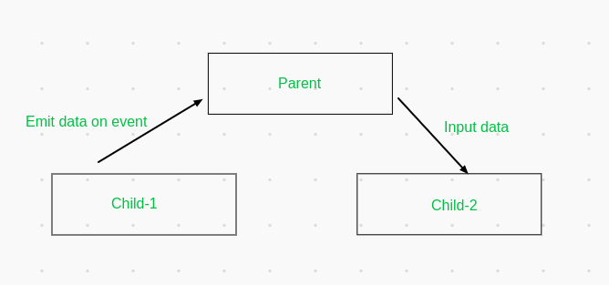

Flow
Sibling A → Parent → Sibling B
Why This Matters
- Maintains unidirectional data flow
- Avoids hidden dependencies
- Improves testability

7. Unrelated Components Communication (Shared Service)
Purpose
Used when components:
- Are not related
- Exist in different modules
- Need shared state or events
Mechanism
- Singleton service
- Observable or Subject
Example Service
@Injectable({ providedIn: 'root' })
export class MessageService {
private messageSource = new Subject<string>();
message$ = this.messageSource.asObservable();

send(msg: string) {
this.messageSource.next(msg);
}
}
Usage in Components
this.messageService.send('Hello');
this.messageService.message$.subscribe(msg => {
console.log(msg);
});
Key Characteristics
- Decoupled
- Scalable
- Industry-standard approach

8. Route-Based Communication
Use Cases
- Passing identifiers
- Navigation context
- Deep linking
Options
Method | Usage
Route Params | /users/101
Query Params | /users?id=101
Navigation State | Temporary data
Example
this.router.navigate(['/details', 101]);
this.route.params.subscribe(p => console.log(p['id']));

Scenario | Recommended Technique
Parent → Child | @Input
Child → Parent | @Output
Parent → Child (method) | @ViewChild
Sibling | Via Parent
Global / Unrelated | Shared Service
Navigation Data | Router

