Choreography Saga Pattern

1. What Is the Choreography Saga Pattern?
The Choreography Saga Pattern is a distributed transaction management pattern used in microservices architectures.
- A Saga is a sequence of local transactions
- Each local transaction:
  - Updates its own database
  - Publishes an event
- Other services listen to events and react accordingly
- No central coordinator exists
In choreography:
- Services do not call each other directly
- Services communicate via events
- Each service knows what to do next based on the event it receives

2. Why Do We Need Choreography Saga?
In microservices:
- Each service has its own database
- Traditional ACID transactions cannot span multiple services
- Failures are inevitable
Choreography Saga provides:
- Event-driven consistency
- Loose coupling
- High scalability
- Better fault tolerance

3. Choreography vs Orchestration (Quick Context)
Aspect | Choreography | Orchestration
Coordinator | ❌ None | ✅ Central orchestrator
Communication | Events | Commands
Coupling | Very loose | Moderate
Complexity | Distributed | Centralized
Scalability | High | Moderate
This session focuses on Choreography.

4. Conceptual Example: Order Processing System
Business Scenario
An e-commerce system with:
- Order Service
- Payment Service
- Inventory Service
Goal:
Place an order → take payment → reserve stock
If any step fails → compensate previous steps

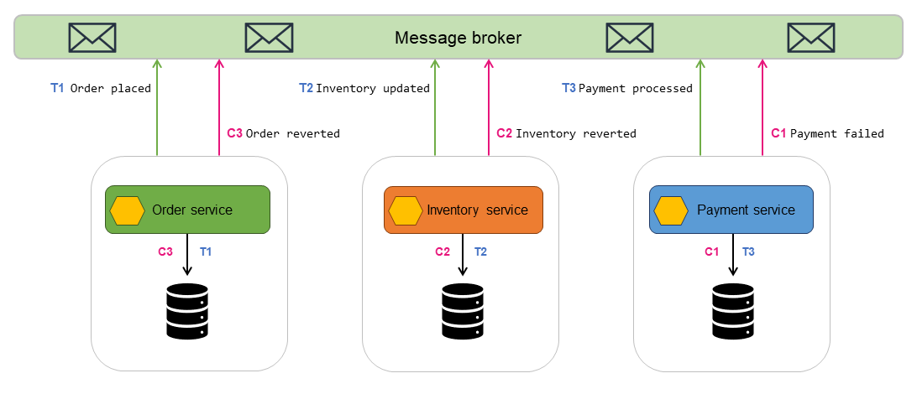

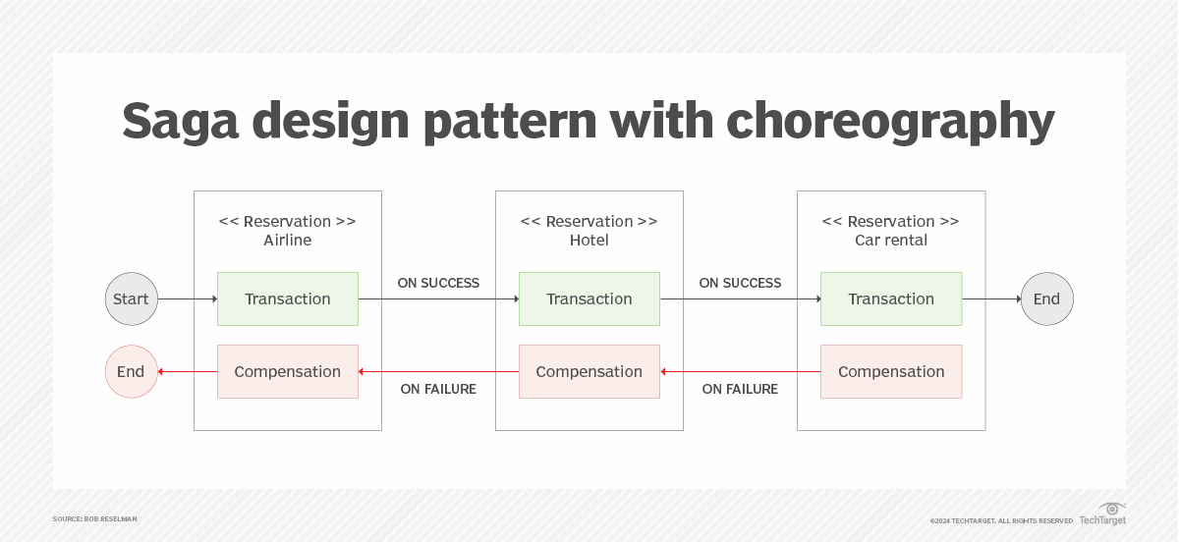

5. Step-by-Step Choreography Saga Flow
Step 1: Order Is Created
- Client sends Create Order
- Order Service:
  - Saves order as Pending
  - Publishes event: OrderCreated
Key point:
Order Service does not know who will handle the event.

Step 2: Payment Service Reacts
- Payment Service subscribes to OrderCreated
- It:
  - Charges the customer
  - On success → publishes PaymentCompleted
  - On failure → publishes PaymentFailed
Important:
Payment Service does not call Order Service directly.

Step 3: Inventory Service Reacts
- Inventory Service subscribes to PaymentCompleted
- It:
  - Reserves stock
  - On success → publishes InventoryReserved
  - On failure → publishes InventoryFailed

Step 4: Order Completion
- Order Service subscribes to:
  - InventoryReserved
  - PaymentFailed
  - InventoryFailed
Based on event:
- InventoryReserved → Order marked as Completed
- PaymentFailed → Order marked as Cancelled
- InventoryFailed → Trigger compensation

6. Compensation Flow (Failure Handling)
Scenario: Inventory Reservation Fails
Steps:
- Inventory publishes InventoryFailed
- Payment Service listens to InventoryFailed
- Payment Service:
  - Refunds payment
  - Publishes PaymentRefunded
- Order Service:
  - Marks order as Cancelled
No rollback
Instead → compensating transactions

7. Event Flow Summary
OrderCreated
↓
PaymentCompleted / PaymentFailed
↓
InventoryReserved / InventoryFailed
↓
OrderCompleted / OrderCancelled
Each service:
- Acts independently
- Reacts to events
- Emits new events

8. Key Characteristics
- Event-driven architecture
- No central coordinator
- Eventually consistent
- Services are loosely coupled
- Uses compensating actions instead of rollback
- Suitable for large-scale microservices

9. Advantages
- High scalability
- Loose coupling
- Natural fit for message brokers (Kafka, Azure Service Bus, RabbitMQ)
- No single point of failure

10. Challenges
- Harder to visualize flow
- Debugging is complex
- Requires good event design
- Needs proper monitoring and correlation IDs

11. When to Use Choreography Saga
Use it when:
- System is event-driven
- Services must remain independent
- High scalability is required
Avoid it when:
- Business flow is very complex
- Strict control and visibility are required (use orchestration instead)

12. One-Line Student-Friendly Definition
Choreography Saga is a pattern where microservices coordinate a distributed transaction by publishing and reacting to events, without any central controller.

