Choreography Saga Pattern to ASP.NET Core + Azure Service Bus

1. High-Level Mapping
Saga Concept | ASP.NET Core + Azure Service Bus
Local Transaction | EF Core transaction inside a microservice
Event | Azure Service Bus Topic Message
Event Publisher | ASP.NET Core service publishing to topic
Event Subscriber | Background Service / Message Handler
Compensation | Reverse local transaction + publish event
No Coordinator | No central API controlling the flow

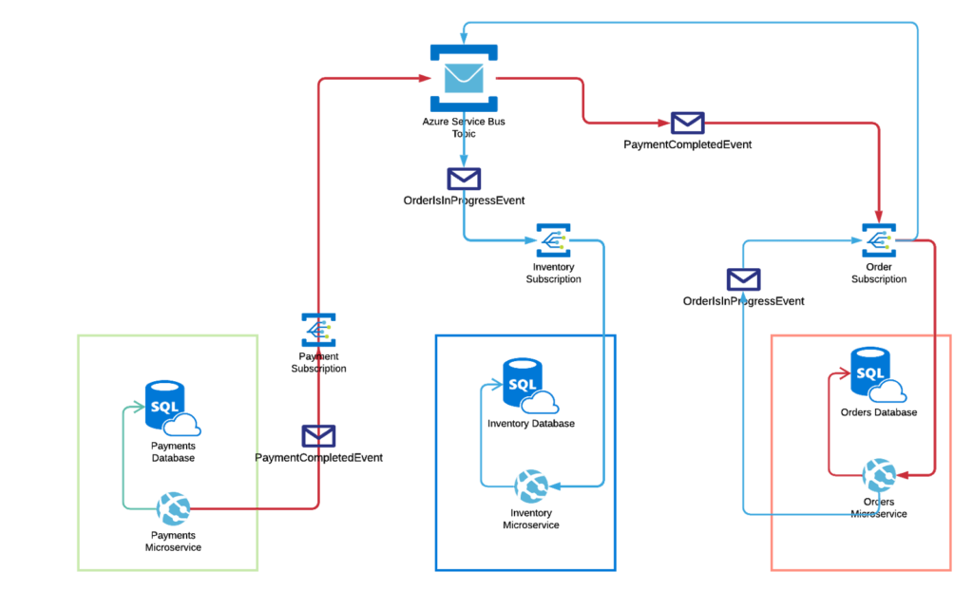

2. Reference Architecture
Microservices
- OrderService
- PaymentService
- InventoryService
Each service:
- Is an ASP.NET Core Web API
- Has its own database
- Communicates only via Azure Service Bus

3. Azure Service Bus Design (Important)
Why Topics, not Queues?
Choreography requires multiple subscribers to the same event.
Topic Structure
Topic: order-saga-topic
Subscriptions:
- order-service-sub
- payment-service-sub
- inventory-service-sub
Each service:
- Publishes events to the topic
- Listens only to relevant events
This is the foundation of choreography.

4. Step-by-Step Flow (Mapped to ASP.NET Core)

Step 1: Order Service – Start the Saga
Controller Action
- Client calls POST /orders
OrderService
- Saves order with status Pending
- Publishes OrderCreated event to Service Bus
Conceptual Responsibility
- Starts the saga
- Does not call Payment or Inventory
Event Payload
{
"eventType": "OrderCreated",
"orderId": "123",
"amount": 5000
}

Step 2: Payment Service – React to Event
PaymentService Background Listener
- Subscribes to OrderCreated
On receiving OrderCreated:
- Processes payment
- If successful → publish PaymentCompleted
- If failed → publish PaymentFailed
Important
- PaymentService does not know OrderService internals
- Only reacts to the event

Step 3: Inventory Service – Continue the Saga
InventoryService Background Listener
- Subscribes to PaymentCompleted
On receiving PaymentCompleted:
- Reserves stock
- If success → publish InventoryReserved
- If failure → publish InventoryFailed

Step 4: Order Service – Final State Update
OrderService Listener
- Subscribes to:
  - InventoryReserved
  - PaymentFailed
  - InventoryFailed
State Transitions
- InventoryReserved → Order = Completed
- PaymentFailed → Order = Cancelled
- InventoryFailed → Order = Cancelled (waits for compensation)

5. Compensation Flow (Failure Scenario)
Scenario: Inventory Reservation Fails
- Inventory publishes InventoryFailed
- PaymentService listens to InventoryFailed
- PaymentService:
  - Refunds payment
  - Publishes PaymentRefunded
- OrderService:
  - Marks order as Cancelled
Key Point
There is:
- ❌ No rollback
- ✅ Only compensating actions

6. ASP.NET Core Implementation Mapping
Controllers
- Used only for external requests
- Example: CreateOrder
Background Services
Each service has:
- IHostedService or BackgroundService
- Responsible for:
  - Subscribing to Service Bus
  - Handling events
Message Handler Flow
Service Bus Message
↓
Deserialize Event
↓
Business Logic
↓
Database Update
↓
Publish Next Event

7. Event Versioning & Contracts
Best practice:
- Create a Shared Contracts project
- Contains event DTOs only
Example:
- OrderCreatedEvent
- PaymentCompletedEvent
- InventoryFailedEvent
This avoids tight coupling.

8. Correlation ID (Critical for Choreography)
Every event must include:
- OrderId
- CorrelationId
Purpose:
- Trace the saga across services
- Debug failures
- Enable distributed logging

