ARM Templates in Azure

What is an ARM Template in Azure?
An ARM Template (Azure Resource Manager Template) is a JSON-based Infrastructure as Code (IaC) file used to define, deploy, and manage Azure resources in a declarative manner.
Instead of creating resources manually through the Azure Portal, you describe what resources you want and Azure handles how to create them.

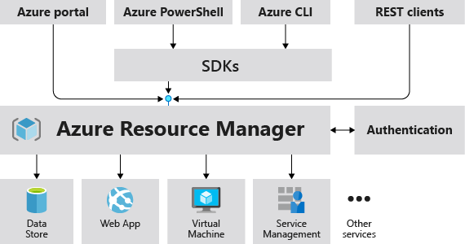
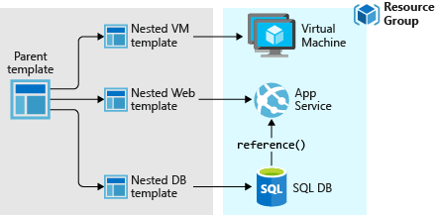
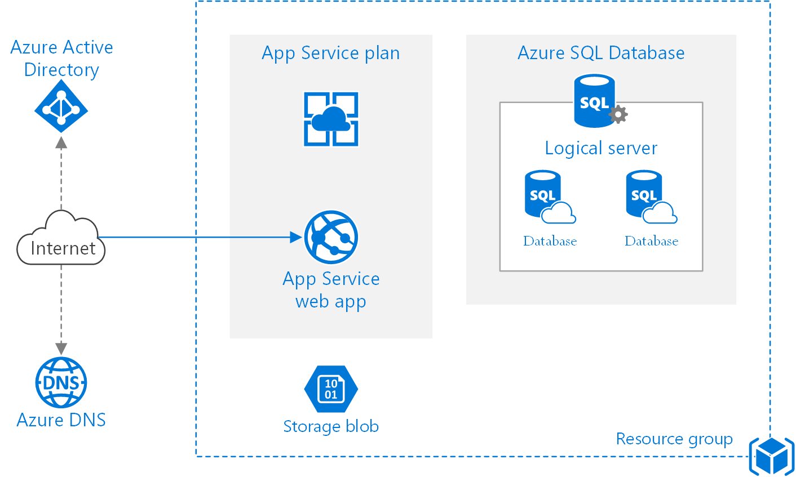

Why ARM Templates Are Needed
Manual resource creation leads to:
- Configuration drift
- Human errors
- Inconsistent environments (Dev / Test / Prod)
ARM Templates solve this by enabling:
- Repeatable deployments
- Version control
- Automated infrastructure provisioning
- Environment consistency

Key Characteristics of ARM Templates
1. Declarative Syntax
You define what you want, not how to do it.
Example:
“Create one App Service, one SQL Database, and one Storage Account”
Azure decides the correct execution order.

2. Idempotent
You can deploy the same template multiple times, and Azure ensures:
- No duplicate resources
- Only required changes are applied

3. JSON Format
ARM templates are written in JSON, making them:
- Machine-readable
- Source-control friendly (Git)
- CI/CD compatible

4. Dependency Management
Azure automatically understands resource dependencies using:
"dependsOn": []
Example:
- App Service depends on App Service Plan
- SQL Database depends on SQL Server

Core Components of an ARM Template
An ARM template typically contains the following sections:
Section | Purpose
$schema | Defines ARM template version
contentVersion | Template versioning
parameters | Inputs provided at deployment time
variables | Reusable values
resources | Azure resources to deploy
outputs | Values returned after deployment

Simple ARM Template Example
{
"$schema": "https://schema.management.azure.com/schemas/2019-04-01/deploymentTemplate.json#",
"contentVersion": "1.0.0.0",
"parameters": {
"storageAccountName": {
"type": "string"
}
},
"resources": [
{
"type": "Microsoft.Storage/storageAccounts",
"apiVersion": "2022-09-01",
"name": "[parameters('storageAccountName')]",
"location": "East US",
"sku": {
"name": "Standard_LRS"
},
"kind": "StorageV2"
}
]
}
This template:
- Takes a storage account name as input
- Deploys a Storage Account in Azure

How ARM Template Deployment Works
- Template is submitted (Portal / CLI / PowerShell / Pipeline)
- Azure Resource Manager:
  - Validates template
  - Resolves dependencies
  - Deploys resources in correct order
- Deployment result is returned

Ways to Deploy ARM Templates
You can deploy ARM templates using:
- Azure Portal
- Azure CLI
- PowerShell
- Azure DevOps Pipelines
- GitHub Actions
Example (CLI):
az deployment group create \
--resource-group MyRG \
--template-file template.json \
--parameters storageAccountName=mystorage123

ARM Template vs Other IaC Tools
Tool | Type
ARM Template | Native Azure IaC
Bicep | Simplified ARM (recommended)
Terraform | Multi-cloud IaC
Pulumi | Code-based IaC
Note: Bicep compiles into ARM Templates and is now Microsoft’s preferred approach.

Real-Time Use Cases
ARM templates are commonly used for:
- Dev / Test / Prod environment setup
- CI/CD pipeline infrastructure provisioning
- Disaster recovery automation
- Standardized enterprise deployments
- Compliance and governance enforcement

Advantages of ARM Templates
- Native Azure support
- No external tools required
- Strong role-based access control (RBAC)
- Deep Azure service integration
- Reliable and production-ready

Limitations
- JSON can become verbose
- Harder to read for beginners
- Less flexible than programming languages
(Reason why Bicep exists)

