1. What is CQRS?
CQRS (Command Query Responsibility Segregation) is an architectural pattern that separates read operations from write operations.
Command → Changes system state (Create, Update, Delete)
Query → Reads data (Get)
Instead of one model handling both reads and writes, CQRS uses separate models and handlers.

2. Traditional CRUD vs CQRS (Quick Comparison)
Traditional CRUD | CQRS
Same model for read & write | Separate models
Simple to start | Scales better
Business logic mixed | Clear responsibility
Hard to optimize | Read & write optimized separately

3. Why Use CQRS?
CQRS is not mandatory, but useful when:
- Application has complex business rules
- Read operations are much heavier than writes
- Need high scalability
- Need clear separation of concerns
- Want clean architecture + testability
When NOT to use CQRS
- Small CRUD apps
- Simple admin panels
- When over-engineering is a risk

4. Core CQRS Concepts
4.1 Command
- Represents an intention to change data
- Example: CreateProductCommand
4.2 Command Handler
- Executes business logic for the command
- Example: CreateProductCommandHandler
4.3 Query
- Used to fetch data only
- Example: GetProductsQuery
4.4 Query Handler
- Executes read logic
- Returns DTOs (not entities)

5. CQRS Flow in REST API
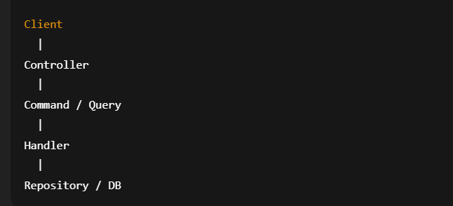
6. Building ASP.NET Core REST API Using CQRS (Simple Version)
7. Project Structure (Recommended)
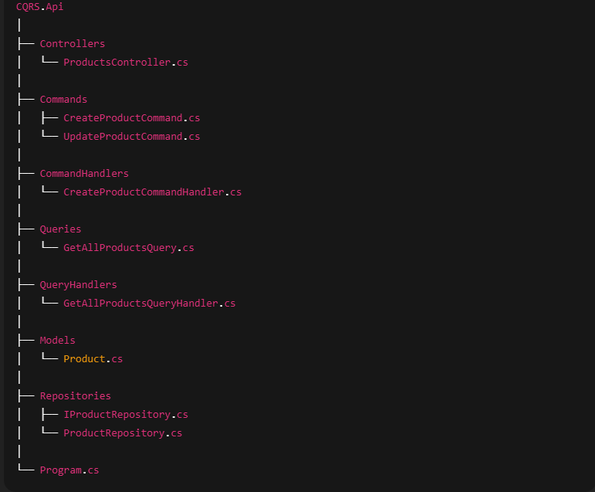
8. Step-by-Step Implementation
8.1 Entity (Domain Model)
public class Product
{
public int Id { get; set; }
public string Name { get; set; } = string.Empty;
public decimal Price { get; set; }
}

8.2 Command (Write Model)
public class CreateProductCommand
{
public string Name { get; set; } = string.Empty;
public decimal Price { get; set; }
}

8.3 Command Handler
public class CreateProductCommandHandler
{
private readonly IProductRepository _repository;

public CreateProductCommandHandler(IProductRepository repository)
{
_repository = repository;
}

public void Handle(CreateProductCommand command)
{
var product = new Product
{
Name = command.Name,
Price = command.Price
};

_repository.Add(product);
}
}

8.4 Query (Read Model)
public class GetAllProductsQuery
{
}

8.5 Query Handler
public class GetAllProductsQueryHandler
{
private readonly IProductRepository _repository;

public GetAllProductsQueryHandler(IProductRepository repository)
{
_repository = repository;
}

public IEnumerable<Product> Handle(GetAllProductsQuery query)
{
return _repository.GetAll();
}
}

8.6 Repository
public interface IProductRepository
{
void Add(Product product);
IEnumerable<Product> GetAll();
}
public class ProductRepository : IProductRepository
{
private static readonly List<Product> _products = new();

public void Add(Product product)
{
product.Id = _products.Count + 1;
_products.Add(product);
}

public IEnumerable<Product> GetAll()
{
return _products;
}
}

8.7 Controller (Very Important in CQRS)
[ApiController]
[Route("api/products")]
public class ProductsController : ControllerBase
{
private readonly CreateProductCommandHandler _createHandler;
private readonly GetAllProductsQueryHandler _getHandler;

public ProductsController(
CreateProductCommandHandler createHandler,
GetAllProductsQueryHandler getHandler)
{
_createHandler = createHandler;
_getHandler = getHandler;
}

[HttpPost]
public IActionResult Create(CreateProductCommand command)
{
_createHandler.Handle(command);
return Ok("Product Created");
}

[HttpGet]
public IActionResult GetAll()
{
var result = _getHandler.Handle(new GetAllProductsQuery());
return Ok(result);
}
}

8.8 Dependency Injection (Program.cs)
builder.Services.AddSingleton<IProductRepository, ProductRepository>();

builder.Services.AddTransient<CreateProductCommandHandler>();
builder.Services.AddTransient<GetAllProductsQueryHandler>();
9. Key CQRS Rules to Remember
- Commands never return data
- Queries never modify data
- Use DTOs for queries
- Controllers are thin
- Handlers contain business logic

