# Data Quality Checklist

Country: Australia Range of Years Covered: 1921-2016

Reported Submitted by: Date: February 25, 2019

Data Quality Charts at:

|  |  |  |
| --- | --- | --- |
| *Updated to include 2015-2016* | **Date**  **Completed** | **Comments** |
| **Checks for Input DB** | | |
| * *Internal Errors*: Check that rows and columns add up correctly |  |  |
| * *Gross Errors*: Note any corrections or problems in published numbers in the “Notes” file |  |  |
| **Internal Consistency (InputDB vs. LexisDB)** | | |
| * Check outliers identified during procedures for splitting open age interval. [see Chart 4] |  |  |
| * Check deaths and population estimates in LexisDB against the raw data in the InputDB [see Charts 5-8] |  |  |
| **Internal Plausibility** |  |  |
| * Inspect plots of death rates by age and time for any unusual patterns [see Charts 9-10] |  |  |
| * Check for evidence of age heaping [see Chart 11] |  |  |
| * Check implied migration for unexpected patterns [see Chart 12] |  |  |
| **External Plausibility** |  |  |
| * Check total annual (implied) migration and compare with external estimates if available [see Chart 13] |  |  |
| * Check e0, e65, and e80 compared to Sweden. Are estimates plausible? [see Chart 14] |  |  |
| * *External Comparisons:* Compare e0 and q0 estimates to some external source   External source: ABS historical statistics and more recent ABS estimates  Range of years: 1921-2015 |  |  |

|  |  |  |
| --- | --- | --- |
|  | **Date**  **Completed** | **Comments** |
| ***IF DATA WAS UPDATED*: Old vs. New** |  |  |
| * Check ratio of “new” to “old” death rates.Investigate any suspicious cases (e.g., ratio <0.95 or >1.05). [see Chart 15] |  |  |
| * *If any big differences between old and new death rates*: Check ratio of deaths and ratio of population estimates. What is the source of the differences? [see Charts 16 & 17] |  |  |

# Additional Notes

***NOTE 1 – External plausibility - implied migration***

Charts below show that implied migration calculated by HMD match official estimates, except for the peak in 1971, which is due to definitional and methodological changes. Starting in 1971, population estimates started to be based on de jure census counts adjusted for net undercount and to include Australians temporarily overseas (See B&D file).

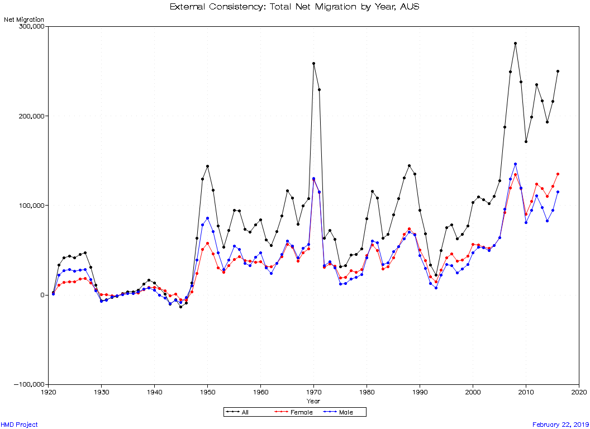

The migration pattern continues to be very similar for the most recent years.

**Net migration, 1925 - 2016 – Australia (ABS)**

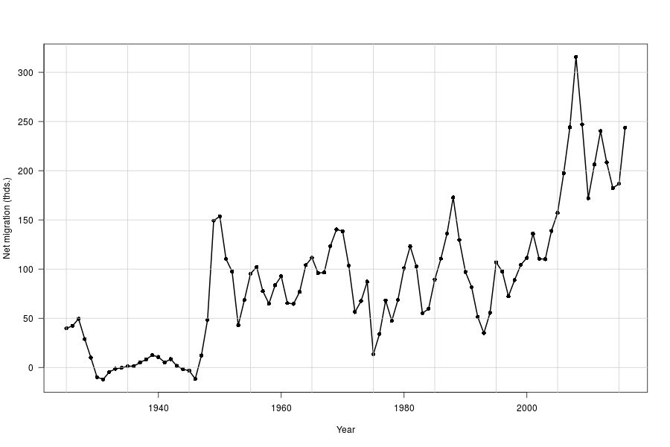

***NOTE 2 – External comparisons: ex and q0***

The charts below show the comparison between HMD estimates of life expectancy at ages 0, 60 and 80 with the official figure published by ABS. ABS publishes 3-year average life tables, which account for most of the differences in e0 and e65. For recent years, HMD estimates are slightly higher than ABS ones, particularly for males. The comparison for e80 shows a more consistent difference between the two estimates, probably due to differences in the methods used to estimate old age mortality. HMD estimates tend to be higher for years before 1980 and lower for the 1990s and 2000s decades but the differences has become negligible since 2001.

**Expectation of life at birth by calendar year and by sex, 1921-2016**

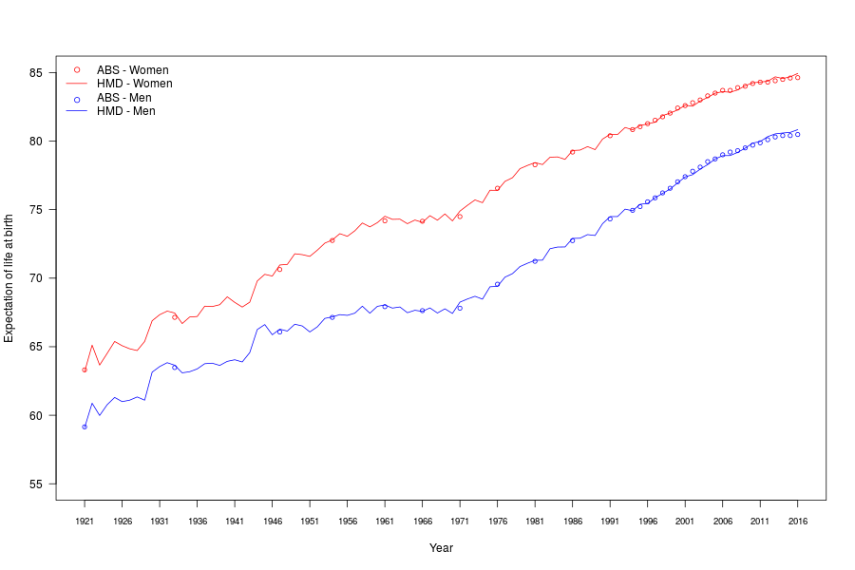

**Expectation of life at age 60 years by calendar year and by sex, 1921-2016**

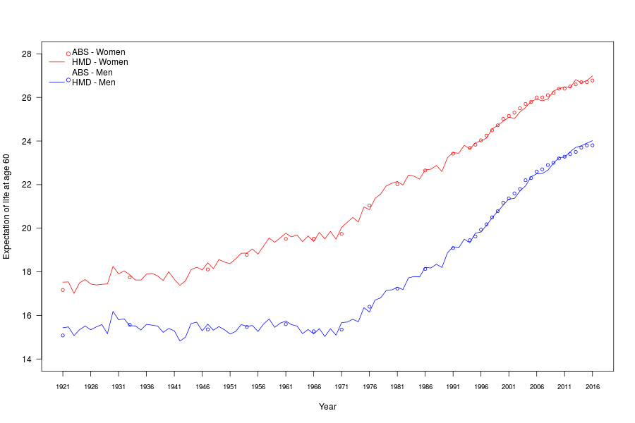

**Expectation of life at age 80 years by calendar year and by sex, 1921-2016**

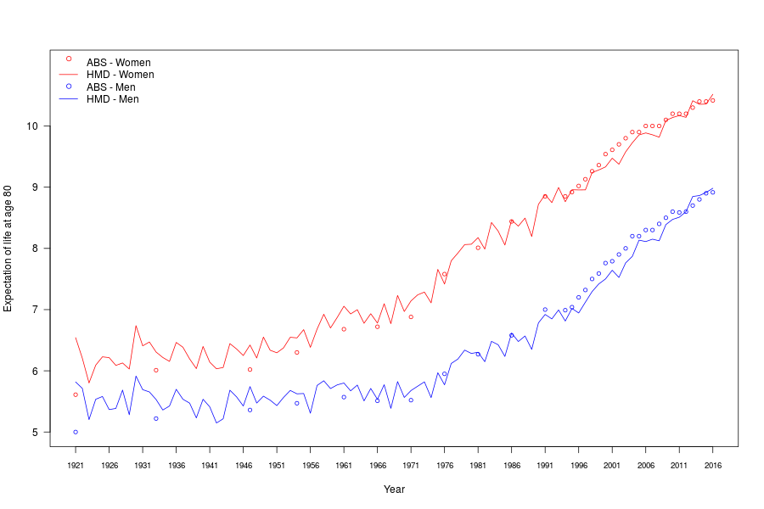

HMD infant mortality estimates also match ABS estimates, as shown by the figures below.

