
NiceLS – Software Detailed Design (SDD)
Prepared for: NiceLS Project • Prepared by: GPT-5 Pro
Date: November 10, 2025
Version: 1.0

Table of Contents

1. Project Description
NiceLS (command: nls) is a modern, cross-platform directory listing tool implemented in ISO C++23. It enhances the traditional `ls` experience with rich visual output—icons, color themes (auto/light/dark), and optional Git repository status—while maintaining compatibility with familiar flags and behaviors. Configuration data (themes, file/folder icons, aliases) is centralized in a bundled SQLite database NLS.sqlite3, enabling easy customization and consistent deployment across Linux and Windows.
The architecture separates concerns into parsing, configuration, scanning, rendering, and database utilities. CMake presets support reproducible builds on multiple platforms, and packaging scripts provide installers and system-level configuration paths.

2. Implemented Features
• Listing formats: long (-l), single-column (-1), multi-column (-C/-x), comma-separated (-m), and tree view (--tree[=DEPTH]).
• Filtering: -a/--all, -A/--almost-all, --dirs/--files, -B/--ignore-backups, --hide/--ignore with patterns.
• Sorting: by name (default), time (-t), size (-S), extension (-X), none (-U); reverse (-r); group directories/files; dots-first.
• Appearance: ANSI colors (--color auto/always/never, --no-color), icons (toggleable), themes (--dark/--light/--theme <Name>), quoting styles (-N/-Q/--quoting-style), hyperlinks (--hyperlink).
• Metadata display: inode (-i), owner/group controls (-g/-o/--no-group, -n numeric), size units (--bytes, -s, --block-size), symlink dereferencing (-L), optional summary reports (--report).
• Git integration: --git-status to prefix entries with Git state via libgit2.
• Performance: guidance for large listings; optional perf diagnostics (--perf-debug).
• Config DB CLI: `nls db` to show/set icons and aliases with user-local override support.

3. System Architecture
At runtime, arguments are parsed into a Config object, themes/icons are loaded from SQLite, and each path is processed: scan entries, optionally apply Git status, sort, and render according to chosen format.
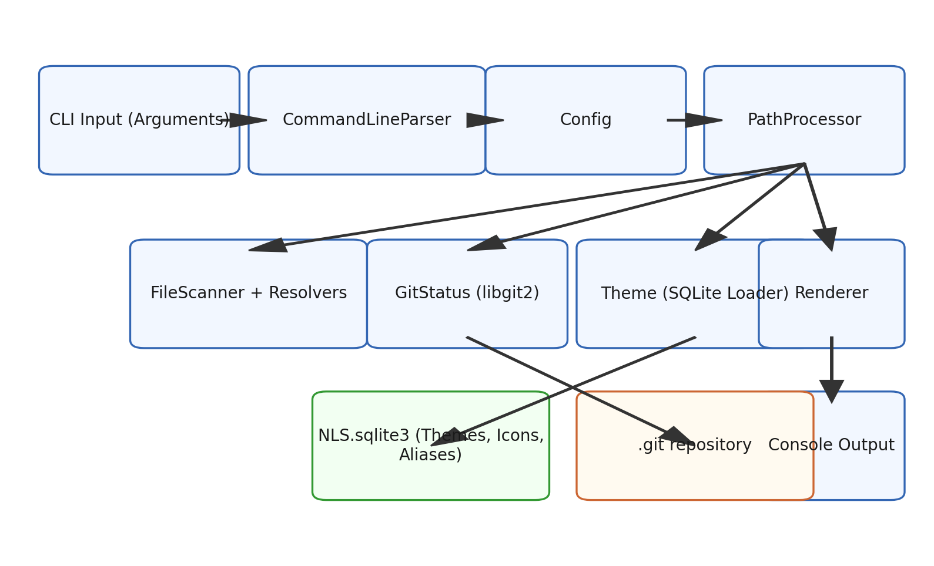
Figure 1 — High-level architecture and data flow.

3.1 Class Structure and Key Responsibilities
Core classes include App (orchestration), CommandLineParser and Config (CLI processing and options), PathProcessor (per-path workflow), FileScanner with FileOwnershipResolver/SymlinkResolver (filesystem metadata), GitStatus (libgit2 integration), Theme (loads colors/icons from SQLite), Renderer (formatting and output), and DatabaseInspector (subcommands for the configuration DB).
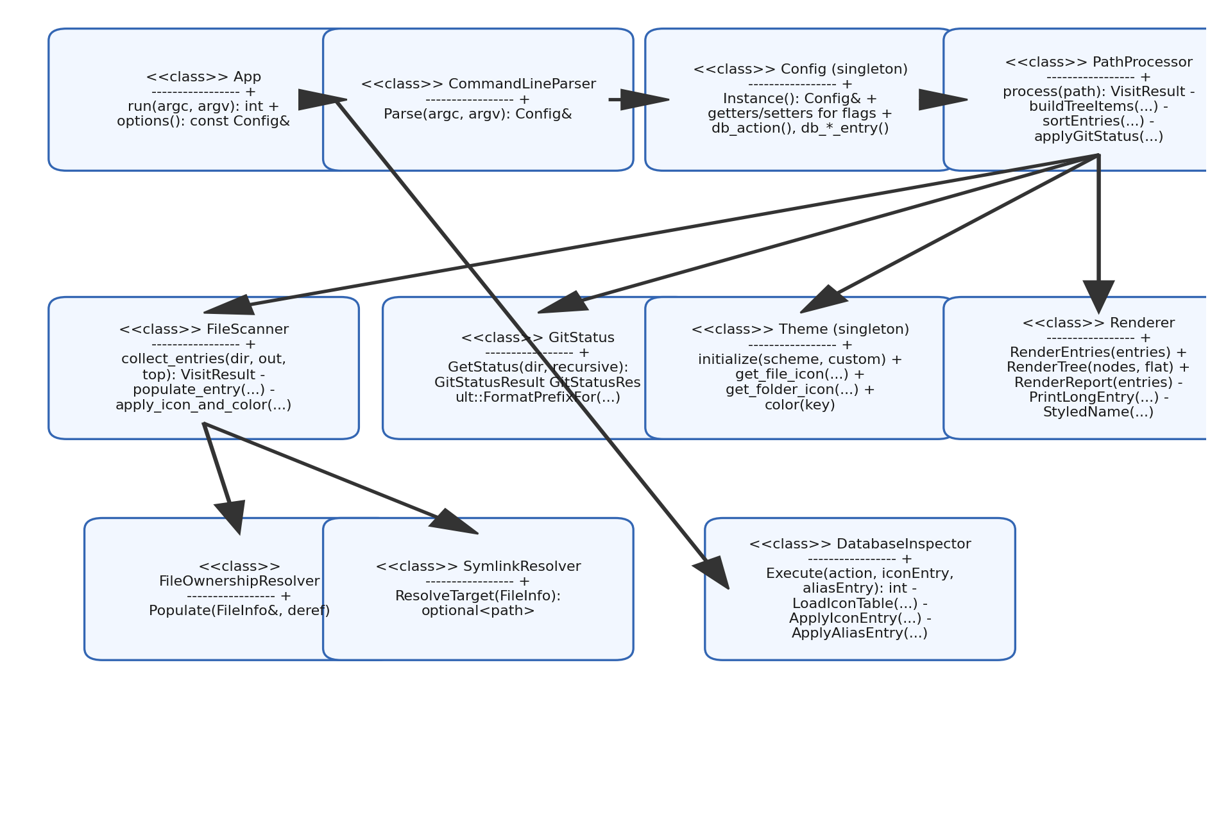
Figure 2 — Simplified class and collaboration diagram.

3.2 Execution Flow
Typical flow: initialize console & paths → parse CLI → (if db) run DatabaseInspector and exit; else initialize Theme → instantiate Scanner/Renderer/GitStatus → for each path: collect entries → apply Git status → sort → render (and optional report) → aggregate exit status.
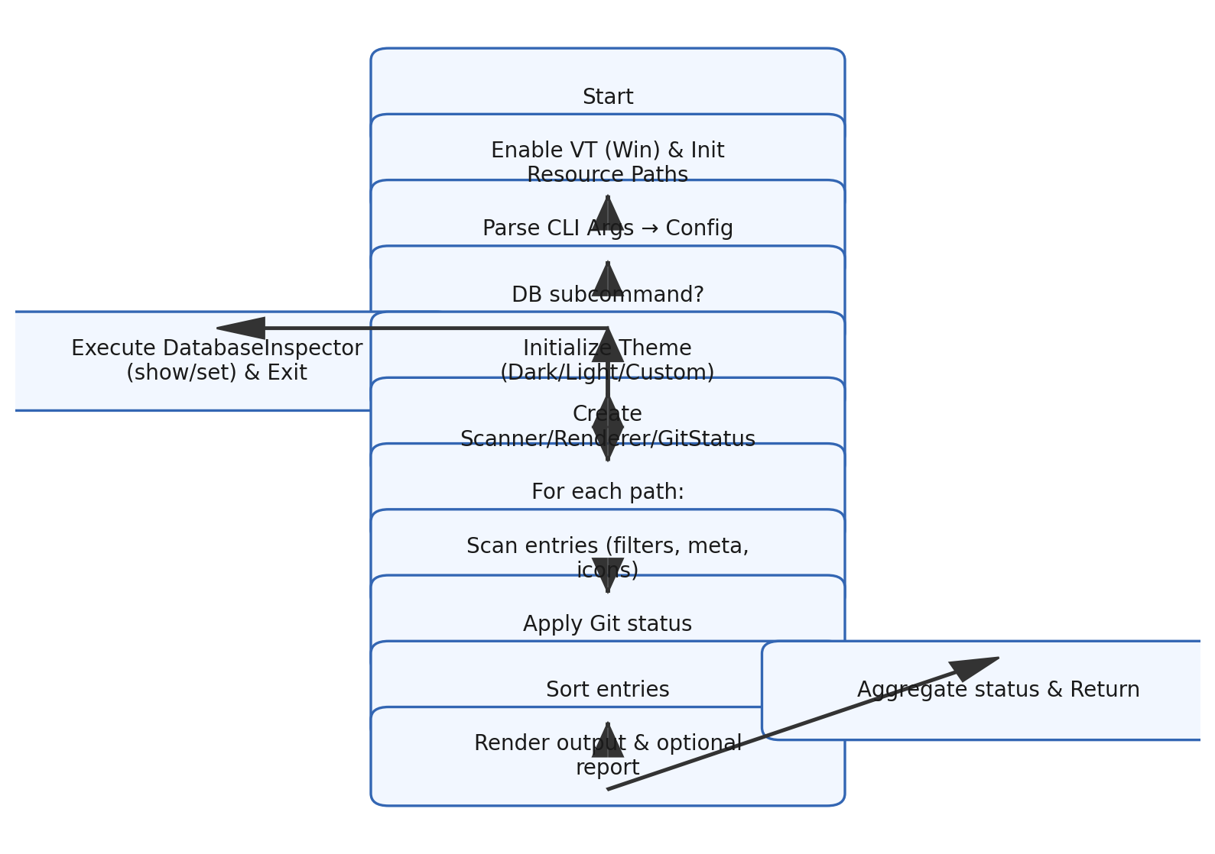
Figure 3 — Execution flow for normal listing and DB subcommand branch.

4. Database Schema & Configuration
The NLS.sqlite3 schema includes Colors, Themes, and Theme_colors (mapping UI elements to colors per theme), and Files/Folders with corresponding Alias tables to define icons and name aliases. At startup, the Theme component loads the active theme palette and icon maps to memory; the DatabaseInspector provides `show` and `set` operations to inspect or modify these tables with user-local overrides.
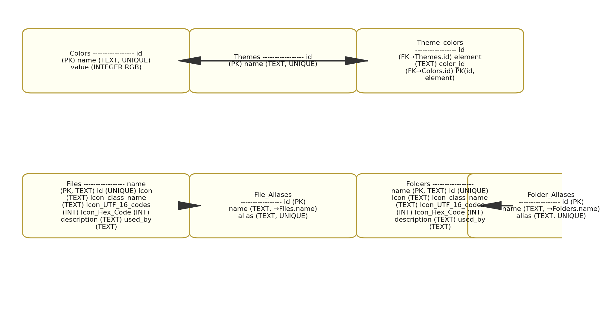
Figure 4 — SQLite configuration schema (themes/colors, file & folder icons, aliases).

