1. Create a New User (Job Seeker)
   1. User Information

j_logan

j_logan

James Logan

35

Riverbend Eyecare   
3505 Pemberton Square Boulevard   
Vicksburg, MS(Mississippi) 39180

[logan@yahooooo.com](mailto:logan@yahooooo.com)

Active

* + 1. Current Status

Looking for a nursing job

Nurse

None

* 1. Resume Information

1

3.5

Master

New York University

12/10/2010

None

Active

* + 1. Add New Skill Category

Oncology_Nurse

Oncology Nursing Certificate

Medical Certificate

Special certificate given for the oncology nurse.

* + 1. Add Skills

ANCC Certificate 5

Team work 3

Planning 3

Communication 3

* + 1. Add Work Experience

1

01/10/2011

01/01/2013

Nurse in Oncology

Hackensack General Hospital

Oncology

Registered Nurse

* 1. Possible Job and Apply
  2. Reference Information

1

Hackensack General Hospital

Supervisor

Head Nurse

Scott Summers

[S_summers@hack_hosp.com](mailto:S_summers@hack_hosp.com)

James Logan worked as registered nurse from 2011-2013. During this period, he worked very hard and diligently. He even got certification on the Oncology Nursing Certificate while working under my supervision. I highly recommend to other hospital.

9

24

Active

1. Create a New User (Employer)
   1. User Information

Holy_name_hospital

Hnhospital

Holy Name Hospital

No Age

Halifax Regional Hospital?   
2204 Wilborn Avenue   
Holy Name, NJ 24592

[HR@holyname.com](mailto:HR@holyname.com)

Active

Holy Name Hospital

Holy Name Medical Center in Teaneck, NJ has provided the communities and families of northern New Jersey with compassionate medical and nursing care.

Oncology

Over 500

* 1. Job Posting Information

1

Oncology Nurse

None

None

Rational Stationary Nurse in Oncology Unit.

4 Shift a week.

06/01/2014

Holy Name, NJ

Medical Profession

05/15/2014

Active

* + 1. Add Skill

ANCC Certification

Oncology Nursing Certificate

* 1. Possible Candidate

Newly Created User should be Seen

1. Visit Existing User (Job Seeker)
   1. Update User Information
      1. ID: ilsun.lee
      2. PW: il2255
      3. Change the status
         1. Name to Ilsun Kim
         2. Current Status to Looking for a job
         3. Maybe some others if necessary
   2. Apply Google thus it shows up later when logged in Google.
   3. Update Resume Information
      1. Resume Information Update
         1. School name to Columbia
         2. GPA to 3.8
         3. Master
            1. New Job for Google Marketing Manager
      2. Update Skill Information
         1. Add Skills
            1. Add AACN Certification Level 5
            2. Bring the Registered Nurse Job
         2. Delete Skills
            1. Delete Python Skill
            2. Remove All the Yahoo, Google, Facebook Job
         3. Update Work Experience
            1. End date update to 2010
            2. Company name change Add Corporation
   4. Update Reference Information
      1. Change the Name of the person who recommended (Charles Xavier)
      2. Change the rating to 5.
2. Visit Existing User (Employer)
   1. Update User Information
      1. ID: google_IT
      2. PW: sDef2bdT
      3. Change the company name to Googla
      4. Change the email address to googla.com
   2. Update Job Posting Information
      1. Indicate the possible candidate
      2. Showed that the I just Applied (Ilsun Kim)
      3. Other applied user information
         1. View Resume of Mason Johnson
            1. Mention it is missing Sun Certificate
         2. View User Info of applied candidate
      4. Add or Delete Skill
         1. Add Sun Certificate.
            1. Mason Johnson removes from possible candidate
         2. Update the location to San Jose
         3. Job Title as Network Administrator
3. Search Functionality
   1. Search for Job

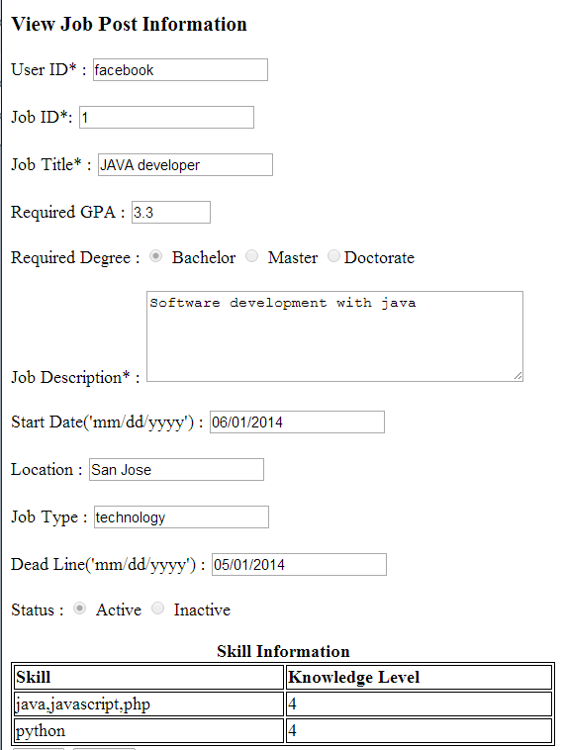

* + 1. Facebook Job Info
    2. Change the parameter according to facebook Job above
  1. Search for Resume

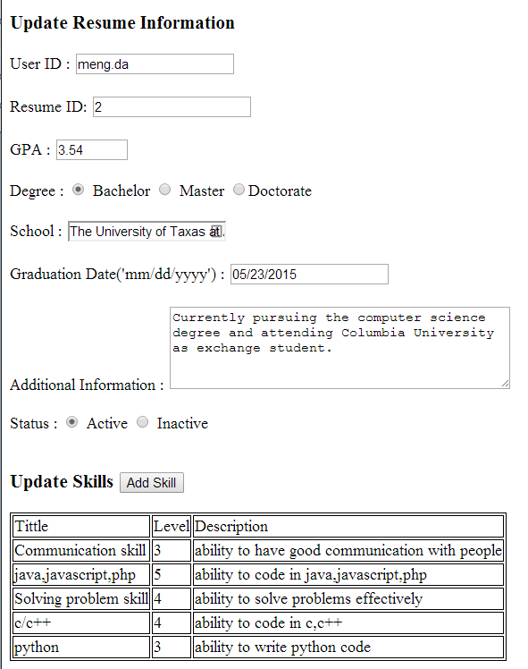

Change the parameter thus this resume shows up or not.