Job Search Engine for the new graduates (YourFirstJob.com)

- Project Description
  - Project Background
There are several job search and posting site in works such as Monster, Indeed and CareerBuilder. While these sites work wonders by providing various filters such as location, job title, job type and others, one of the most time consuming step for the job applicant is manually looking at required GPA, degree or skills section of each job-posting to filter out incompatible postings. Additionally, it is very hard for the employer to filter out incompatible job applicant by job requirement as well. As a result, we are proposing a new database for the job search that focuses on the requirement of the job such as GPA, degree and skills. Since, these GPA, degree requirement are often found for the new graduate job, our main end user target will be the student in school who is looking for the first job.

  - Project Solution
Our system will consist of two types of users. One is the job seeker who will post resumes, and the other is the employer who will be posting jobs. End users can be either a job seeker or employer, or both, or neither depending on the situation.
An end user who decides to be a job seeker will post resumes with relevant information such as their objective, school and etc. The database will specifically ask for GPA and degree information and will store them separately thus it can be utilized to the matching functionality. Additionally, each resume will allow the end user to enter work experience and skills. End user can choose skills from the pre-populated skill list and enter the knowledge level for each skill. If such skill is missing from the database, end user can add a new skill to the database accordingly thus it can be registered.
For the employer, they will post jobs with pertinent information such as job title, location and etc. Similarly to resume, they will be entering the required minimum GPA, degree. If those fields are left as null, it will be regarded as no requirement needed for those criteria. Furthermore, job-posting will have required skill sets. Each job posting will choose required skills and required knowledge level for each skill.
Using this specified information about required GPA, degree and skills, an applicable job posting will be provided to the job seeker and valuable job applicants will be available to the employer who posted the job.
Additional functionality such as reference and applying for a specific job will be also available to the job seeker. Populating and maintaining the skills database will be the most challenging part of this project. There are various skills on the job and efficiently organizing and curating this information, thus it could be searched quickly and effectively will be the main key to the project’s success.

  - Data Population
Data will be populated by manually for the test of the project. While some of the attributes and entities could be populated using the publicly available database from other Job search site like Indeed or Monster, their data is not specifically categorized to our database model and needs a lot of manual parsing. While we will analyze and try to populate the data from these public data, if it is not feasible for our timeline, we will populate the database manually. We are planning to write a program, which will randomly generate the entry as necessary from a given set of category lists for each attribute.

- Entity – Relationship Model Diagram (Original Size JPG is available as separate file)
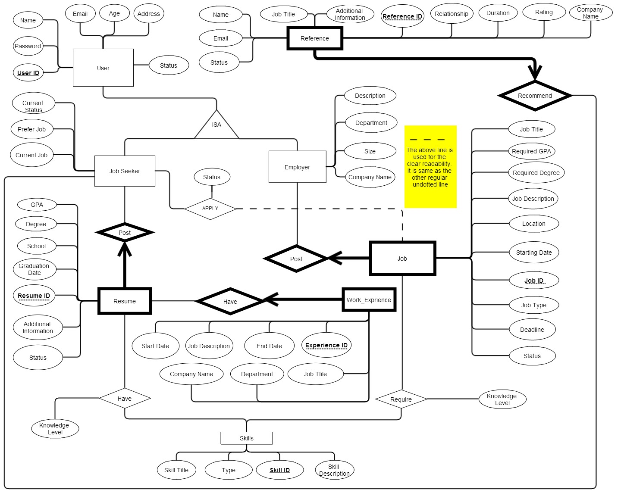
- SQL Schema
CREATE TABLE User (
userID CHAR(20),
password CHAR(20) NOT NULL,
name CHAR(20) NOT NULL,
age INTEGER,
address CHAR(50),
email CHAR(20) NOT NULL,
status INTEGER,
PRIMARY KEY (userID),
UNIQUE (email))

CREATE TABLE Employer(
companyName CHAR(50) NOT NULL,
description CHAR(250),
department CHAR(250),
size CHAR(20),
userID CHAR(20),
PRIMARY KEY (userID),
FOREIGN KEY (userID)
REFERENCES User ON DELETE CASCADE)

CREATE TABLE Job_Seeker(
currentStatus CHAR(20),
preferJob CHAR(20),
currentJob CHAR(20),
userID CHAR(20),
PRIMARY KEY (userID),
FOREIGN KEY (userID)
REFERENCES User ON DELETE CASCADE)

CREATE TABLE Resume_Post(
gpa REAL,
degree CHAR(20),
school CHAR(20),
graduationDate DATE,
resumeID CHAR(20),
additionalInfomation CHAR(500),
userID CHAR(20),
status INTEGER,
PRIMARY KEY (resumeID, userID),
FOREIGN KEY (userID)
REFERENCES Job_Seeker ON DELETE CASCADE)
CREATE TABLE Job_Post(
jobTitle CHAR(20) NOT NULL,
requiredGPA REAL,
requiredDegree CHAR(20),
jobDescription CHAR(250) NOT NULL,
location CHAR(20),
startDate DATE,
jobID CHAR(20),
jobType CHAR(20),
deadline DATE,
status INTEGER,
userID CHAR(20),
PRIMARY KEY (jobID, userID),
FOREIGN KEY (userID)
REFERENCES Employer ON DELETE CASCADE)

CREATE TABLE Reference_Recommend(
jobTitle CHAR(20),
additionalInformation CHAR(500),
referenceID CHAR(20),
relationship CHAR(20) NOT NULL,
duration INTEGER,
rating INTEGER NOT NULL,
companyName CHAR(20) NOT NULL,
name CHAR(20),
email CHAR(20),
status INTEGER
jobSeekerID CHAR(20),
PRIMARY KEY (referenceID, jobSeekerID),
FOREIGN KEY (jobSeekerID)
REFERENCES Job_Seeker.userID ON DELETE CASCADE)

CREATE TABLE Skill(
skillTitle CHAR(20) NOT NULL,
type INTEGER NOT NULL,
skill_ID CHAR(20),
skillDescription(250),
PRIMARY KEY (skill_ID),
UNIQUE(skillTitle, type))
CREATE TABLE Job_Require_Skill(
jobID CHAR(20),
skill_ID CHAR(20),
knowledgeLevel INTEGER,
PRIMARY KEY (skill_ID, jobID)
FOREIGN KEY (skill_ID)
REFERENCES Skill,
FOREIGN KEY (jobID)
REFERENCES Job_Post ON DELETE CASCADE)

CREATE TABLE Resume_Have_Skill(
resumeID CHAR(20),
skill_ID CHAR(20),
knowledgeLevel INTEGER,
PRIMARY KEY (resumeID, skill_ID)
FOREIGN KEY (skill_ID)
REFERENCES Skill,
FOREIGN KEY (resumeID)
REFERENCES Resume_Post ON DELETE CASCADE)

CREATE TABLE JobSeeker_Apply_Job(
userID CHAR(20),
jobID CHAR(20),
status INTEGER,
PRIMARY KEY (userID, jobID)
FOREIGN KEY (userID)
REFERENCES Job_Seeker ON DELETE CASCADE,
FOREIGN KEY (jobID)
REFERENCES Job_Post ON DELETE CASCADE)

CREATE TABLE Resume_Have_WorkExperience(
resumeID CHAR(20),
experienceID CHAR(20),
startDate DATE NOT NULL,
endDate DATE,
jobDescription CHAR(100),
companyName CHAR(20) NOT NULL,
department CHAR(20),
jobTitle CHAR(20),
PRIMARY KEY (resumeID, experienceID)
FOREIGN KEY (resumeID)
REFERENCES Resume_Post ON DELETE CASCADE)

- Project Planning for the Part 3.
For the part 3 of the project, we are planning to build the web front end for our database using the Java and php

- Contingency Plan
For our the contingency plan, some of the entities or relationships will be dropped thus a single person can manage it. Reference and Skills entities will be dropped and replaced as a simple string attribute to simplify the database. Furthermore, any relationship related to these two entities will be dropped. This will reduce the size of the project significantly, thus a single person can finish the project. On the other hand, either one of us can expand our database for the part 3 as well. For example, we could add Message, Search or Friend related entities and relationships to the database to be more user-friendly while adding social network site aspect.
- Copy of the Approved Proposal (Original Size PDF is available as separate file)
The approved proposal is provided on the next page. From the advice, the search entity was removed, added a primary key for each entity and revised the plan to simplify the database while removing redundant attributes.
