- ER-модель бд
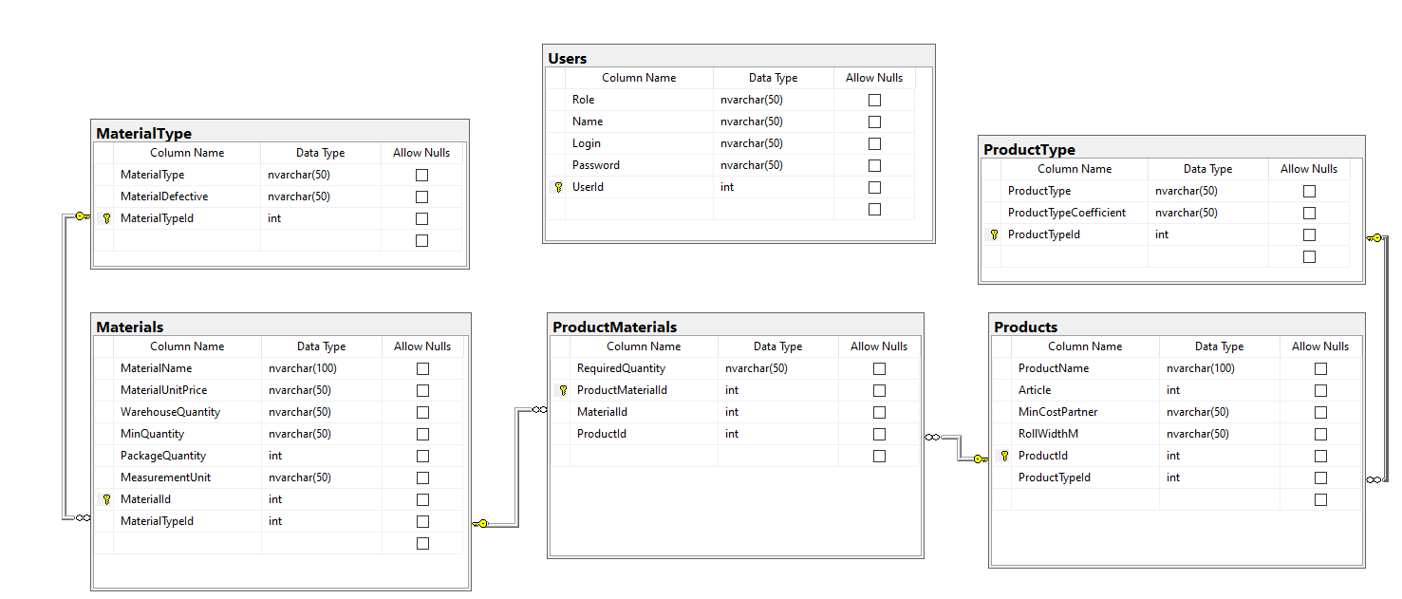

- Скрипт бд
USE [master]
GO

/****** Object: Database [УП1221] Script Date: 10.11.2025 11:53:36 ******/
CREATE DATABASE [УП1221]
CONTAINMENT = NONE
ON PRIMARY
( NAME = N'УП1221', FILENAME = N'D:\MSSQL14.SQLSERVER\MSSQL\DATA\УП1221.mdf' , SIZE = 8192KB , MAXSIZE = UNLIMITED, FILEGROWTH = 10%)
LOG ON
( NAME = N'УП1221_log', FILENAME = N'D:\MSSQL14.SQLSERVER\MSSQL\DATA\УП1221_log.ldf' , SIZE = 1024KB , MAXSIZE = 2048GB , FILEGROWTH = 10%)
GO

IF (1 = FULLTEXTSERVICEPROPERTY('IsFullTextInstalled'))
begin
EXEC [УП1221].[dbo].[sp_fulltext_database] @action = 'enable'
end
GO

ALTER DATABASE [УП1221] SET ANSI_NULL_DEFAULT OFF
GO

ALTER DATABASE [УП1221] SET ANSI_NULLS OFF
GO

ALTER DATABASE [УП1221] SET ANSI_PADDING OFF
GO

ALTER DATABASE [УП1221] SET ANSI_WARNINGS OFF
GO

ALTER DATABASE [УП1221] SET ARITHABORT OFF
GO

ALTER DATABASE [УП1221] SET AUTO_CLOSE OFF
GO

ALTER DATABASE [УП1221] SET AUTO_SHRINK OFF
GO

ALTER DATABASE [УП1221] SET AUTO_UPDATE_STATISTICS ON
GO

ALTER DATABASE [УП1221] SET CURSOR_CLOSE_ON_COMMIT OFF
GO

ALTER DATABASE [УП1221] SET CURSOR_DEFAULT GLOBAL
GO

ALTER DATABASE [УП1221] SET CONCAT_NULL_YIELDS_NULL OFF
GO

ALTER DATABASE [УП1221] SET NUMERIC_ROUNDABORT OFF
GO

ALTER DATABASE [УП1221] SET QUOTED_IDENTIFIER OFF
GO

ALTER DATABASE [УП1221] SET RECURSIVE_TRIGGERS OFF
GO

ALTER DATABASE [УП1221] SET DISABLE_BROKER
GO

ALTER DATABASE [УП1221] SET AUTO_UPDATE_STATISTICS_ASYNC OFF
GO

ALTER DATABASE [УП1221] SET DATE_CORRELATION_OPTIMIZATION OFF
GO

ALTER DATABASE [УП1221] SET TRUSTWORTHY OFF
GO

ALTER DATABASE [УП1221] SET ALLOW_SNAPSHOT_ISOLATION OFF
GO

ALTER DATABASE [УП1221] SET PARAMETERIZATION SIMPLE
GO

ALTER DATABASE [УП1221] SET READ_COMMITTED_SNAPSHOT OFF
GO

ALTER DATABASE [УП1221] SET HONOR_BROKER_PRIORITY OFF
GO

ALTER DATABASE [УП1221] SET RECOVERY SIMPLE
GO

ALTER DATABASE [УП1221] SET MULTI_USER
GO

ALTER DATABASE [УП1221] SET PAGE_VERIFY CHECKSUM
GO

ALTER DATABASE [УП1221] SET DB_CHAINING OFF
GO

ALTER DATABASE [УП1221] SET FILESTREAM( NON_TRANSACTED_ACCESS = OFF )
GO

ALTER DATABASE [УП1221] SET TARGET_RECOVERY_TIME = 0 SECONDS
GO

ALTER DATABASE [УП1221] SET DELAYED_DURABILITY = DISABLED
GO

ALTER DATABASE [УП1221] SET QUERY_STORE = OFF
GO

ALTER DATABASE [УП1221] SET READ_WRITE
GO

USE [УП1221]
GO

/****** Object: Table [dbo].[Materials] Script Date: 10.11.2025 11:54:16 ******/
SET ANSI_NULLS ON
GO

SET QUOTED_IDENTIFIER ON
GO

CREATE TABLE [dbo].[Materials](
[MaterialName] [nvarchar](100) NOT NULL,
[MaterialUnitPrice] [nvarchar](50) NOT NULL,
[WarehouseQuantity] [nvarchar](50) NOT NULL,
[MinQuantity] [nvarchar](50) NOT NULL,
[PackageQuantity] [int] NOT NULL,
[MeasurementUnit] [nvarchar](50) NOT NULL,
[MaterialId] [int] IDENTITY(1,1) NOT NULL,
[MaterialTypeId] [int] NOT NULL,
CONSTRAINT [PK_Materials] PRIMARY KEY CLUSTERED
(
[MaterialId] ASC
)WITH (PAD_INDEX = OFF, STATISTICS_NORECOMPUTE = OFF, IGNORE_DUP_KEY = OFF, ALLOW_ROW_LOCKS = ON, ALLOW_PAGE_LOCKS = ON) ON [PRIMARY]
) ON [PRIMARY]
GO

ALTER TABLE [dbo].[Materials] WITH CHECK ADD CONSTRAINT [FK_Materials_MaterialType] FOREIGN KEY([MaterialTypeId])
REFERENCES [dbo].[MaterialType] ([MaterialTypeId])
GO

ALTER TABLE [dbo].[Materials] CHECK CONSTRAINT [FK_Materials_MaterialType]
GO

USE [УП1221]
GO

/****** Object: Table [dbo].[MaterialType] Script Date: 10.11.2025 11:55:00 ******/
SET ANSI_NULLS ON
GO

SET QUOTED_IDENTIFIER ON
GO

CREATE TABLE [dbo].[MaterialType](
[MaterialType] [nvarchar](50) NOT NULL,
[MaterialDefective] [nvarchar](50) NOT NULL,
[MaterialTypeId] [int] IDENTITY(1,1) NOT NULL,
CONSTRAINT [PK_MaterialType] PRIMARY KEY CLUSTERED
(
[MaterialTypeId] ASC
)WITH (PAD_INDEX = OFF, STATISTICS_NORECOMPUTE = OFF, IGNORE_DUP_KEY = OFF, ALLOW_ROW_LOCKS = ON, ALLOW_PAGE_LOCKS = ON) ON [PRIMARY]
) ON [PRIMARY]
GO

USE [УП1221]
GO

/****** Object: Table [dbo].[ProductMaterials] Script Date: 10.11.2025 11:55:49 ******/
SET ANSI_NULLS ON
GO

SET QUOTED_IDENTIFIER ON
GO

CREATE TABLE [dbo].[ProductMaterials](
[RequiredQuantity] [nvarchar](50) NOT NULL,
[ProductMaterialId] [int] IDENTITY(1,1) NOT NULL,
[MaterialId] [int] NOT NULL,
[ProductId] [int] NOT NULL,
CONSTRAINT [PK_ProductMaterials] PRIMARY KEY CLUSTERED
(
[ProductMaterialId] ASC
)WITH (PAD_INDEX = OFF, STATISTICS_NORECOMPUTE = OFF, IGNORE_DUP_KEY = OFF, ALLOW_ROW_LOCKS = ON, ALLOW_PAGE_LOCKS = ON) ON [PRIMARY]
) ON [PRIMARY]
GO

ALTER TABLE [dbo].[ProductMaterials] WITH CHECK ADD CONSTRAINT [FK_ProductMaterials_Materials] FOREIGN KEY([MaterialId])
REFERENCES [dbo].[Materials] ([MaterialId])
GO

ALTER TABLE [dbo].[ProductMaterials] CHECK CONSTRAINT [FK_ProductMaterials_Materials]
GO

ALTER TABLE [dbo].[ProductMaterials] WITH CHECK ADD CONSTRAINT [FK_ProductMaterials_Products] FOREIGN KEY([ProductId])
REFERENCES [dbo].[Products] ([ProductId])
GO

ALTER TABLE [dbo].[ProductMaterials] CHECK CONSTRAINT [FK_ProductMaterials_Products]
GO

USE [УП1221]
GO

/****** Object: Table [dbo].[Products] Script Date: 10.11.2025 11:56:13 ******/
SET ANSI_NULLS ON
GO

SET QUOTED_IDENTIFIER ON
GO

CREATE TABLE [dbo].[Products](
[ProductName] [nvarchar](100) NOT NULL,
[Article] [int] NOT NULL,
[MinCostPartner] [nvarchar](50) NOT NULL,
[RollWidthM] [nvarchar](50) NOT NULL,
[ProductId] [int] IDENTITY(1,1) NOT NULL,
[ProductTypeId] [int] NOT NULL,
CONSTRAINT [PK_Products] PRIMARY KEY CLUSTERED
(
[ProductId] ASC
)WITH (PAD_INDEX = OFF, STATISTICS_NORECOMPUTE = OFF, IGNORE_DUP_KEY = OFF, ALLOW_ROW_LOCKS = ON, ALLOW_PAGE_LOCKS = ON) ON [PRIMARY]
) ON [PRIMARY]
GO

ALTER TABLE [dbo].[Products] WITH CHECK ADD CONSTRAINT [FK_Products_ProductType] FOREIGN KEY([ProductTypeId])
REFERENCES [dbo].[ProductType] ([ProductTypeId])
GO

ALTER TABLE [dbo].[Products] CHECK CONSTRAINT [FK_Products_ProductType]
GO

USE [УП1221]
GO

/****** Object: Table [dbo].[ProductType] Script Date: 10.11.2025 11:56:24 ******/
SET ANSI_NULLS ON
GO

SET QUOTED_IDENTIFIER ON
GO

CREATE TABLE [dbo].[ProductType](
[ProductType] [nvarchar](50) NOT NULL,
[ProductTypeCoefficient] [nvarchar](50) NOT NULL,
[ProductTypeId] [int] IDENTITY(1,1) NOT NULL,
CONSTRAINT [PK_ProductType] PRIMARY KEY CLUSTERED
(
[ProductTypeId] ASC
)WITH (PAD_INDEX = OFF, STATISTICS_NORECOMPUTE = OFF, IGNORE_DUP_KEY = OFF, ALLOW_ROW_LOCKS = ON, ALLOW_PAGE_LOCKS = ON) ON [PRIMARY]
) ON [PRIMARY]
GO

USE [УП1221]
GO

/****** Object: Table [dbo].[Users] Script Date: 10.11.2025 11:56:35 ******/
SET ANSI_NULLS ON
GO

SET QUOTED_IDENTIFIER ON
GO

CREATE TABLE [dbo].[Users](
[Role] [nvarchar](50) NOT NULL,
[Name] [nvarchar](50) NOT NULL,
[Login] [nvarchar](50) NOT NULL,
[Password] [nvarchar](50) NOT NULL,
[UserId] [int] IDENTITY(1,1) NOT NULL,
CONSTRAINT [PK_Users] PRIMARY KEY CLUSTERED
(
[UserId] ASC
)WITH (PAD_INDEX = OFF, STATISTICS_NORECOMPUTE = OFF, IGNORE_DUP_KEY = OFF, ALLOW_ROW_LOCKS = ON, ALLOW_PAGE_LOCKS = ON) ON [PRIMARY]
) ON [PRIMARY]
GO

-- БД
CREATE DATABASE УП1221;
GO
USE УП1221;
GO

UPDATE m
SET m.ProductTypeId = t.Id
FROM Products m
JOIN ProductType t
ON m.тип_продукции = t.тип_продукции;

UPDATE m
SET m.MaterialTypeId = t.Id
FROM Materials m
JOIN MaterialType t
ON m.тип_материала = t.тип_материала;

UPDATE pm
SET pm.ProductId = p.Id
FROM ProductMaterials pm
JOIN Products p
ON pm.продукция = p.наименование_продукции;

UPDATE pm
SET pm.MaterialId = m.Id
FROM ProductMaterials pm
JOIN Materials m
ON pm.наименование_материала = m.наименование_материала

- Скриншоты резервного копирования;
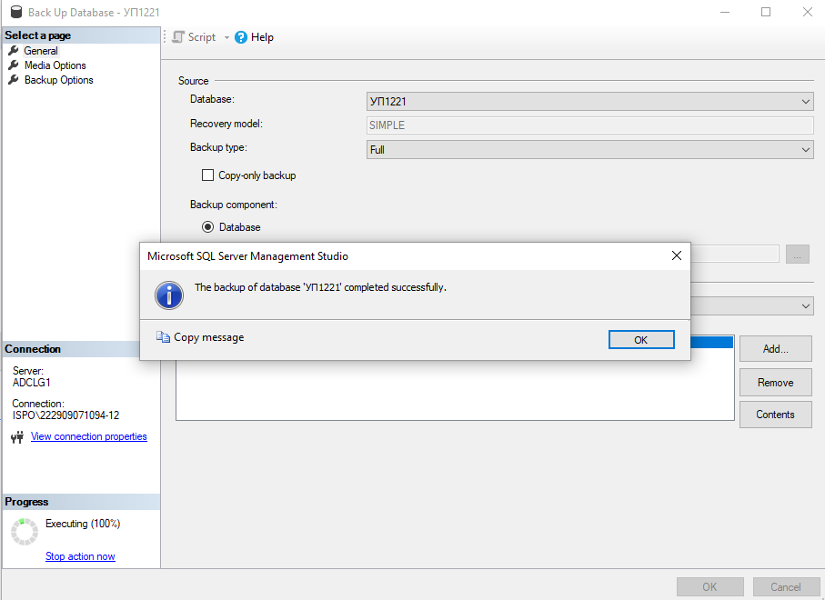

- Скриншоты готовых таблиц с заполненными данными.
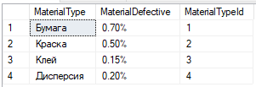
Рисунок 1 – Таблица MaterialType
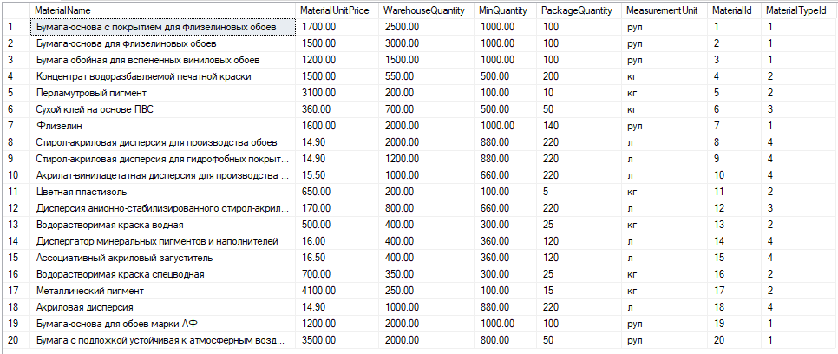
Рисунок 2 – Таблица Materials
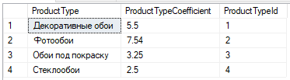
Рисунок 3 – Таблица ProductType
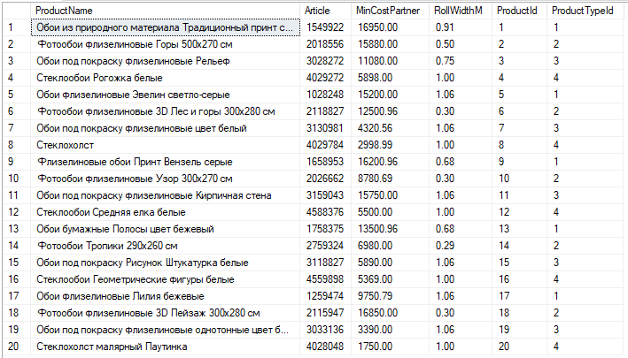
Рисунок 4 – Таблица Products
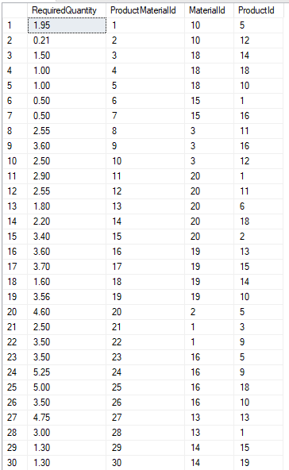
Рисунок 5 – Таблица ProductMaterials
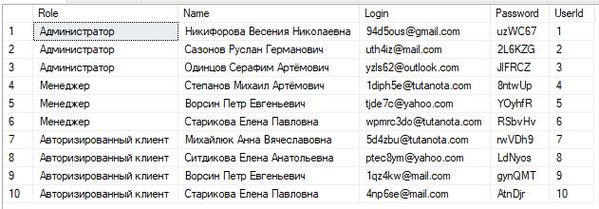
Рисунок 6 – Таблица Users

