**Media Queries Responsive Website Layout Tutorial**

Learn to easily create responsive website layouts using CSS media queries. Media queries allow us to target a particular media type and then apply zero or more expressions that check for the conditions of particular media features. Using this logic we can adjust all CSS for our site according to the screen size of the device that a user is viewing it with.

Example 1 - Media Queries Changing Stylesheet

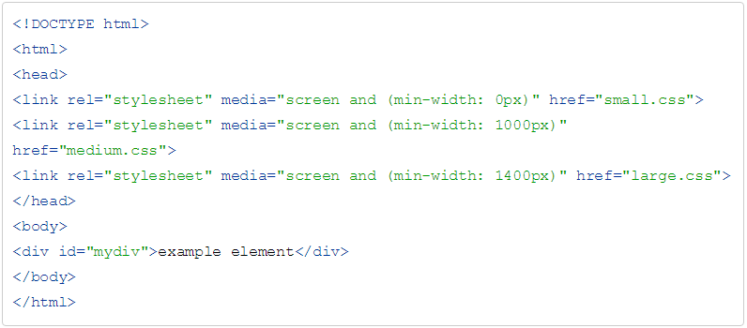

Example 2 - Media Queries Inline CSS

