**box-sizing**

Over the generations, people realized that math is not fun, so a new CSS property called box-sizing was created. When you set box-sizing: border-box; on an element, the padding and border of that element no longer increase its width. Here is the example with box-sizing: border-box; on both elements:

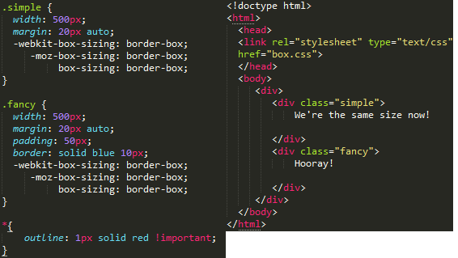

Since this is so much better, some authors want all elements on all their pages to always work this way. Such authors put the following CSS on their pages:

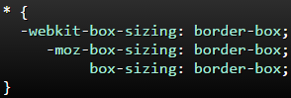

This ensures that all elements are always sized in this more intuitive way.

Since box-sizing is pretty new, you should use the -webkit- and -moz- prefixes for now, as I have in these examples. This technique enables experimental features in specific browsers. Also, keep in mind that this one is [IE8+](http://caniuse.com/#search=box-sizing).

# box-sizing

Over the generations, people realized that math is not fun, so a new CSS property called box-sizing was created. When you set box-sizing: border-box; on an element, the padding and border of that element no longer increase its width. Here is the same example as the previous page, but with box-sizing: border-box; on both elements:

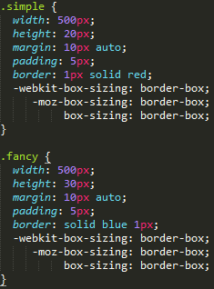

<div class="simple"></div>

<div class="fancy"></div>

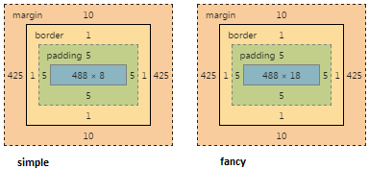

Since this is so much better, some authors want all elements on all their pages to always work this way. Such authors put the following CSS on their pages:

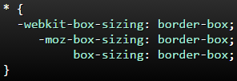

This ensures that all elements are always sized in this more intuitive way.

Since box-sizing is pretty new, you should use the -webkit- and -moz- prefixes for now, as I have in these examples. This technique enables experimental features in specific browsers. Also, keep in mind that this one is [IE8+](http://caniuse.com/#search=box-sizing).