**CSS Float and Clear Explained**

The float CSS property specifies that an element should be taken from the normal flow and placed along the left or right side of its container, where text and inline elements will wrap around it.

<https://www.youtube.com/watch?v=xara4Z1b18I>

<https://www.youtube.com/watch?v=4gE1mThzhSw>

For understanding float CSS property, assume, browser window is a 3-dimensional fish tank filled with water.

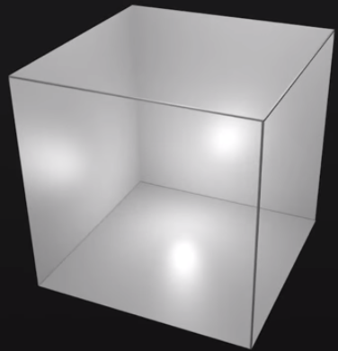

In this example, we will be using 4 div tags called red, green, blue and **yellow**

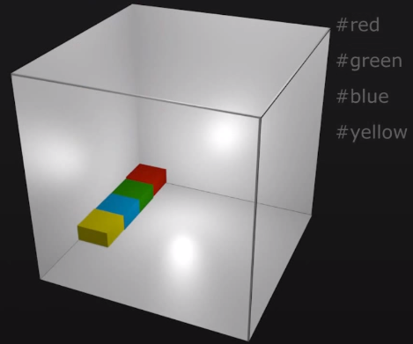

By default, there is no float on any of these elements. This means, they sink to the bottom of the fish tank and stack one below the other on the left hand side.

Floating 1 element:

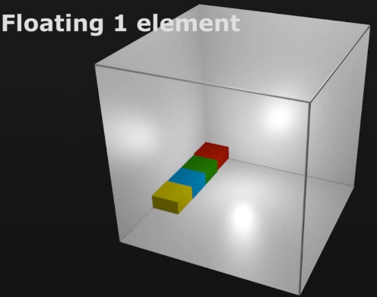

It will cause to rise above the normal stacking order, 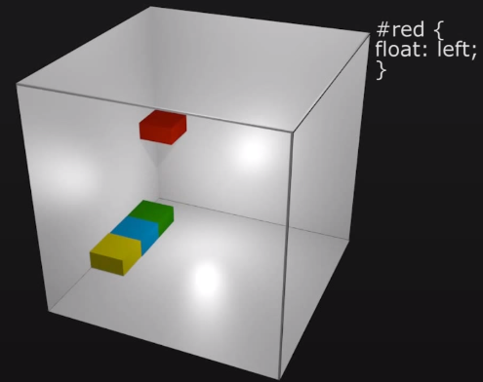

The other blocks will move up to fill the gap.

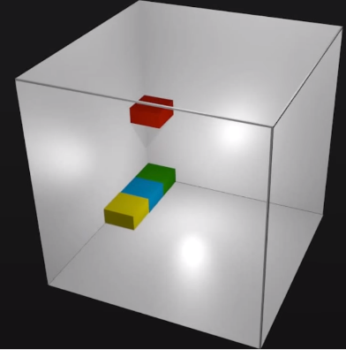

Looking down on the browser window, the green block would seem to disappear, because green is underneath the red one.

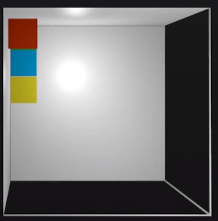

Floating multiple elements:

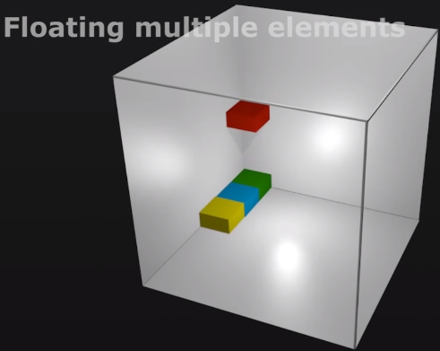

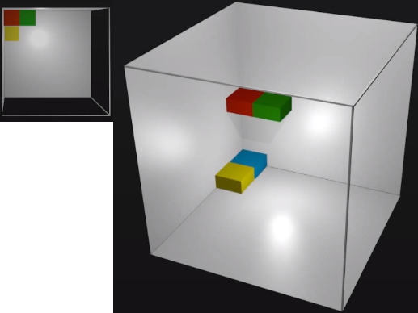

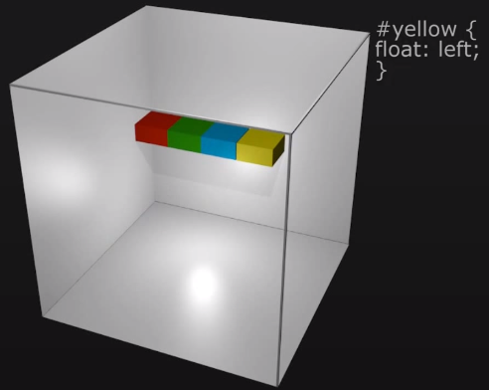

Float with clear:

