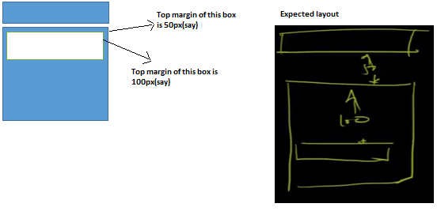

For the above situation, how the margin gets collapsed for nested elements?

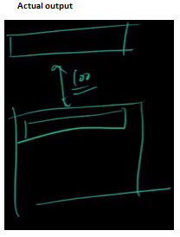

Using a padding or border will prevent collapse only in nested elements. Also, any value of overflow different from its default (visible) applied to the parent will prevent collapse. Thus, both overflow: auto and overflow: hidden will have the same effect.