Content size is going beyond the container.

The overflow property specifies whether to clip content, render scrollbars or just display content when it overflows its block level container.

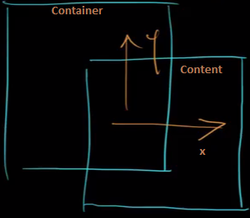

Using the overflow property with a value different to visible (its default) will create a new [block formatting context](https://developer.mozilla.org/en-US/docs/CSS/block_formatting_context). This is technically necessary — if a float intersected with the scrolling element it would forcibly rewrap the content. The rewrap would happen after each scroll step, leading to a slow scrolling experience.

In order for the overflow property to have an effect, the block level container must either have a bounding height (height or max-height) or have white-space set to nowrap.

