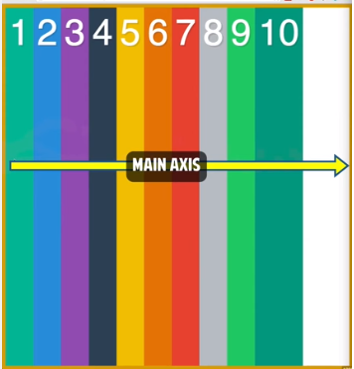

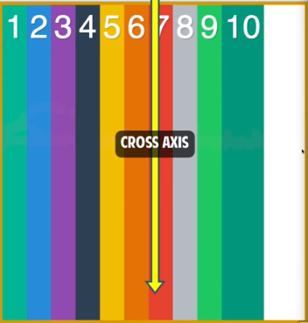

1vw = 1% of viewport width  
1vh = 1% of viewport height  
1vmin = 1vw or 1vh, whichever is smaller  
1vmax = 1vw or 1vh, whichever is larger