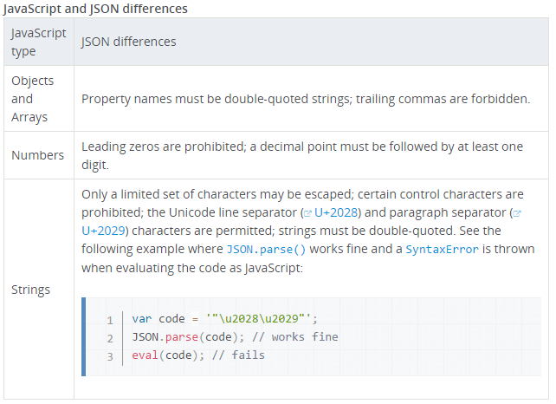

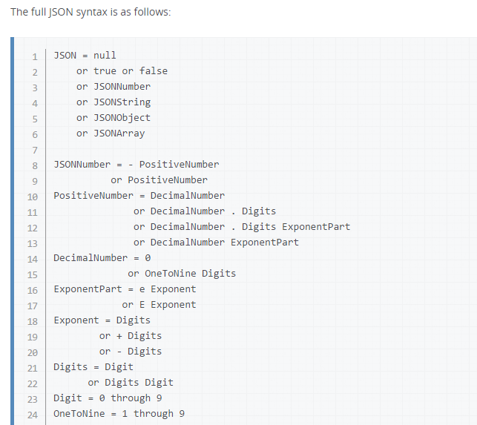

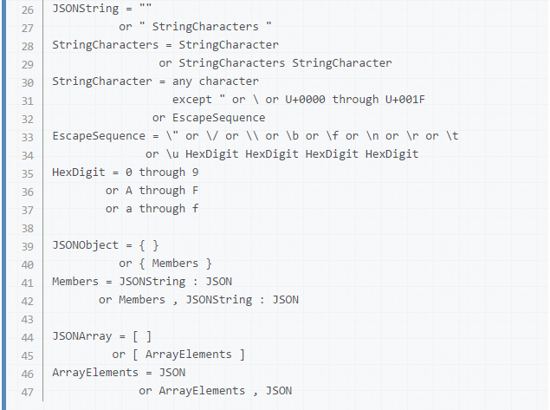

Insignificant whitespace may be present anywhere except within a JSONNumber (numbers must contain no whitespace) or JSONString (where it is interpreted as the corresponding character in the string, or would cause an error). The tab character ([U+0009](http://unicode-table.com/en/0009/)), carriage return ([U+000D](http://unicode-table.com/en/000D/)), line feed ([U+000A](http://unicode-table.com/en/000A/)), and space ([U+0020](http://unicode-table.com/en/0020/)) characters are the only valid whitespace characters.

The JSON object is not supported in older browsers. You can work around this by inserting the following code at the beginning of your scripts, allowing use of JSON object in implementations which do not natively support it (like Internet Explorer 6).

The following algorithm is an imitation of the native JSON object:

if (!window.JSON) {

window.JSON = {

parse: function(sJSON) { return eval('(' + sJSON + ')'); },

stringify: (function () { … }

}

}