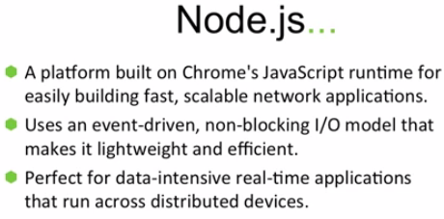

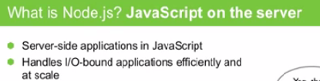

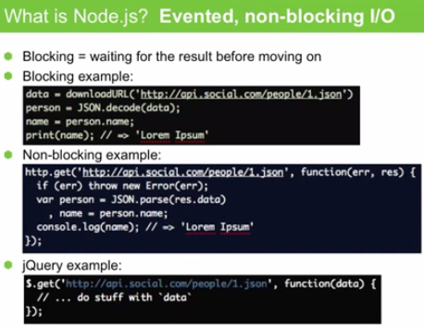

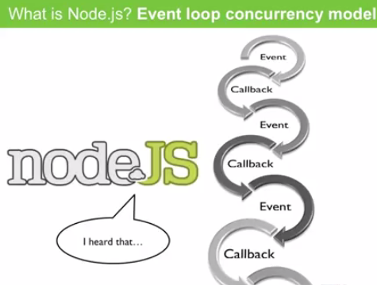

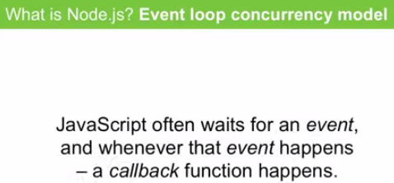

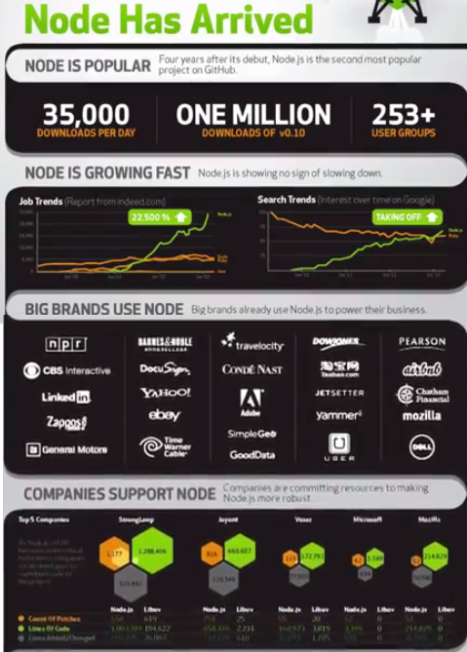



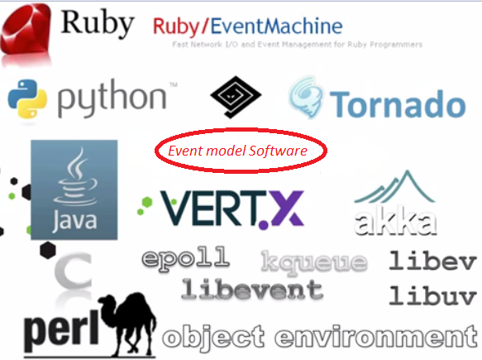

When multiple languages have such libraries, why NodeJS? It is the community that makes difference.

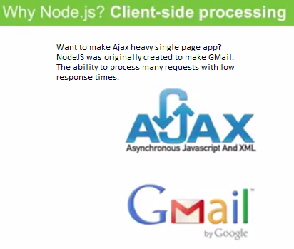

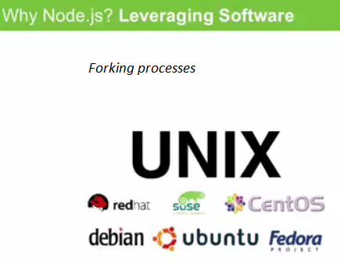

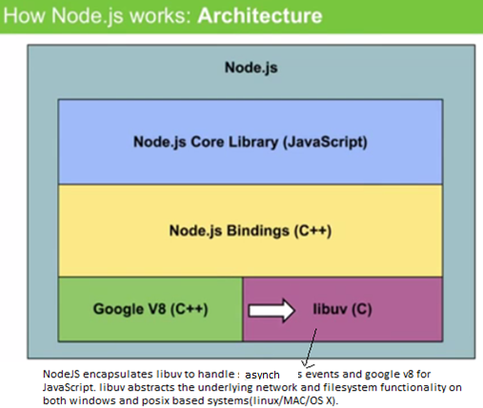

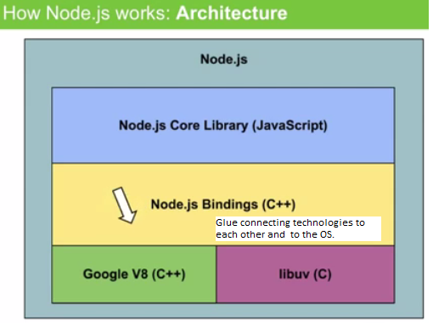

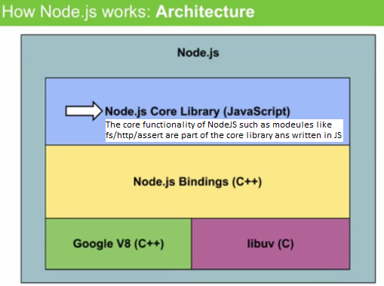



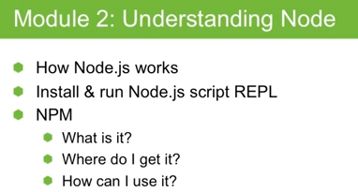

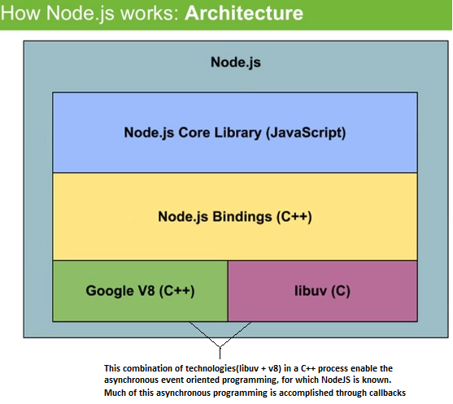

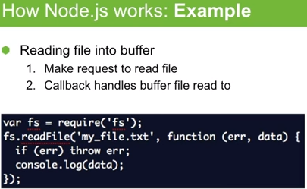

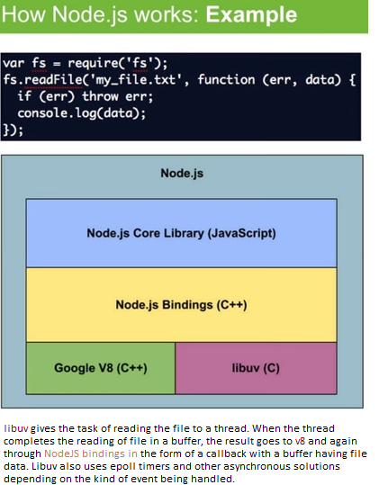

Event loop in NodeJS:

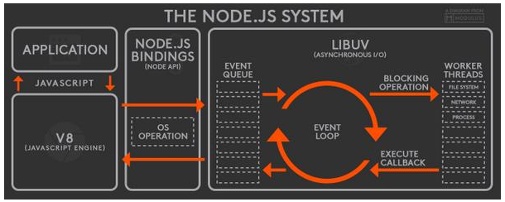

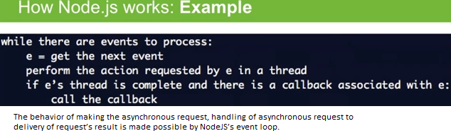

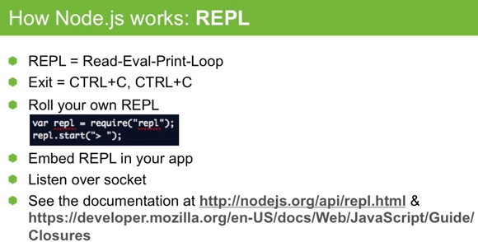

**Front end code deployment using NodeJS**



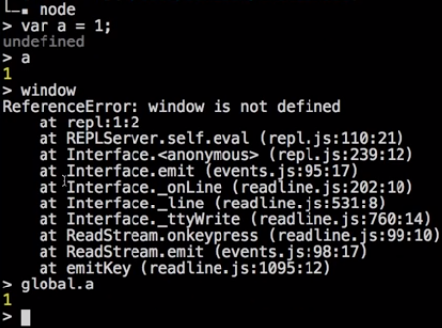

**How to make scripts.js available to html using node modules?**

Example1:

**module_loaders/js/module2.js**:

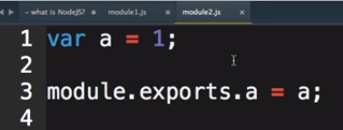

**module_loaders/js/module1.js**:

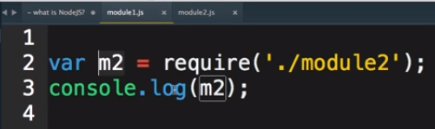

Example2:

**module_loaders/js/Module2.js**:

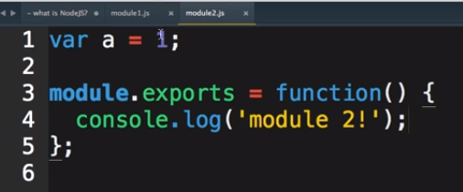

**module_loaders/js/Module1.js**:

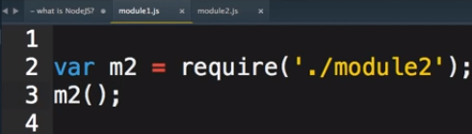

**module_loaders/Index.html**:

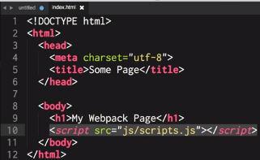

Where **module_loaders/js/scripts.js** is:

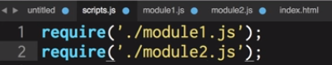

In folder(module_loaders) run npm init and create package.json

Install webpack(npm install –S webpack) with webpack config as

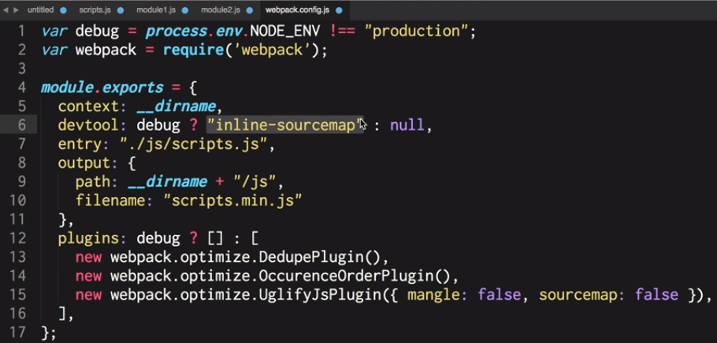

>**webpack**

> **open index.html**

**npm – Node package manager:**

* npm init

creates *package.json* file that manages dependencies.

*package.json* will allow you to manage NOT downloading node modules from github. You do not need to run *npm install XYZ* for every dependency. *npm install* would install all its dependencies given in *package.json*.

Before you check-in *package.json* file to github, you need to run “*npm install XYZ –S”*, to install XYZ as well as save the dependency in *package.json*. So that, when you check out *package.json*, you just need to run “*npm install*”.