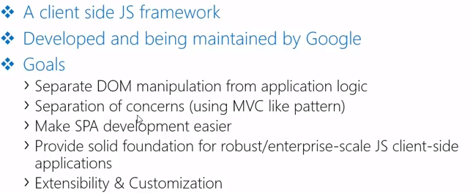

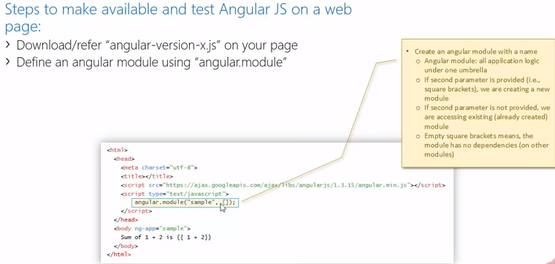

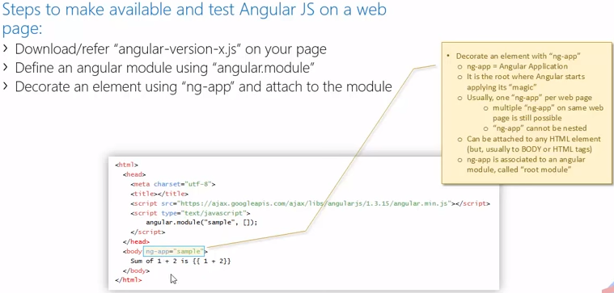

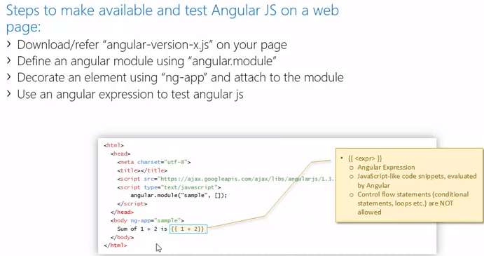

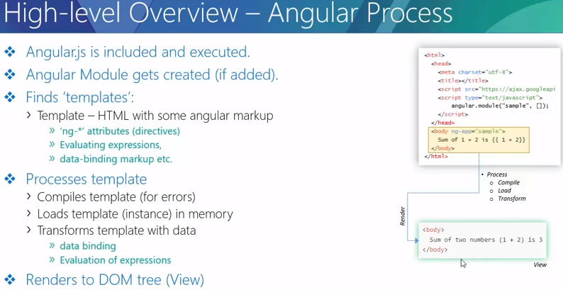

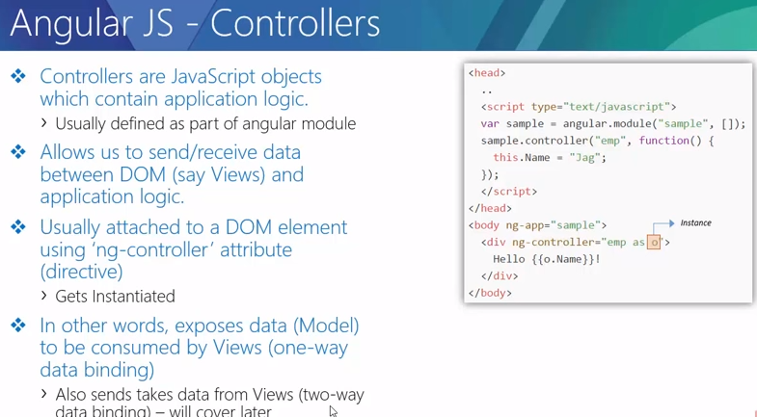
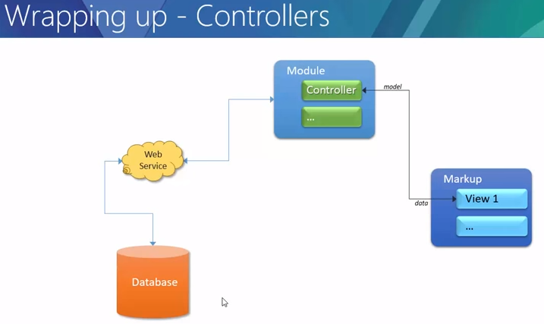
Example:
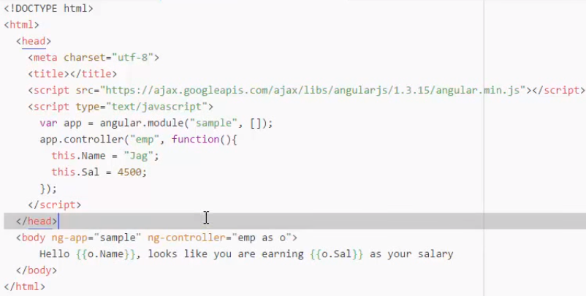

Understanding $scope and its relation with Controller/View

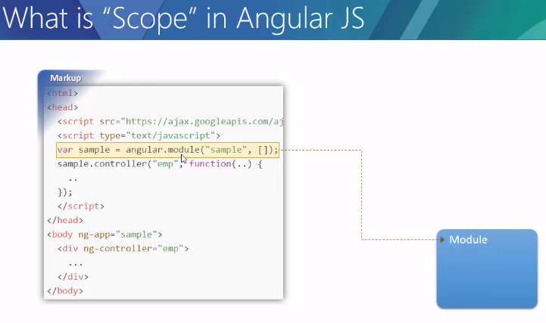

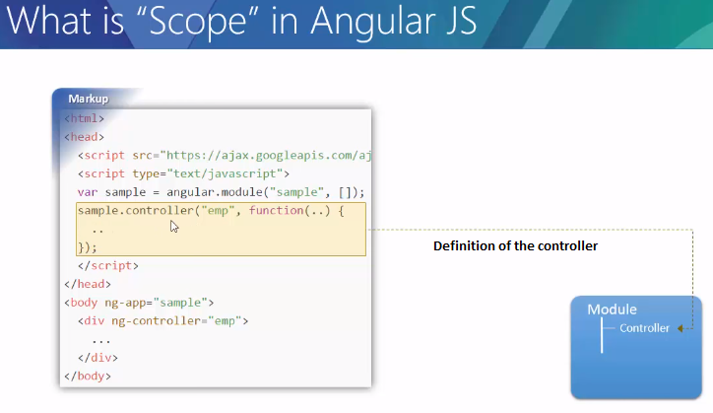

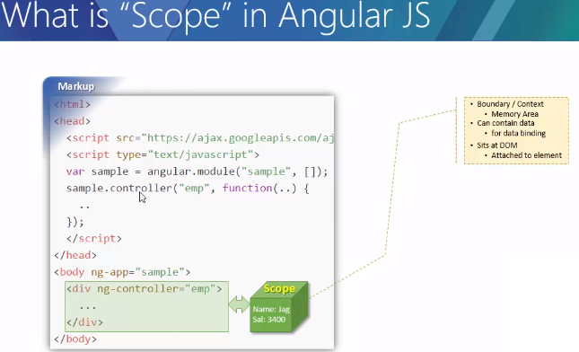

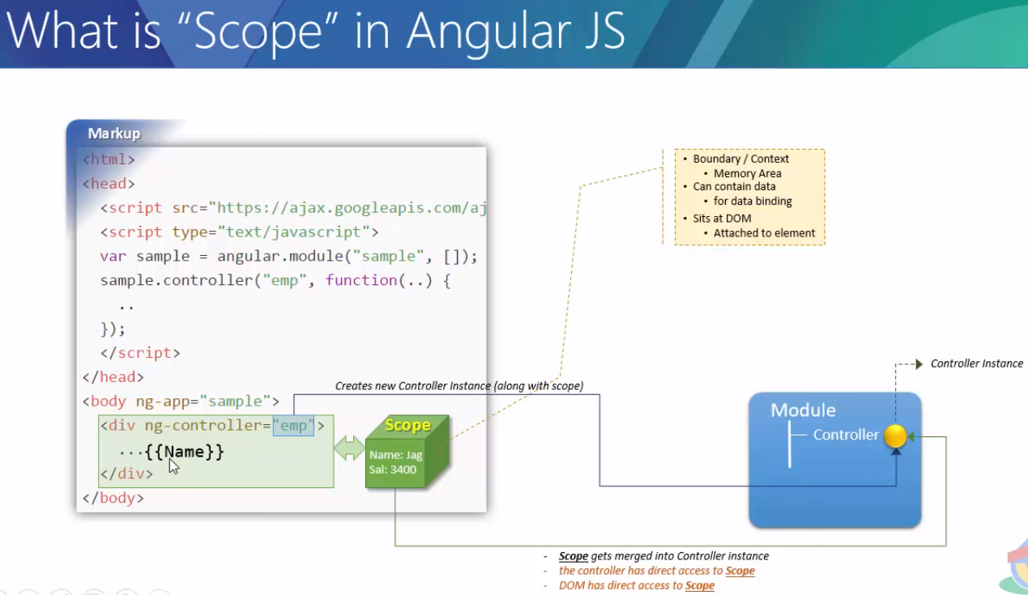
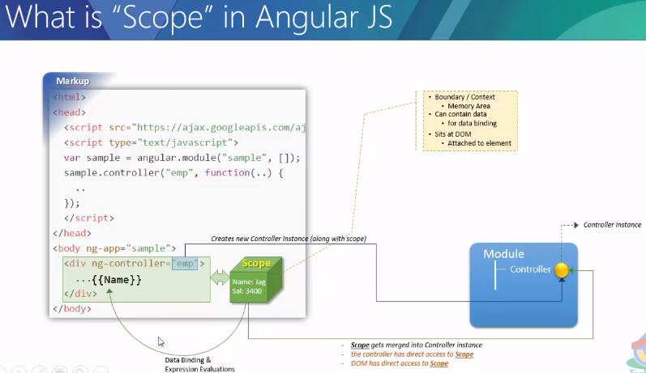

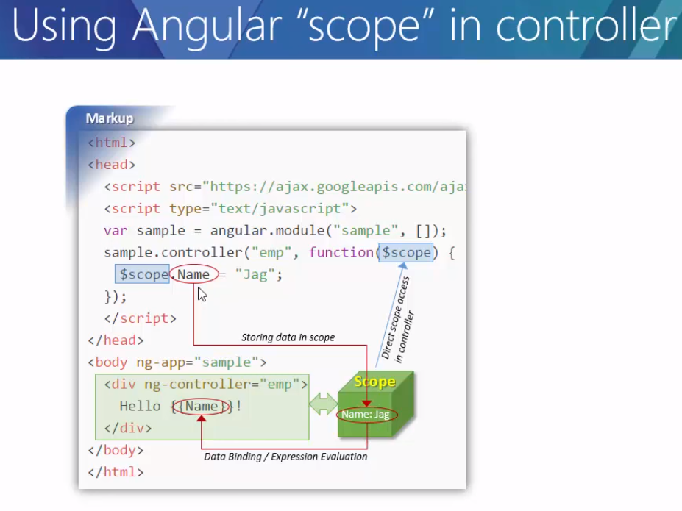


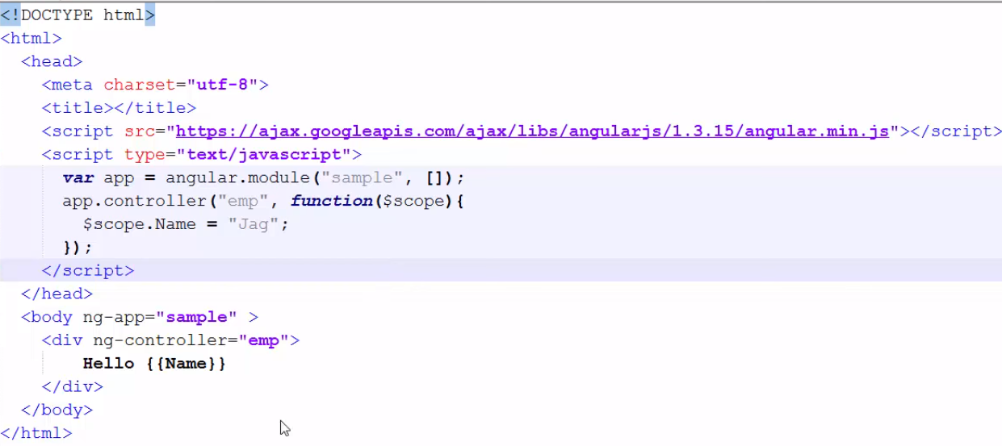

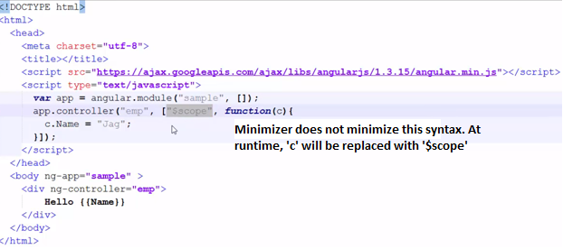
Accessing/Modifying scope in console
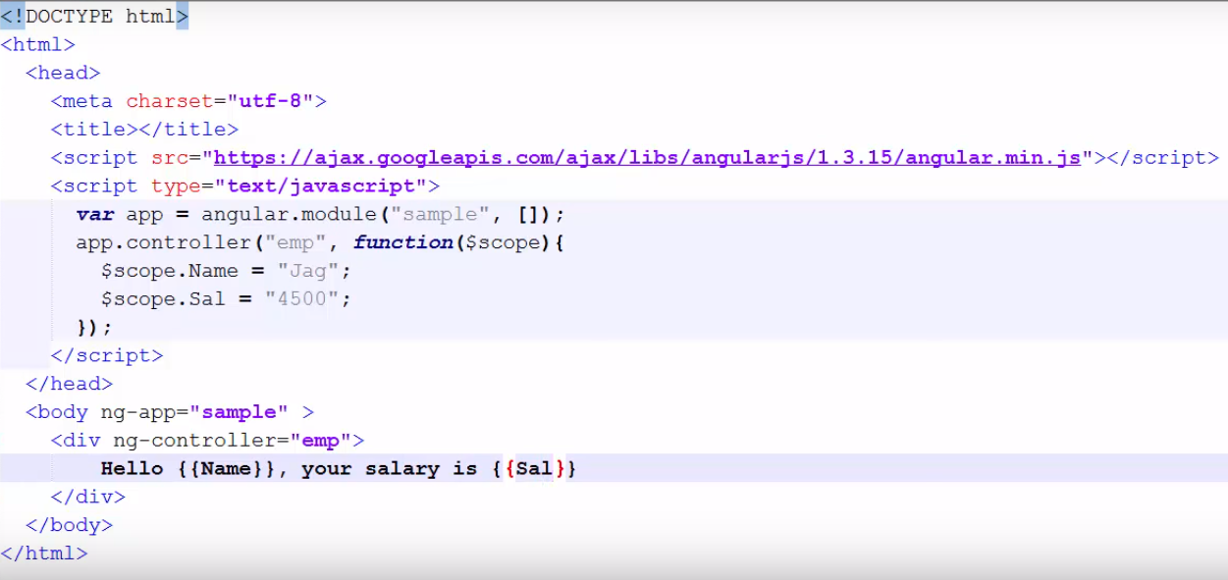
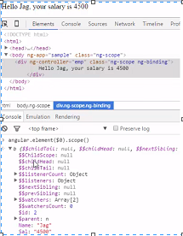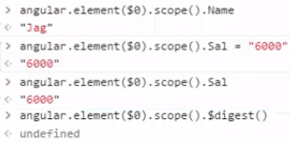

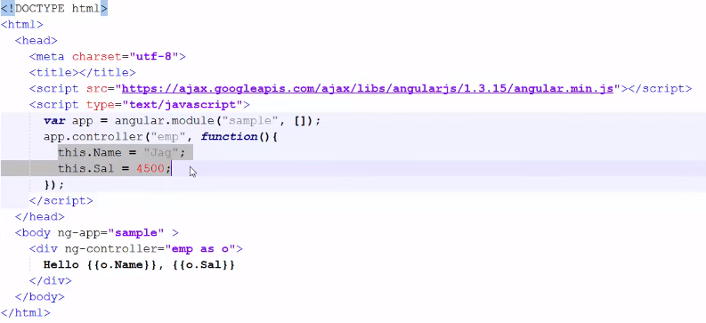

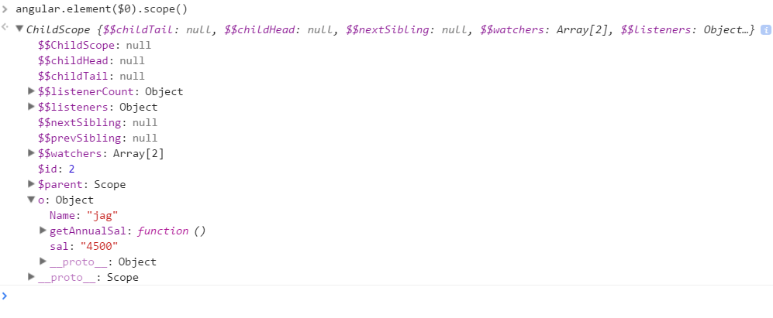
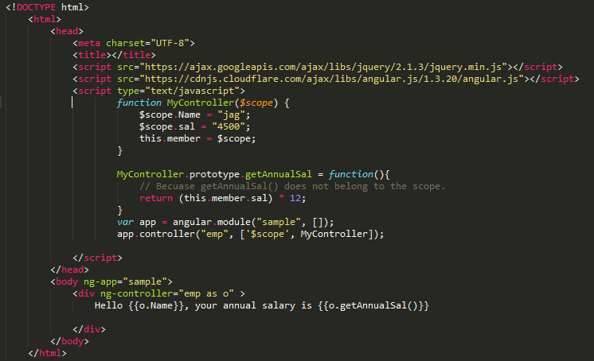
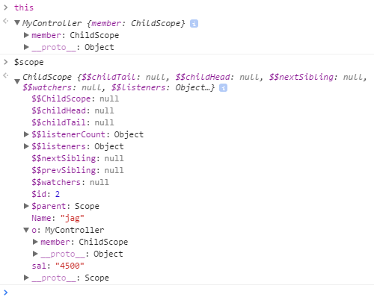

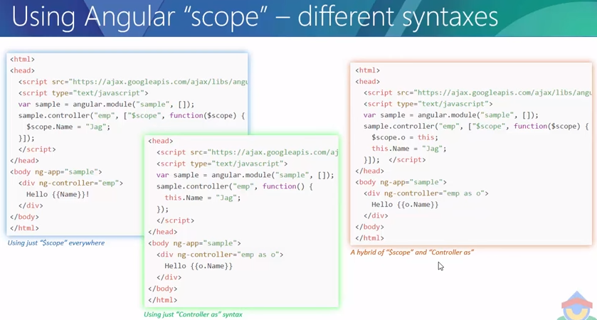

Understanding scope inheritance
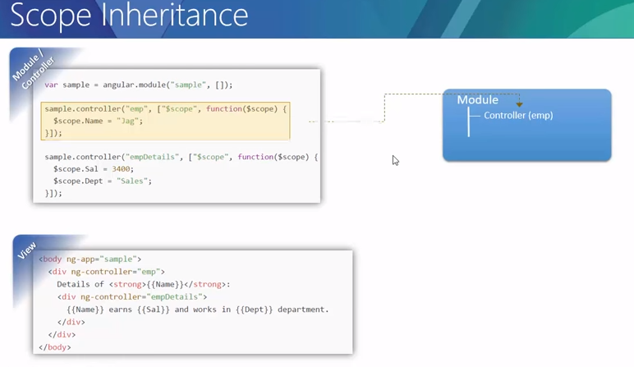

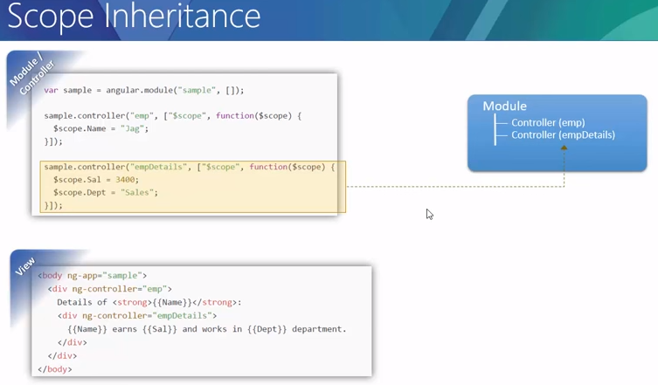

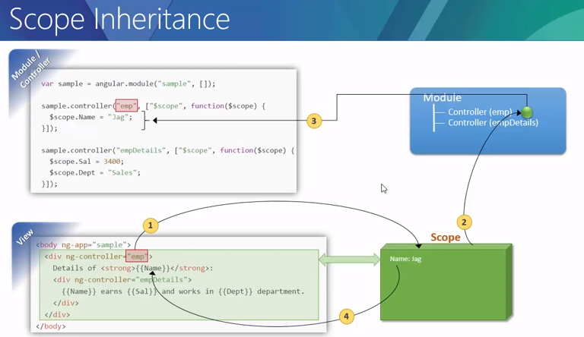

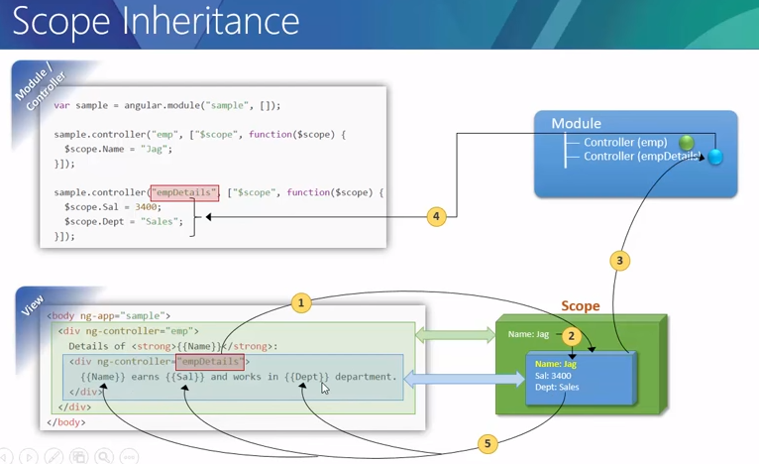
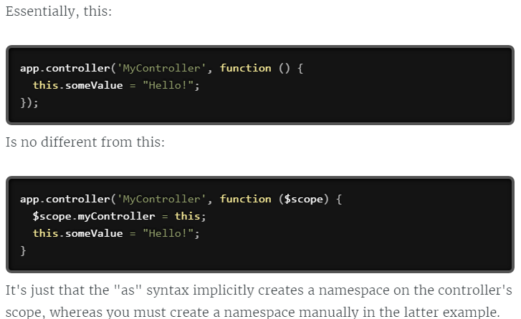

Understanding root scope:
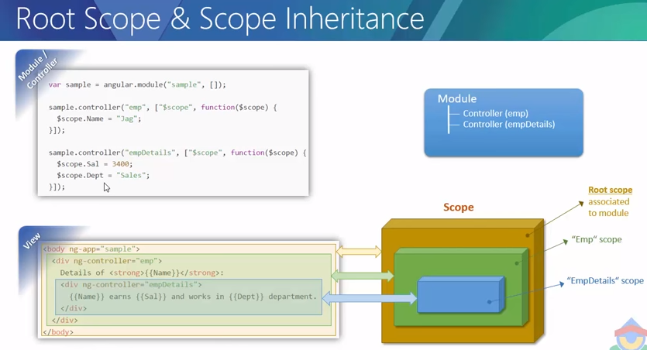

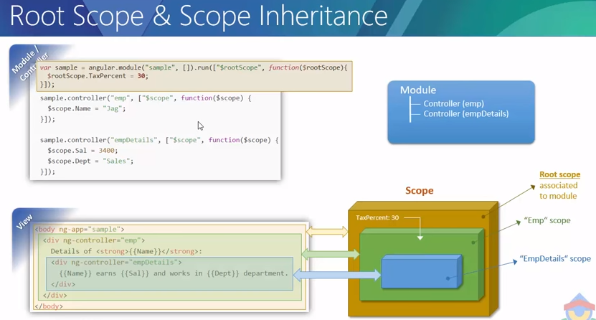
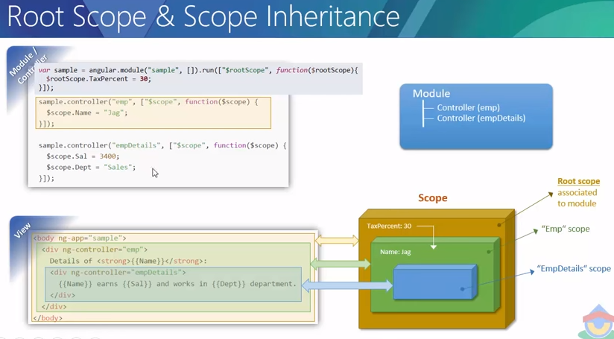
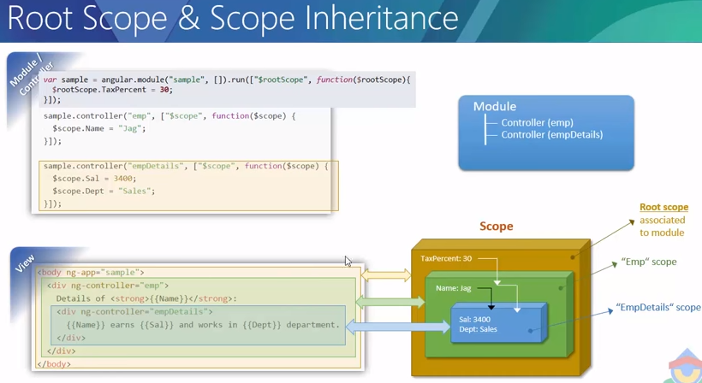

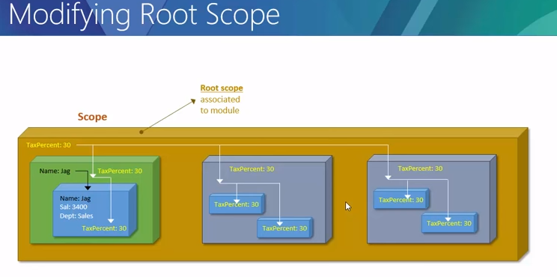
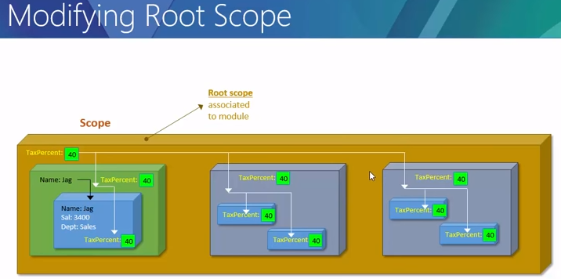

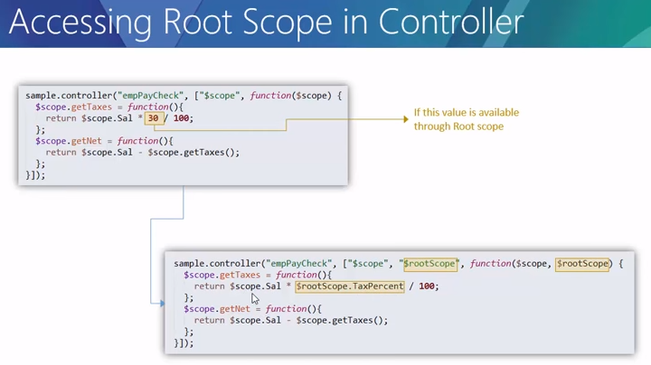

AngularJS – AJAX
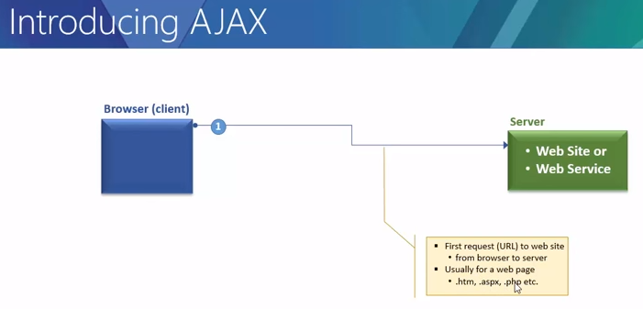
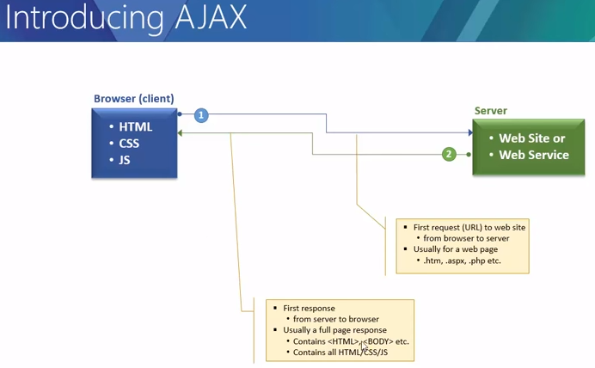

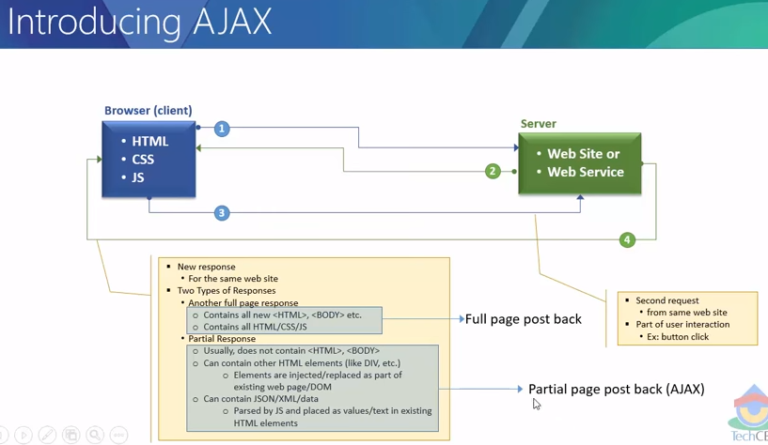

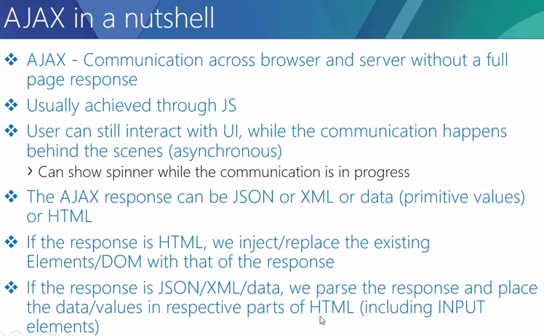

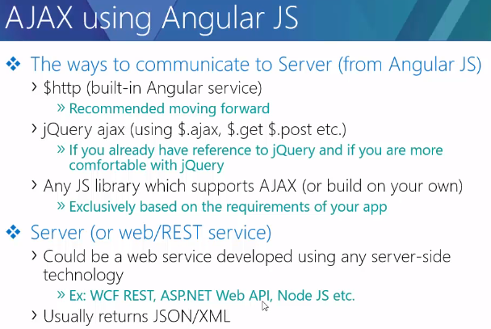

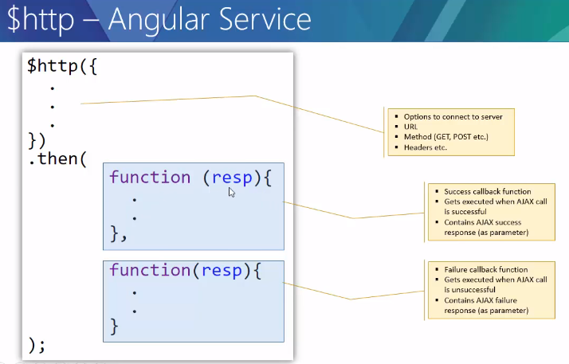
What are Directives?
At a high level, directives are markers on a DOM element (such as an attribute, element name, comment or CSS class) that tell AngularJS's HTML compiler ($compile) to attach a specified behavior to that DOM element (e.g. via event listeners), or even to transform the DOM element and its children.
Angular comes with a set of these directives built-in, like ngBind, ngModel, and ngClass. Much like you create controllers and services, you can create your own directives for Angular to use. When Angular bootstraps your application, the HTML compiler traverses the DOM matching directives against the DOM elements.
What does it mean to "compile" an HTML template? For AngularJS, "compilation" means attaching directives to the HTML to make it interactive. The reason we use the term "compile" is that the recursive process of attaching directives mirrors the process of compiling source code in compiled programming languages.

Matching Directives
Before we can write a directive, we need to know how Angular's HTML compiler determines when to use a given directive.
Similar to the terminology used when an element matches a selector, we say an element matches a directive when the directive is part of its declaration.
In the following example, we say that the <input> element matches the ngModel directive
<input ng-model="foo">
The following <input> element also matches ngModel:
<input data-ng-model="foo">
And the following element matches the person directive:
<person>{{name}}</person>

Normalization
Angular normalizes an element's tag and attribute name to determine which elements match which directives. We typically refer to directives by their case-sensitive camelCase normalized name (e.g. ngModel). However, since HTML is case-insensitive, we refer to directives in the DOM by lower-case forms, typically using dash-delimited attributes on DOM elements (e.g. ng-model).
The normalization process is as follows:
- Strip x- and data- from the front of the element/attributes.
- Convert the :, -, or _-delimited name to camelCase.
Best Practice: Prefer using the dash-delimited format (e.g. ng-bind for ngBind). If you want to use an HTML validating tool, you can instead use the data-prefixed version (e.g. data-ng-bind for ngBind). The other forms shown above are accepted for legacy reasons but we advise you to avoid them.

Directive types
$compile can match directives based on element names, attributes, class names, as well as comments.
All of the Angular-provided directives match attribute name, tag name, comments, or class name. The following demonstrates the various ways a directive (myDir in this case) can be referenced from within a template:
<my-dir></my-dir>
<span my-dir="exp"></span>
<!-- directive: my-dir exp -->
<span class="my-dir: exp;"></span>
Best Practice: Prefer using directives via tag name and attributes over comment and class names. Doing so generally makes it easier to determine what directives a given element matches.
Best Practice: Comment directives were commonly used in places where the DOM API limits the ability to create directives that spanned multiple elements (e.g. inside <table> elements). AngularJS 1.2 introduces ng-repeat-start and ng-repeat-end as a better solution to this problem. Developers are encouraged to use this over custom comment directives when possible.

Custom directives
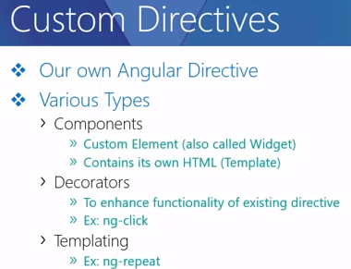
Wraps a raw DOM element or HTML string as a jQuery element.
If jQuery is available, angular.element is an alias for the jQuery function. If jQuery is not available, angular.element delegates to Angular's built-in subset of jQuery, called "jQuery lite" or jqLite.
jqLite is a tiny, API-compatible subset of jQuery that allows Angular to manipulate the DOM in a cross-browser compatible way. jqLite implements only the most commonly needed functionality with the goal of having a very small footprint.
To use jQuery, simply ensure it is loaded before the angular.js file. You can also use the ngJq directive to specify that jqlite should be used over jQuery, or to use a specific version of jQuery if multiple versions exist on the page.
Note: All element references in Angular are always wrapped with jQuery or jqLite (such as the element argument in a directive's compile / link function). They are never raw DOM references.
Note: Keep in mind that this function will not find elements by tag name / CSS selector. For lookups by tag name, try instead angular.element(document).find(...) or $document.find(), or use the standard DOM APIs, e.g. document.querySelectorAll().

Angular’s jqLite
jqLite provides only the following jQuery methods:
- addClass()
- after()
- append()
- attr() - Does not support functions as parameters
- bind() - Does not support namespaces, selectors or eventData
- children() - Does not support selectors
- clone()
- contents()
- css() - Only retrieves inline-styles, does not call getComputedStyle(). As a setter, does not convert numbers to strings or append 'px', and also does not have automatic property prefixing.
- data()
- detach()
- empty()
- eq()
- find() - Limited to lookups by tag name
- hasClass()
- html()
- next() - Does not support selectors
- on() - Does not support namespaces, selectors or eventData
- off() - Does not support namespaces, selectors or event object as parameter
- one() - Does not support namespaces or selectors
- parent() - Does not support selectors
- prepend()
- prop()
- ready()
- remove()
- removeAttr()
- removeClass()
- removeData()
- replaceWith()
- text()
- toggleClass()
- triggerHandler() - Passes a dummy event object to handlers.
- unbind() - Does not support namespaces or event object as parameter
- val()
- wrap()

jQLite Extra’s
Angular also provides the following additional methods and events to both jQuery and jqLite:

Events
- $destroy - AngularJS intercepts all jqLite/jQuery's DOM destruction apis and fires this event on all DOM nodes being removed. This can be used to clean up any 3rd party bindings to the DOM element before it is removed.

Methods
- controller(name) - retrieves the controller of the current element or its parent. By default retrieves controller associated with thengController directive. If name is provided as camelCase directive name, then the controller for this directive will be retrieved (e.g. 'ngModel').
- injector() - retrieves the injector of the current element or its parent.
- scope() - retrieves the scope of the current element or its parent. Requires Debug Data to be enabled.
- isolateScope() - retrieves an isolate scope if one is attached directly to the current element. This getter should be used only on elements that contain a directive which starts a new isolate scope. Calling scope() on this element always returns the original non-isolate scope. Requires Debug Data to be enabled.
- inheritedData() - same as data(), but walks up the DOM until a value is found or the top parent element is reached.
Usage:
angular.element(element);
Parameters: String or DOMELement
Return: jQuery object

Building Custom directives

Developing Custom Services
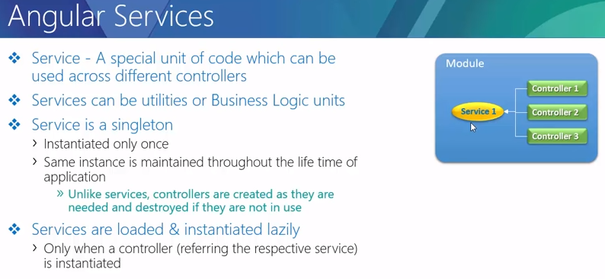
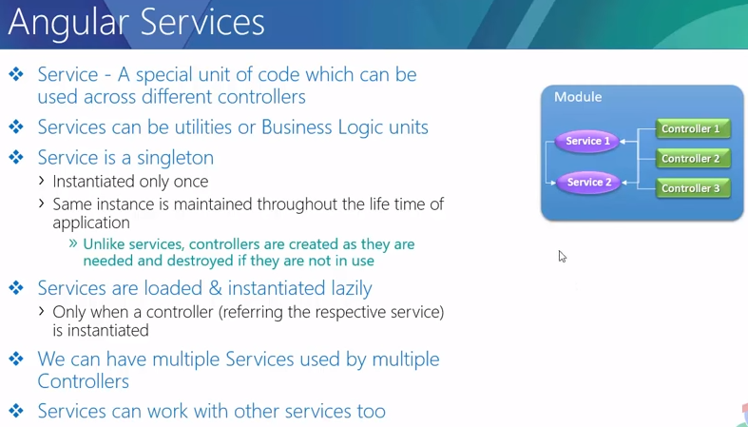
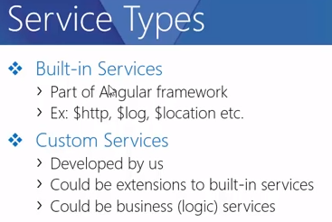
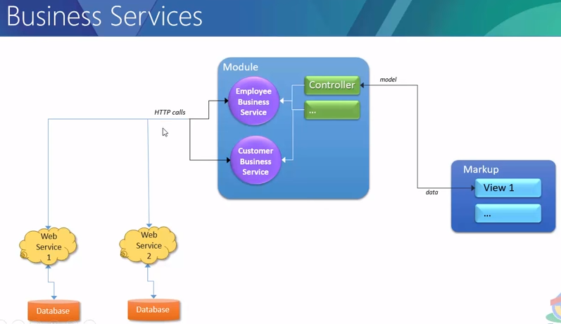
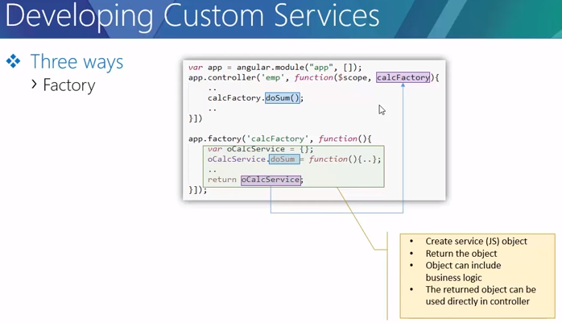
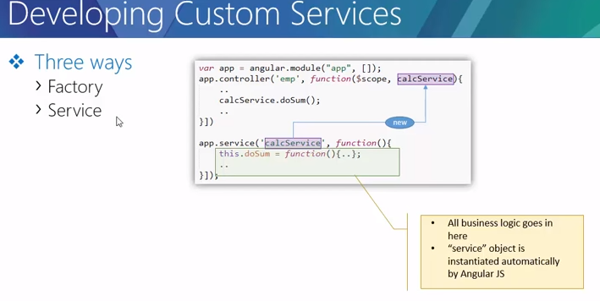

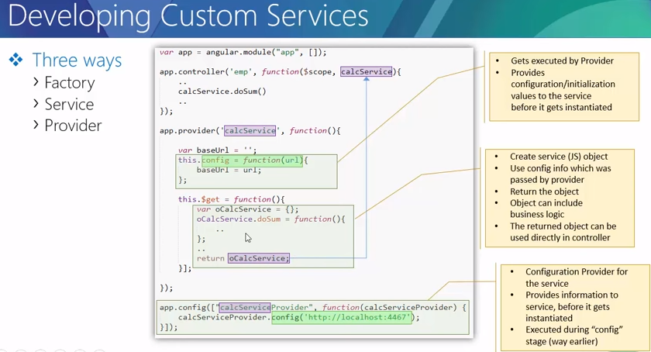

Q) Why $scope.getList() function gets invoked not only on a state change, but on every digest cycle?
In the below code,
<label>
<input type="checkbox" ng-model="showList">
Show unordered list
</label>

<ng-include src="getList()"></ng-include>
$scope.getList() gets invoked on change of $scope.showList by check or uncheck, where $scope.showList is used as,

app3.controller('gListCtrl', function($scope){
$scope.getList = function(){
return $scope.showList ? "ulgrocerylist.html" : "grocerylist.html";
};
});

A)
Because the framework has absolutelly no clue what code is in the getList function. It does not statically analize your code, since it would be both very hard and very inneficient. Due to the nature of how you can use AngularJS, you could be changing the output of getList according to a variable in a completely different controller, service, scope, etc. Thus, this output might need to be rerendered upon every digest cycle. AngularJS recognizes this, because you have the function call in your template and calls it on every digest to check whether it needs to swap out the template.
Consider this application structure:
<div ng-app="testTest">
<script type="text/ng-template" id="template.html">
<div>Hello world!</div>
</script>
<div ng-controller="templateViewer">
<div>
<div ng-include="content()"></div>
</div>
</div>
<div ng-controller="templateChanger">
<button ng-click="handleClick()">Show / hide content</button>
</div>
</div>
and this code to wire it:
var app = angular.module('testTest', []);
app.factory('template', function() {
return {
show: false
};
});
app.controller('templateChanger', function($scope, template) {
$scope.handleClick = function() {
// toggle showing of template
template.show = !template.show;
};
});
app.controller('templateViewer', function($scope, template) {
// if the result of this function is not re-evaluated on every digest cycle,
// Angular has no idea whether to show or hide the template.
$scope.content = function() {
return template.show ? 'template.html' : '';
};
});
So, the framework needs to rely on this constant re-evaluation of properties and functions that are binded to the templates in the HTML. Since all the data structures that you use are plain javascript objects, and you don't explicitly tell the framework that something in your viewmodel has changed (as you would do by invoking set() methods on your models in other frameworks, such as Backbone or Ember) – angular has to check all variables and re-run all the functions that could possibly change the look of your view, and ng-include is one of these cases.

