Flexbox - A CSS3 layout mode that provides an easy and clean way to arrange/re-arrange items within a container.
- NO FLOATS!
- Responsive and mobile friendly
- Positioning child elements is MUCH easier
- Flex container’s margin do not collapse with the margins of its contents
- Order of elements can easily be changed without editing the source of HTML

Flexible box model concept
- The ability to alter item width and height to best fit in its containers available free space
- Flexbox is direction-agnostic. Block model is vertically biased. Inline model is horizontaly biased.
- Built for small-scale layouts while the upcoming “Grid” specification is for more large scale

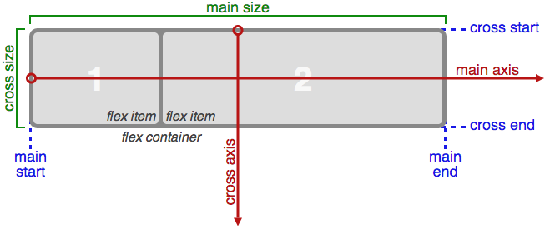
Flex properties:
display: flex | inline-flex;
flex-direction: row | column;
flex-wrap: wrap | nowrap | wrapreverse;
flex-basis: <length>
justify-content: flex-start | flex-end | center;
align-self: flex-start | flex-end | center;
align-items: flex-start | flex-end | center;
align-content: flex-start | flex-end | center;
flex-grow: <number>;
flex-shrink: <number>;
flex: <integer>;
order: <integer>;

dddd

