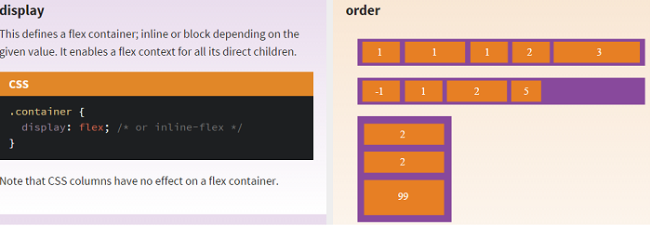
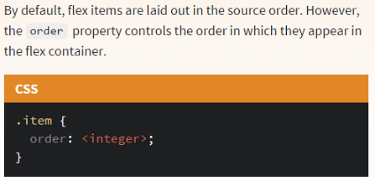

When flex and column both came out into the mainstream many people thought they were the same thing column is used within a single element to create columns whereas flex is used across multiple elements

The CSS multi-column layout extends the block layout mode to allow the easy definition of multiple columns of text. People have trouble reading text if lines are too long; if it takes too long for the eyes to move from the end of the one line to the beginning of the next, they lose track of which line they were on. Therefore, to make maximum use of a large screen, authors should have limited-width columns of text placed side by side, just as newspapers do.
Unfortunately this is impossible to do with CSS and HTML without forcing column breaks at fixed positions, or severely restricting the markup allowed in the text, or using heroic scripting. This limitation is solved by adding new CSS properties to extend the traditional block layout mode.

Using columns

Column count and width
Two CSS properties control whether and how many columns will appear: column-count andcolumn-width.
The column-count property sets the number of columns to a particular number. E.g.,
<div style="-webkit-column-width:10em;">Lorem ipsum dolor sit amet, consectetur adipisicing elit, sed do eiusmod tempor incididunt ut labore et dolore magna aliqua. Ut enim ad minim veniam,
quis nostrud exercitation ullamco laboris nisi ut aliquip ex ea commodo consequat.
Duis aute irure dolor in reprehenderit in voluptate velit esse cillum dolore eu fugiat
nulla pariatur. Excepteur sint occaecat cupidatat non proident, sunt in culpa
qui officia deserunt mollit anim id est laborum</div>
will display the content in two columns (if you're using a multi-column compliant browser):
Lorem ipsum dolor sit amet, consectetur adipisicing elit, sed do eiusmod tempor incididunt ut labore et dolore magna aliqua. Ut enim ad minim veniam, quis nostrud exercitation ullamco laboris nisi ut aliquip ex ea commodo consequat. Duis aute irure dolor in reprehenderit in voluptate velit esse cillum dolore eu fugiat nulla pariatur. Excepteur sint occaecat cupidatat non proident, sunt in culpa qui officia deserunt mollit anim id est laborum
The column-width property sets the minimum desired column width. If column-count is not also set, then the browser will automatically make as many columns as fit in the available width.
<div style="-webkit-column-width:10em;">Lorem ipsum dolor sit amet, consectetur adipisicing elit,
sed do eiusmod tempor incididunt ut labore et dolore magna aliqua. Ut enim ad minim veniam,
quis nostrud exercitation ullamco laboris nisi ut aliquip ex ea commodo consequat.
Duis aute irure dolor in reprehenderit in voluptate velit esse cillum dolore eu fugiat
nulla pariatur. Excepteur sint occaecat cupidatat non proident, sunt in culpa
qui officia deserunt mollit anim id est laborum</div>
becomes:
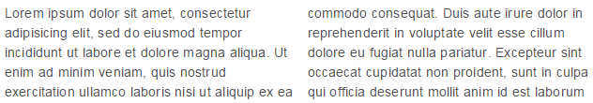
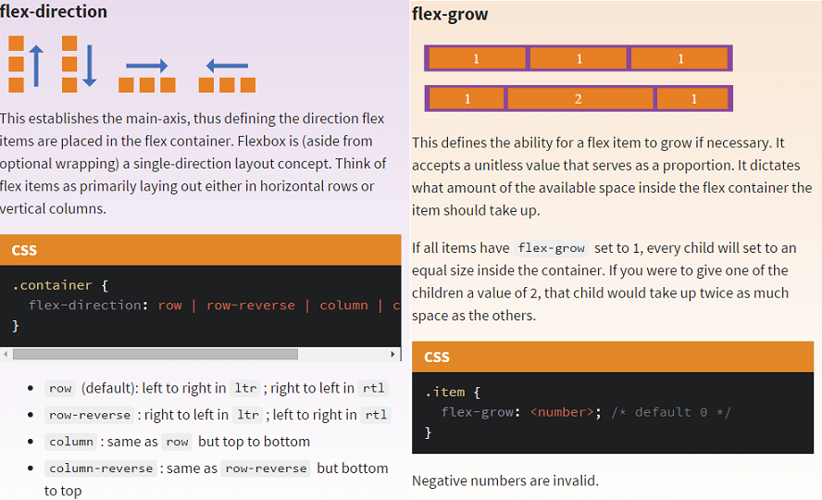
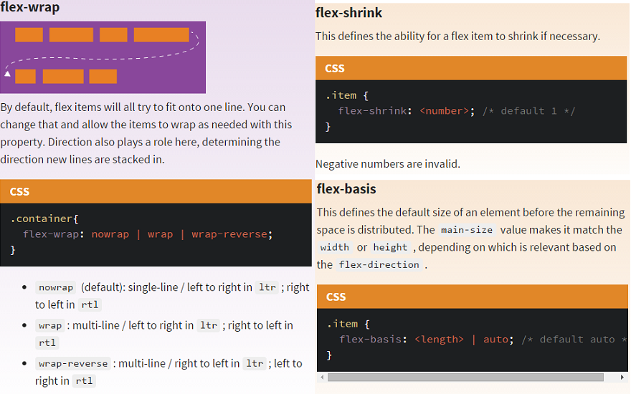
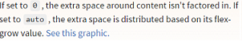
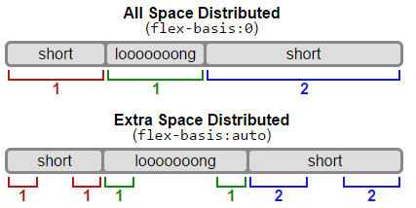
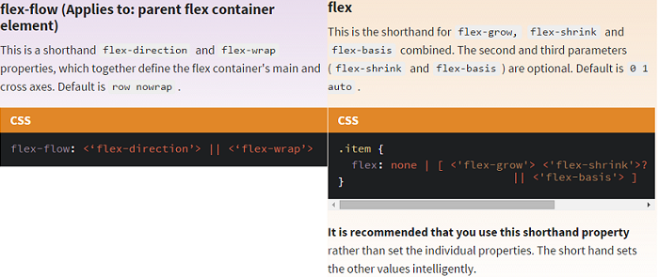
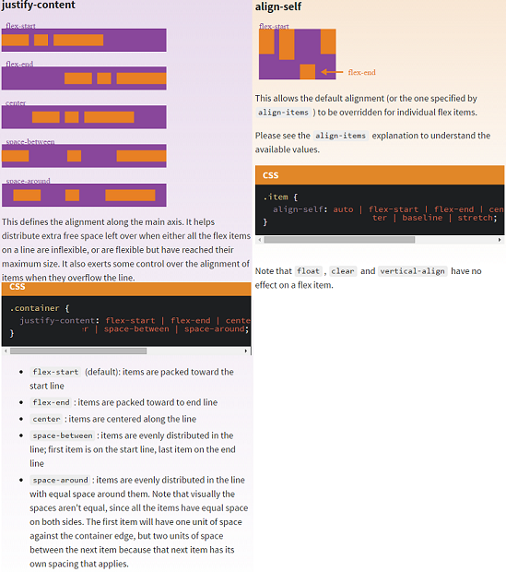

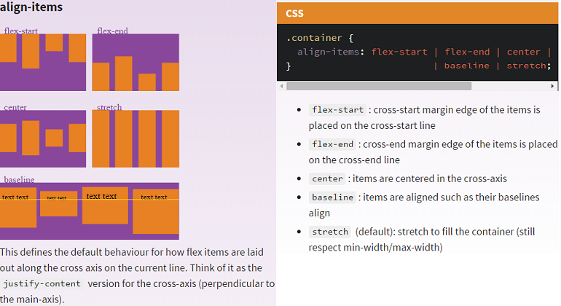
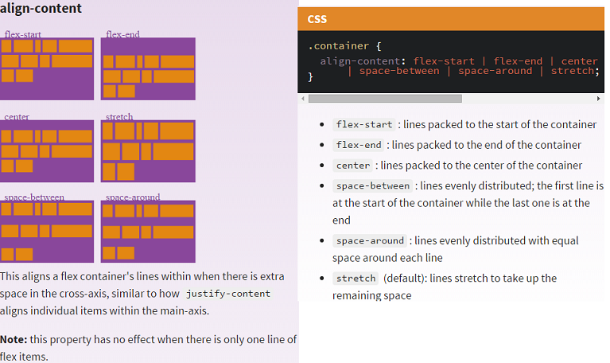

Q) What's the difference between align-content and align-items?
A) Align-content aligns a flex container's lines within the flex container when there is extra space on the cross-axis. This property has no effect on single line flexible boxes. Align-items aligns flex items of the current flex line the same way as justify-content but in the perpendicular direction. This is the difference between the two.
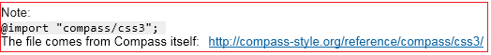
Now let's use some more properties. Consider a list of 6 items, all with a fixed dimensions in a matter of aesthetics but they could be auto-sized. We want them to be evenly and nicely distributed on the horizontal axis so that when we resize the browser, everything is fine.
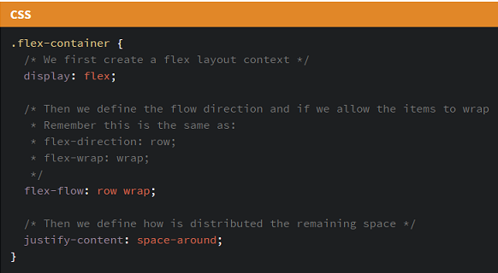
Done. Everything else is just some styling concern. Below is a pen featuring this example. Be sure to go to CodePen and try resizing your windows to see what happens.

You can remove bullets by setting the list-style-type to none on the CSS for the <ul> element, for example
ul
{
list-style-type: none;
}
You might also want to add padding:0; margin:0; to that, if you want to remove indentation as well.
See http://css.maxdesign.com.au/listutorial/index.htm ,for a great walkthrough of list formatting techniques.

Example:

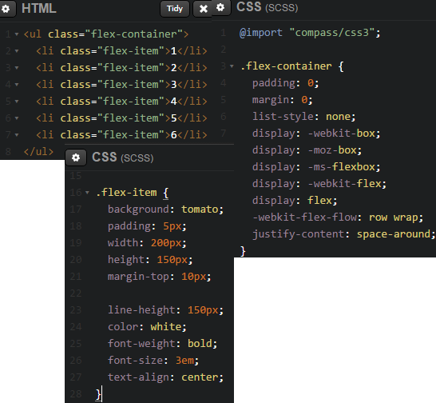

Output:
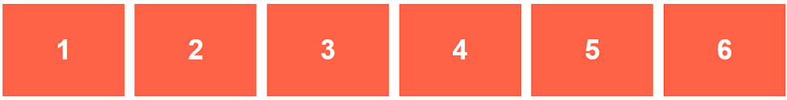

Let's try something else. Imagine we have a right-aligned navigation on the very top of our website, but we want it to be centered on medium-sized screens and single-columned on small devices. Easy enough.

