Angular 2

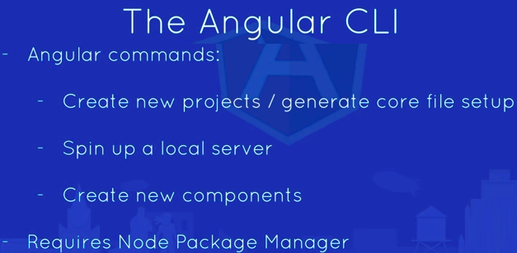
> npm install -g @angular/cli
https://github.com/angular/angular-cli/wiki/new
https://stackoverflow.com/q/47129041/3317808
https://github.com/angular/angular-cli/releases

$ node -v
v6.11.5
$ npm -v
3.10.10
$ ng --version
_ _ ____ _ ___
/ \ _ __ __ _ _ _| | __ _ _ __ / ___| | |_ _|
/ △ \ | '_ \ / _` | | | | |/ _` | '__| | | | | | |
/ ___ \| | | | (_| | |_| | | (_| | | | |___| |___ | |
/_/ \_\_| |_|\__, |\__,_|_|\__,_|_| \____|_____|___|
|___/

Angular CLI: 1.5.0
Node: 6.11.5
OS: linux x64
Angular:
...
$

Use angular-cli tool to create angular project:
> ng new angular-project

