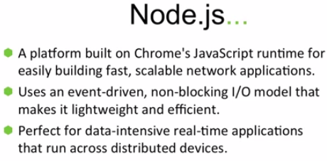

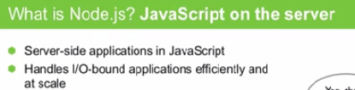

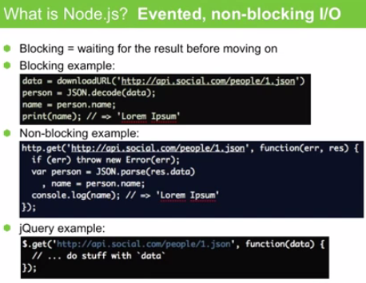

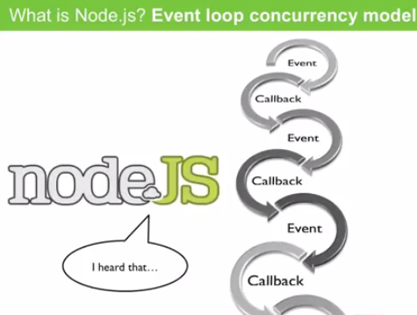

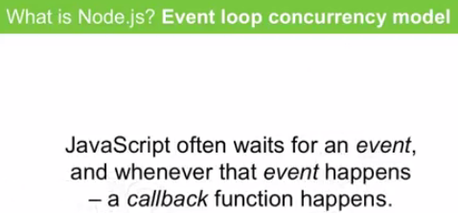

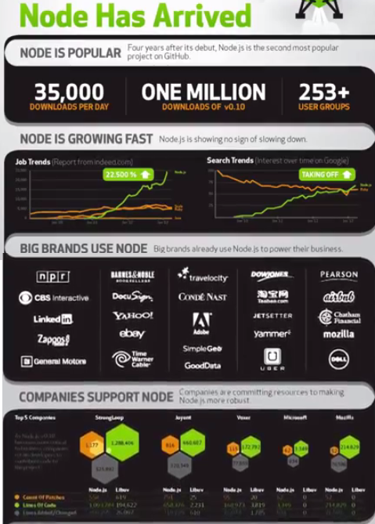

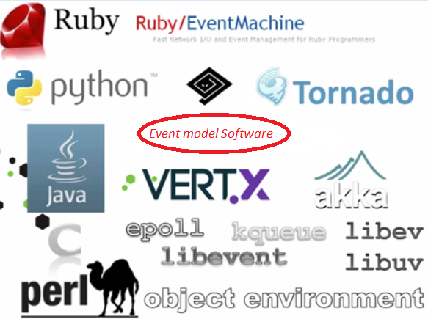
When multiple languages have such libraries, why NodeJS? It is the community that makes difference.
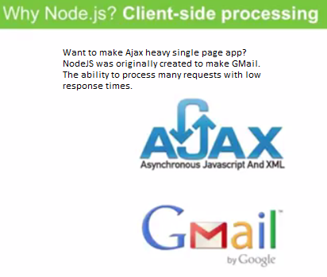
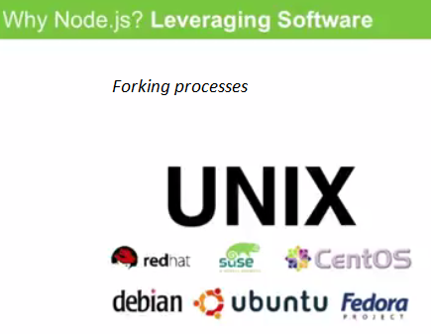

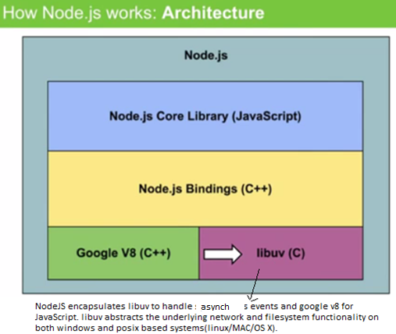

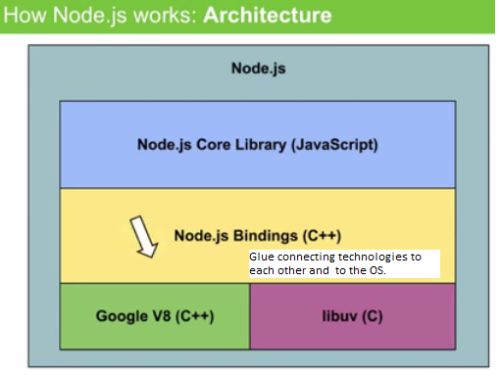
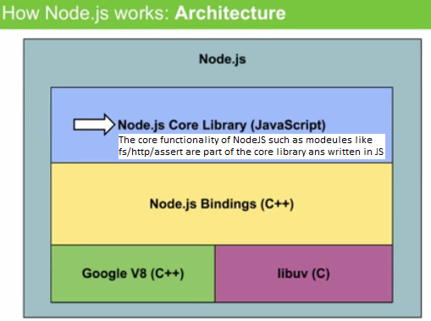

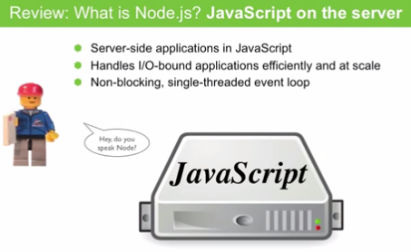

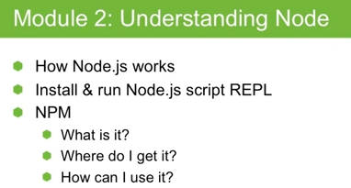

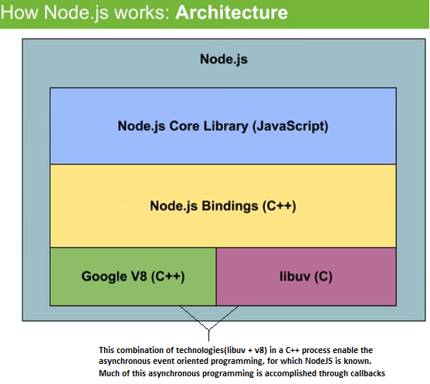
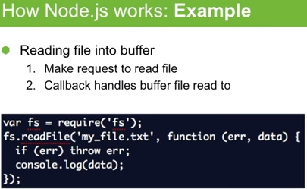

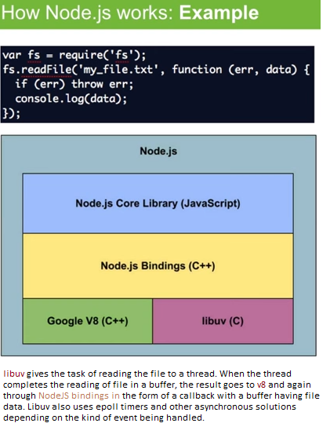

Event loop in NodeJS:
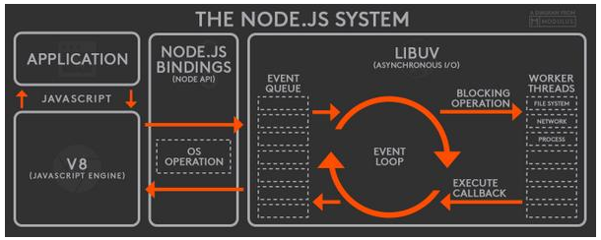

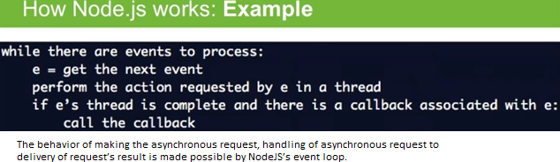

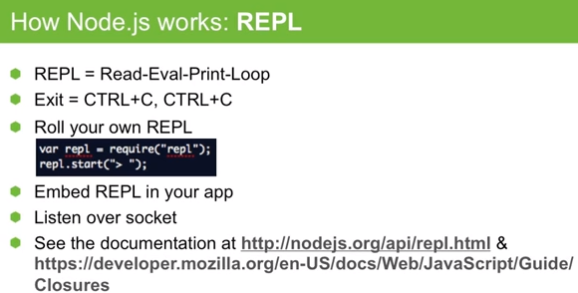

Front end code deployment using NodeJS
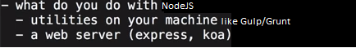
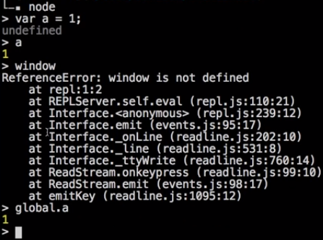

How to make scripts.js available to html using node modules?
Example1:
module_loaders/js/module2.js:
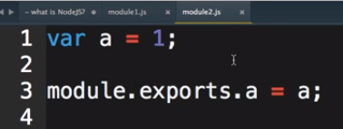

module_loaders/js/module1.js:
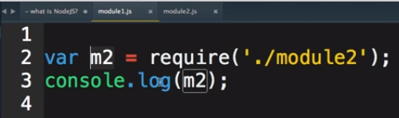
Example2:
module_loaders/js/Module2.js:
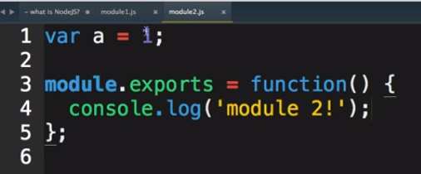
module_loaders/js/Module1.js:
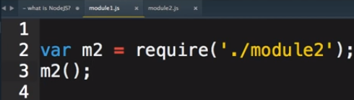

module_loaders/Index.html:
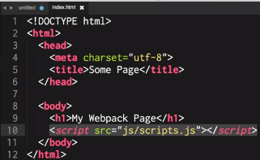
Where module_loaders/js/scripts.js is:
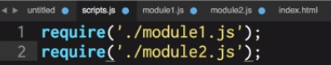
In folder(module_loaders) run npm init and create package.json
Install webpack(npm install –S webpack) with webpack config as
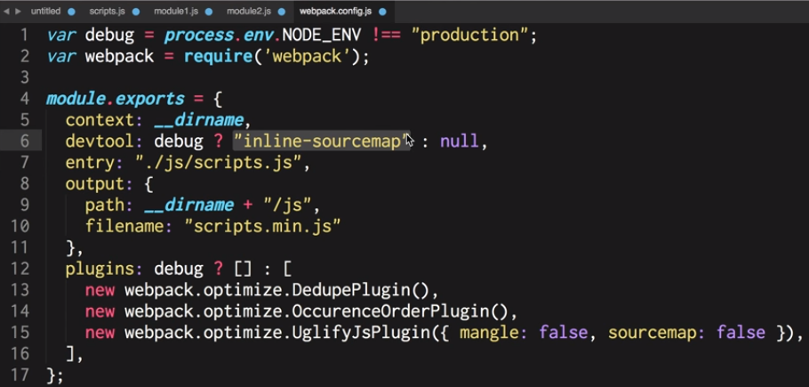
>webpack
> open index.html

npm – Node package manager:
- npm init
creates package.json file that manages dependencies.
package.json will allow you to manage NOT downloading node modules from github. You do not need to run npm install XYZ for every dependency. npm install would install all its dependencies given in package.json.
Before you check-in package.json file to github, you need to run “npm install XYZ –S”, to install XYZ as well as save the dependency in package.json. So that, when you check out package.json, you just need to run “npm install”.

