Pipes in Angular:

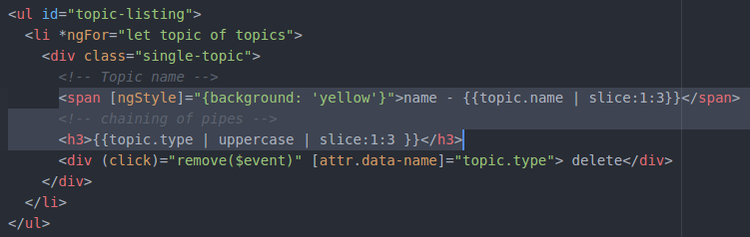

Custom filter pipe in Angular:

../ninja-directory$ ng generate pipe filter
create src/app/filter.pipe.spec.ts (187 bytes)
create src/app/filter.pipe.ts (201 bytes)
update src/app/app.module.ts (656 bytes)
../ninja-directory$

and update filter.pipe.ts as shown below:

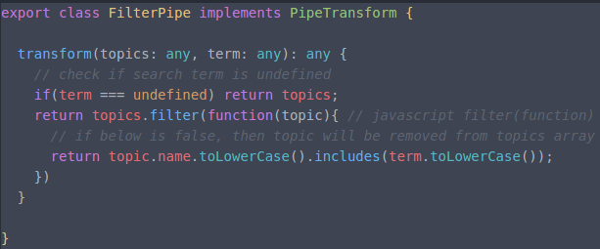

Below is the component view:

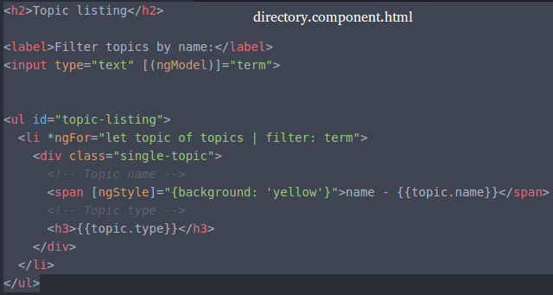

Below is the component class:

