Component based architecture
One of the main architectural principles in Angular 2 is that an application should be composed of well encapsulated, loosely coupled components. This principle is obvious in the backend world, but it is not yet well established in the frontend development.

In this article, we discuss the advantages of this approach, show how easy it is to write components in Angular 2 and share our experience about how it worked for us in practice. In particular, we give some hints, whether or not something deserves to be a separate component.

Application as a Tree of Components
In Angular 2, the UI of an application is a tree of components. Let us consider a very simple application for ordering lunches to your office. The user is presented with a list of available meals, each of them with some details, such as meal name and photo as well as nutrition information and a summary of the current order. Additionally, there is a separate widget with a promoted meal of the day. Once the user makes her choice, the order details are updated.

A UML 2 class diagram of the components in such an application could look as follows:

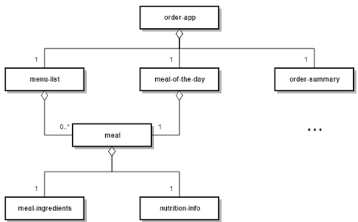

Here, the whole application is a component (order-app) that hosts two other components: menu-list and order-summary. The menu-list implements the functionality of the list of meals, but it does not bother with the logic behind a particular a meal – it delegates this to the meal component. The meal component employs even more specialized components to handle functionalities and behavior of cohesive elements such as the nutrition information. Note how the meal component is reused in menu-list and meal-of-the-day.

Benefits of Component-based Architecture
Component-based architecture has similar properties and gives us similar benefits as a proper Object-Oriented Model. Good components have high cohesion, i.e. each component contains only elements with related functionality. They are also well encapsulated and loosely coupled. They provide a clean API that does not reveal the component’s internal state.

Advantages of this approach include:
- reusability: it often happens that we need to expose the same functionality in multiple places in the application. If we have a component that does this, we can re-use it in all these places. We would save time for development and maintenance and have a more consistent application. The reusability is especially important when building large-scale enterprise applications. A component can be very generic (e.g. a list with sorting and pagination or a datepicker) and thus reusable across multiple, even unrelated, systems. The component can be also domain-specific and reusable only within this particular domain.
- testability: it is much easier to unit-test a component with well-defined API and a small set of responsibilities than an unstructured application.
- readability: well encapsulated and specialized components are much easier to understand than a poorly structured application. When the components are arranged in a proper package structure, the code becomes easy to read even for new developers.
- maintainability: components in a loosely coupled system can be easily replaced with alternative implementations.

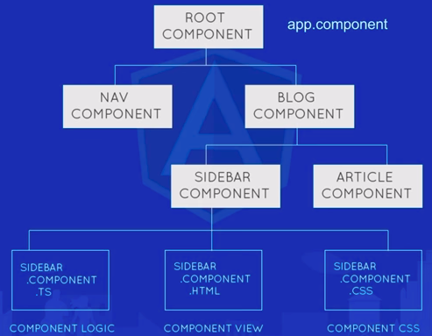

http://www.sparkbit.pl/component-based-architecture-angular-2/

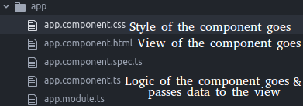

Create a new component:
../src/app$ ng generate component home
create src/app/home/home.component.css (0 bytes)
create src/app/home/home.component.html (23 bytes)
create src/app/home/home.component.spec.ts (614 bytes)
create src/app/home/home.component.ts (261 bytes)
update src/app/app.module.ts (388 bytes)
../src/app$

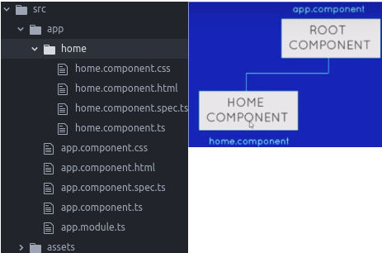

where the logic of home component looks like:
@Component({
selector: 'app-home',
templateUrl: './home.component.html',
styleUrls: ['./home.component.css']
})

Copy the sleector `app-home` in root component html.
<section id="main">
<app-home> </app-home>
</section>
How root component knows about the creation of nested component?
> In later versions of Angular2, new components are imported automatically upon creation.

Component and modules
https://angular.io/guide/architecture
https://stackoverflow.com/a/47307163/3317808
https://stackoverflow.com/a/47341327/3317808

