To manage dynamic data, we need data binding

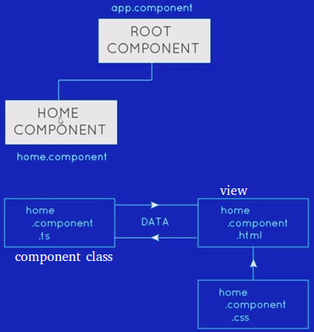

Data flow (INTO THE VIEW)
- String interpolation - {{title}}(always resolves to a string)
- Property binding – Bind to html properties
Example:
<input [required]=’expression’> // Native html porperties
<input [ngClass]=’expression’> // Built in angular directives
<input [myProp]=’expression’> // Custom-made properties

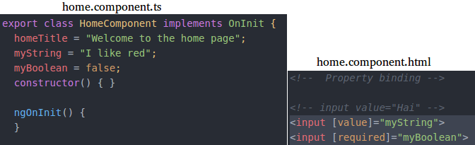

Data flow (OUT OF THE VIEW)
- Event binding – Bind events to html elements
1) Bind to native events - <button (click) = ‘function’>
2) Bind to custom events - <app-home (update) = ‘function’></app-home>
Component class can handle this event, by firing that function

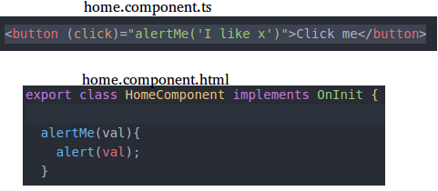

Data flow (BOTH WAYS)
Two-way data binding - <input [(ngModel)] = “model/object”>
1) From view to component class - Updates the model/object in the component class
2) From component class to view – Updates any reference to the model/object in the view/template
https://stackoverflow.com/a/47310755/3317808
if you want to use ngModel inside the form tags, either the name attribute must be set or the form control must be defined as 'standalone' in ngModelOptions
https://stackoverflow.com/a/47324991/3317808

Above 3 kinds of data flow occured within a component. What about data flow between components?
> We can do that using custom property binding & @Input decorator., to pass data from root component to home component, into the view.

Customer property binding from root component into home component(into the view):

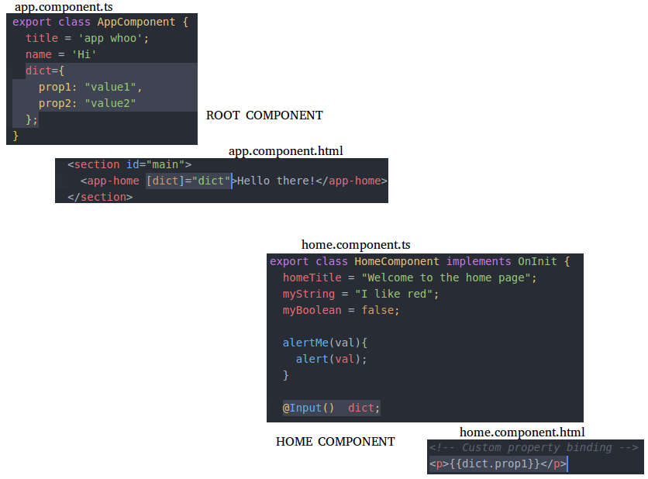
In this approach, passing data from parent to child with input binding is main approach for component interaction.
https://stackoverflow.com/a/47320006/3317808

Custom event binding(OUT OF THE VIEW)
In this approach, passing data from child to parent with output binding is main approach for component interaction.

Flow is like this:

