DRY principle:

Component1: Component2:
Does something Does something else
Connects to the database Connects to the database

Apply DRY principle:



Create a service:
../src/app$ ng generate service logging
create src/app/logging.service.spec.ts (380 bytes)
create src/app/logging.service.ts (113 bytes)
../src/app$

Procedure:
https://coursetro.com/posts/code/20/Angular-2-Services-Tutorial---Understanding-&-Creating-Them

Injecting service in every component instantiates the separate service instance.
In order to avoid injecting service in every component, perform the following changes in AppModule
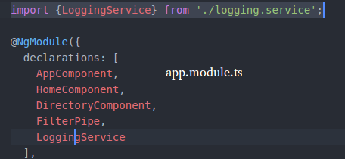

that will instantiate service only once.

