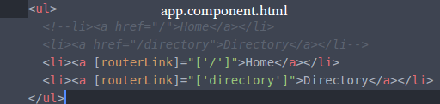

Customer property routerLink custom property will not request page from server on clicking the link.

