Directives are instructions which tell Angular to do something
Ex:
<router-outlet></router-outlet>
[routerLink]=””

Types of directive
Attribute directives: Interacts with the element it is on to change it’s properties Eg: ngClass
Structural directives: Changes the structure of the HTML code Eg: *ngIf, *ngFor

Example 1: Attribute directive

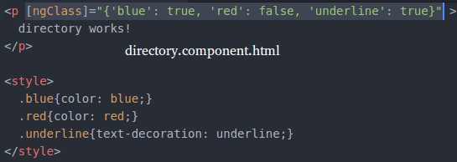

Example 2: Attribute directive

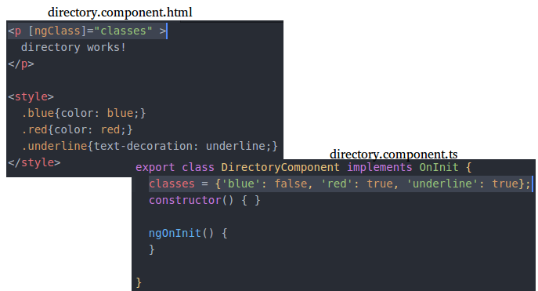

Example 3: Structural directive

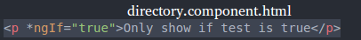

Example 4: Structural directive
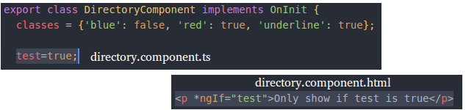

Example 4: Structural directive
