Front-end development is one of the fastest evolving aspects of modern web development. It seems like there is a new framework or methodology every other week built to solve the issues around this relatively new technical area.

In the dark ages of web development, front-end development was something either flogged off onto over-burdened designers, or hacked on by exhausted software developers. Not ideal, and unfortunately many web projects are still scattered with the results of this way of thinking.

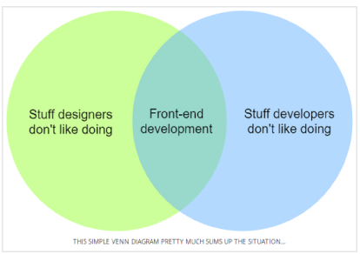

Those were grim times.
Fast-forward to the present day and look at the tools and resources we have available.

To think of producing design and code of the highest standard. This permeates into how we approach our workflow.

We’ll look at:
- Four key areas of a front-end workflow:
- Design
- HTML and CSS
- JavaScript
- Post-deployment maintenance
- How to make front-end development accessible to all members of your team
- How these tools improve code quality, help to reduce bugs in a web application and generally result in a higher quality product

Let’s dive in…

Step 1: Web page design phase (Sketch and Zeplin):

Two web-oriented design tools into our workflow: Sketch and Zeplin.
These two tools are very vital to our front-end development process.

Here’s a brief summary of each for context:
- Sketch is a digital design app built from the ground up with web in mind
- Zeplin is a collaboration tool to share designs across a team
Sketch is an app that's Mac OSX only. Figma can import Sketch files. It's web-based and should work fine on Ubuntu as long as your browser supports WebGL. I would recommend a free web-based photo editor Photopea, that can open Sketch files. After opening, you can edit it, save as JPG, PNG, SVG, PSD, etc...

Read more about using Sketch, here. Read more about using Zeplin, here.

These tools are not only great for cutting down design time, they make it easier to extract resources, ascertain dimensions and are largely web-focussed. No more pt to px conversion, inconsistent rendering of fonts, or soul-crushing frustration of building something from an out-of-date design mock-up.

Sketch makes designs easier to work with, Zeplin let’s you measure and extract assets from an up-to-date mock-up.

Website optimisation starts at the web page design phase. Read more for web design guidelines before designing sketches.

Step 2: Converting sketch to html & css
Read this step completely before converting the sketch to html & css. Read more.

Say, if this is a Django(backend) project, then html & css code goes as part of templating and maintaining static files of Django project. Django(python) is a MTV framework.
So, that means, before starting step 2, Django development project (backend) should get into git repo, with required apps, where each app should be ready with their view & model Component.

Models of each django app are designed based on the outcome of step 1 :
- Database table (RDBMS) or document (MongoDB) schema design relies on fields of each web page
- Fields part of a single form would drive a document/table schema design, preferring performance over normalisation of database schema
- Fields that are logically divided in each webpage, drive database schema of tables/collections

View of each dhango app is controller(aspect of MVC) in Django, as you already know this.

So, step 2 burns its story points in agile approach parallel to backend project(Django) story points. Just FYI.... django development process, provided here.
Agile SCRUM framework involves addaptive planning, but not predictive planning.
If you can easily list all requirements use Predictive Planning.

There have been a few CSS methodologies around for a while now, these three stand out as the most popular:

- OOCSS - Object oriented CSS
- SMACSS - Scalable and modular architecture for CSS
- BEM - Block element modifier

When followed closely, the first two in this list have been used to great success in web design. But when it comes to building apps in a large team of engineers, BEM is by far the easiest and most scalable methodology to follow.

Read more on performance issues to consider, for html & css.

Step 3: Adding JavaScript/jQuery make pages dynamic

For Javascript/jQuery/Angular, follow,
https://stackoverflow.com/a/15012542/3317808
https://stackoverflow.com/a/28989557/3317808
https://stackoverflow.com/questions/46024821/angularjs-dont-design-the-page-and-then-change-it-with-dom-why

