Courtesy: http://www.aptivate.org/webguidelines/Introduction.html

GUIDELINES

Introduction
High-Level Design
Search
HTML
Style Sheets (CSS)
Images
Compression
Caching
PDF Optimisation
Downloads
Multimedia
Scripting
Using Tools
Browser Compatibility
Glossary

Introduction
These guidelines should help you design and build websites that are fast, easy to use and work over low bandwidth connections.

The Parameters
We need to make pages load fast, but how fast?
Forty years of research into Human Computer Interaction has found acceptable response times of computer systems, based on the limits of human attention. Jakob Nielsen's on-line article "Response Times" gives a good introduction. Research has found that users will abandon web pages that take longer than 10 seconds to load. However, if useful data starts to appear within 2 seconds, they are prepared to wait up to 30 seconds for the page to finish loading. Read more.
In summary the golden rules are:
- pages must load within 10 seconds
- incrementally displayed pages must show useful content within 2 seconds and complete loading within 30 seconds.
Page loading speed is determined by the size of the page, the number and size of external files it references (JavaScript, style sheets, images and multimedia), and two properties of the user's Internet connection (bandwidth and latency).
Internet connections vary around the world. In Kenya, at the time of writing, all international connections are routed through high latency satellite links. This means that the minimum page loading time in Kenya is about two seconds - making it easier to fulfill the first rule than the second.
How large can pages be and still load within 10 seconds?
The quick answer is 25KB.
The size depends on the available bandwidth. It is hard to make a good estimate of available bandwidth. We chose to base our estimates on African Universities because there are recent surveys of their available bandwidth. Also a number of initiatives supply educational information to these universities (the African Digital Library, AGORA, HINARI, JSTOR and PERI) which are affected by a lack of bandwidth.
According to the African Tertiary Institutions Connectivity Survey (ATICS 2006)(survey) the average bandwidth available to an African university is 1254kbps. On average, there are about 600 connected computers in each university. Assuming that 1 in 20 of these computers is using the Internet at any one time (based on ADSL contention ratios), this would give each user about 40kbps on average.
However most universities do not have a Committed Information Rate so their true bandwidth is roughly half of the stated bandwidth they have bought. Many developing world institutions are not implementing effective bandwidth management practices which further reduces available bandwidth(read more).
We arrive at a figure of 20kbps as a sensible upper limit on bandwidth available to the user, which is consistent with our experience.

Page Size Limits
Taking into consideration the desired response times at 20kbps gives us the following upper limits on page size:
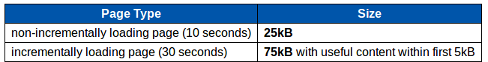
These limits are for the total page including images, external JavaScript files and external CSS files. Sharing images, script files and CSS files between pages is encouraged, as it allows them to be cached by the user's browser and reduces the loading time of subsequent pages. They should still be counted in the page size because they will slow down each user's first page view of your site, affecting their first impressions.
The Webpage speed report advises:
"Consider reducing total page size to less than 30K to achieve sub eight second response times on 56K connections. Be sure to provide feedback for pages over 30K by layering your design to display useful content within the first two seconds."

Size Indicators
Any object over 75KB, such as an image or PDF document, could take upwards of 30 seconds to load. Usability research suggests that users will often abandon processes that take more than 30 seconds without feedback. All links to objects over 75kB should, at the very least, be clearly labeled with the size of the object, for example:
PDF Optimisation

Accessibility
Websites should cater for access by people with disabilities. Designing for accessibility and designing for low bandwidth can be very similar, but please note that we have not attempted to include guidelines for accessibility within our low bandwidth guidelines. The WebAIM project provides guidelines on designing for accessibility.

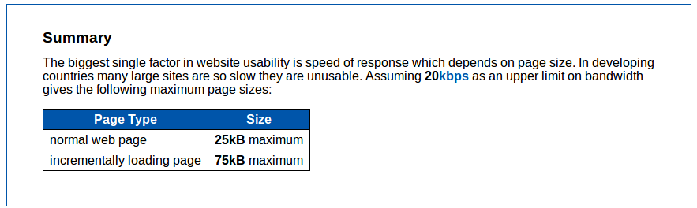

High-Level Design

Introduction
Web site optimisation starts at the design stage. Before discussing details of how to optimise HTML, CSS or images, we should consider how high-level design decisions will affect the bandwidth use of your site.

Site Structure
Like a good road network, your website needs to be well connected and signposted. By providing a logical hierarchy to the pages on your website you will save your users from wasting bandwidth by loading unnecessary pages before finding the one they want.
Before deciding upon the visual aspect of your site navigation, it's important first to have organised the pages of your website into a logical hierarchy.
If possible, ask a few potential users of your website to help in this process. Give them a list of your pages and ask them to categorise the pages into groups. Then ask each of the users to name the groups. These groups and names will help you design the menus and links that will make up your website's navigation.
For example, the website for an online publisher of journals might have the following structure:
Most Popular Journals
- Journals A-Z
  - Journals A
  - Journals B
  - ...
- Journals by Subject
  - Arts
    - Applied Arts
      - Design
      - Photography
      - ...
    - Architecture
    - ...
  - Business
    - ...
  - ...
- Search Catalogue
- About us
- Contact us
Navigation to any area of the site should be both intuitive and achievable and take only a few steps so that downloading time is minimised. In the example above, the most popular journals could even be linked directly from the front page, making the download only one step away. The A-Z index would allow users to look up journals where they know the title. The subject index would provide an alternative method where the title isn't known. The search facility would by default allow users to search for journals by keyword, with maybe an advanced search option to restrict the search by article author or date.
If your website links to documents on another site, it should still be possible to access them in a minimum number of steps. Ideally, the documents should download directly from a link on your website, without the need for the user to navigate through the linked website.

Stress-free Navigation
The navigation of your site should still work with JavaScript disabled and without third-party plugins such as Adobe Flash Player installed in your web browser.
Users want to find the information they are looking for quickly and without having to go through intermediate steps, such as filling in contact details for registration or logging in. If certain areas of your site are restricted to registered users, warn them of this but don't force them to register or log in until the final stage when they have found the information they are looking for. Users are less likely to log in or register their details if there is no incentive for them to do so.

Language
Depending on your target audience, it may be necessary to make your website available in several languages. Users should be able to visit a particular language version of your home page without the need first to load the page in the default language. Make it clear if certain areas of your website are only available in one particular language.

Further Improvements
Good website structure and intuitive navigation are key to a successful design. For larger websites, these can be complemented with a site map or site index and search facility, which we discuss in the Search chapter.

Static and Dynamic Content
Static pages are pages that do not change. Dynamic pages are created on the fly with scripting languages such as PHP.
Taking a static approach allows the user to cache the content, reducing their bandwidth use and speeding up loading. We explain more about caching in the Caching chapter.
Sometimes scripting is used to serve up what are essentially static pages. For example, news sites may have archives of news articles which are stored in a database. Server-side scripts will generate web pages from the contents of the database. But the individual news article pages are effectively static. Content Management Systems (CMS) or server-side scripts will generate these pages in a way that will stop the user from being able to cache them. For instance they will not set an Expires or Last-Modified header or disable caching.
Static content also allows the web server to work out the length of the file and send a Content-Length header. The browser can then display progress while downloading the page. This is important for large pages. If the user doesn't see some sign of progress within 10 seconds, they are likely to give up or reload the page.

Minimise HTTP Requests
Each resource of your website requires an HTTP request and response to fetch it. That is every image, CSS file, JavaScript file and HTML page requires a separate HTTP request. Each request has an amount of overhead and latency associated with it. Too many requests will add delays to page loading. It is important to consider how HTTP requests can be kept to a minimum. Try to design pages that do not require too many resources. CSS files can be combined to reduce latency. This is also true of JavaScript files and images.

Screen Size
According to W3Schools[1], 14% of their visitors still have 800x600 screens, and this is from a community of web developers one would expect to be using higher-resolution displays than the average web user. We estimate that 30% of users within the developing world have a screen resolution of 800x600.
In general it is best practice to design your site so that it resizes smoothly to any browser window size. Where you need to specify a size, it is usually best to give it as a percentage (of the container element); second best is a measurement in ems (calculated from the font size of the element), and the least preferred option is to give a measurement in pixels. It is a good idea to test your website with different font sizes and browser window sizes to ensure that it remains usable over the widest possible range.
However if you are designing your site to a fixed screen resolution then we would advise designing for 800x600 resolution.

Summary
- Good site structure and navigation will reduce bandwidth used
- Use static rather than dynamic content where possible
- Minimise the number of HTTP requests
- Make your design resolution independent or design for 800x600 screen resolution

Search

Introduction
Good structure and navigation are essential to a well-designed website. When implemented properly, a simple search facility and a site map will provide users of larger websites with alternative means to find what they are looking for easily.

Search Facility

Search Box
A search box for your site should be visible from all pages and, in particular, visible on the main page. By placing the search box at the top of each page, alongside the main navigation menus, your users will be able to start a search before the page has finished loading.
The default search should be simple so that your users can just type a few keywords into the box and submit the search, without having to learn any complicated search syntax. An advanced search, linked from the main page, will allow users to perform more powerful searches and find documents quickly and accurately.
A flawed search engine, which produces no results when matching documents obviously exist is frustrating and will cause users to lose confidence in your site. It's better to have no search facility than a broken one. Test your search engine for known keywords to make sure it picks up documents you know to exist. If you do not wish to provide your own search engine, use an established one such as Google's Free SiteSearch. For example, adding these lines to your page:
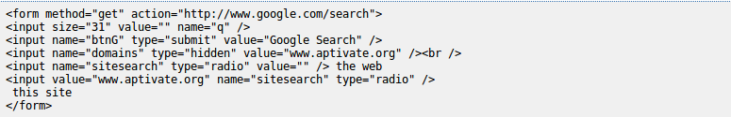
will produce a search facility like this:


Submitting the Search
Once the search is submitted, avoid displaying an intermediate page saying Please wait... before the search results appear. This will only add to the delay. Most browsers have built-in animation to indicate that a search is in progress.

Search Results
The search results page should not contain so many results that they take a long time to download and display or so few that the user has to download several pages of results before finding the one they want. 20 results per page is a good compromise. Over a low bandwidth connection, it should be possible to read the first search results whilst the rest of the results are being downloaded.
The search results should contain a summary of each document in the form of a preview or extract, which will allow the user to select the most relevant documents to download without having to spend time downloading entire documents.

Metadata
Use of document metadata can also help users locate documents relevant to their needs. Document metadata are data that describe a document such as a PDF. Examples of such metadata are a short description of the document and the search terms (keywords) that may be used to locate it. The accuracy of the metadata is of key importance if this approach is used, particularly in the case of scanned documents where no plain text is available for searching. For HTML and PDF documents, it is important that the title accurately reflects the contents of the document as search engines will make use of this. Some search engines may also use HTML META tags, such as keywords and description. However these are subject to abuse by unscrupulous websites attempting to draw more traffic to them by using false keywords and so search engines tend to place less emphasis on them or ignore them altogether. The PDF standard also allows for metadata but there is no evidence to suggest that these are actually used by search engines.

Offline Search
With larger projects and repositories of information, it is possible to make an offline search interface to a website or document repository, which installs on the user's computer and allows them to search for documents without needing Internet access. This could be made available for download from the website and could also be distributed on CD-ROMs. Moving the online searching process to the local computer is much more efficient in situations where Internet connectivity is a problem and where the repository is likely to be used regularly within an institution. Since a significant effort may be required to achieve this, it is often worthwhile to carry out research into patterns of usage by institutions currently accessing website content. This will help you to identify the number of regular users in low bandwidth environments who might benefit from an offline approach.

Site Map
Another method to allow users of your website to find information quickly is to provide a site map linked from the main page, which is a table of contents for your site. Obviously the site map must be kept up-to-date with any changes to the structure of your website. Only consider adding a site map if you can be sure of this. As with the search facility, not including a site map is better than including a broken one.

Summary
A search facility may reduce the number of pages needing to be downloaded to navigate to desired information if:
- Basic searches are keyword-based and simple to use
- The box or link is visible and accessible from the top of a website's main page
- A search query returns about 20 results per page
- Results provide adequate metadata for users to recognise their desired page
As a rule, no search box or site map is better than a broken one.

