DOCTYPE declaration
https://www.w3schools.com/tags/tag_doctype.asp

Inline elements:
- Do not start on a new line
- Take only the necessary width
Ex: <span>, <img>, <a>,<em>, <strong>.<label> <input>

Block elements:
- Start on a new line
- Take full width available
Ex: <div>, <h1> to <h6>, <p>, <form>.

Tag attributes:
- All tags can have attributes
- Provide information about an element
- Placed within the start tag
- key/value pairs(Id = “some Id”)

We use to use <table> to create website layouts. That is not recommended any more. Go through web design history, for more.

<form> tag:
With HTML, we can only contribute for actual look of the form. To add functionality, we need PHP, Java in the backend. The action and name attributes within form tag are used by server side programming. The type attribute sometimes add validation. For ex: <input type="email" name="email"></input>

value attribute is visible in the text box that has to be removed(onclick()) using JavaScript. placeholder attribute in html5 solves this problem, by showing it gray. Onclick, it the value vanishes.

HTML5 semantic tags:
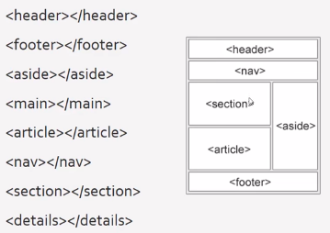

A semantic element clearly describes its meaning to both the browser and the developer.

