For this code,
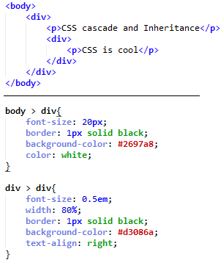
Specified, computed, used & actual values for font-size & width are, as shown below:
