Boxes
When your browser displays an element, the element takes up space. There are four parts to the space that it takes up.
In the middle, there is the space that the element needs to display its content. Around that, there is padding. Around that, there is a border. Around that, there is a margin that separates the element from other elements.
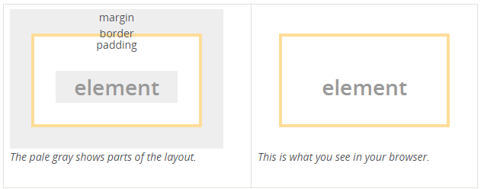

All html elements are rectangular. Each html tag is an element in a DOM.

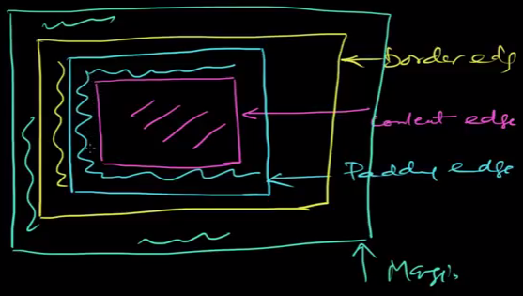

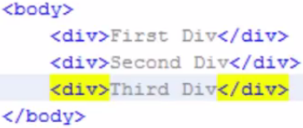

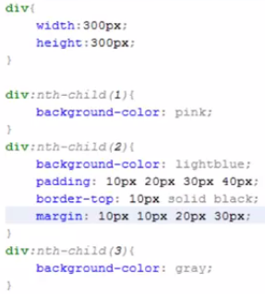

Q) Why does any html element require padding & border? Would margin that creates white space between any two boxes do not suffice?
Answer

A) Not if you also need a border, or some padding.
Though it is true that both margin and padding create space, there is a difference between where they create space. And that difference is the border.
A border, as the word already implies, is to create a visible border. Padding creates space between said border and the content within. But padding can also be used to create some room around an element when it has a background, for example.
To better illustrate the differences, I'll create a couple of snippets:

Below snippet has no border, margin or padding, so no spacing.
.row {
background: red;
}

.column {
background: green;
}

.blue {
background: blue;
}

<div class="row">
<div class="column">
Some text
</div>
<div class="column blue">
Some other text
</div>
</div>

Below snippet has margins, giving it some space around the element, which is evident because of the background colors.

.row {
background: red;
}

.column {
margin: 10px;
background: green;
}

.blue {
background: blue;
}

<div class="row">
<div class="column">
Some text
</div>
<div class="column blue">
Some other text
</div>
</div>

Below example has both a margin and a border, giving you a wider range of coloring options, as well as more space. Yet, you would be unable to give the different spaces a different color with just a margin.
.row {
background: red;
}

.column {
margin: 10px;
border: 5px solid purple;
background: green;
}

.blue {
background: blue;
}

<div class="row">
<div class="column">
Some text
</div>
<div class="column blue">
Some other text
</div>
</div>

Below example has it all. As you can see, the padding creates space within the box, inside of the border. Added to that, you can also see more of the background color of the element.
.row {
background: red;
}

.column {
margin: 10px;
border: 5px solid purple;
padding: 20px;
background: green;
}

.blue {
background: blue;
}

<div class="row">
<div class="column">
Some text
</div>
<div class="column blue">
Some other text
</div>
</div>

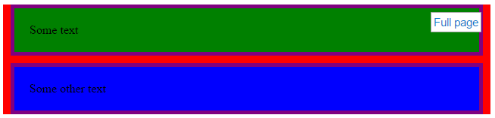

Q) Why margins collapse?

A)
Each one of those properties controls a different aspect of the box.
Margin
The margin clears an area around an element (outside the border). The margin does not have a background color, and is completely transparent. The top, right, bottom, and left margin can be changed independently using separate properties. A shorthand margin property can also be used, to change all margins at once.
Padding
The padding clears an area around the content (inside the border) of an element. The padding is affected by the background color of the element. The top, right, bottom, and left padding can be changed independently using separate properties. A shorthand padding property can also be used, to change all paddings at once.
Border
The CSS border properties allow you to specify the style, size, and color of an element's border.

To better illustrate the differences, below are the couple of snippets:

1) This snippet has no border, margin or padding, so no spacing.

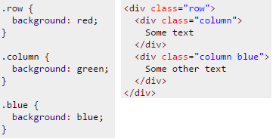

2) This snippet has margins, giving it some space around the element, which is evident because of the background colors.

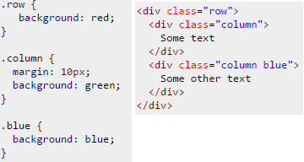

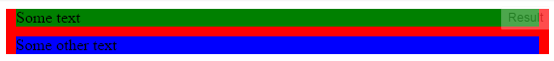

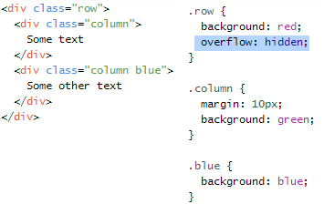

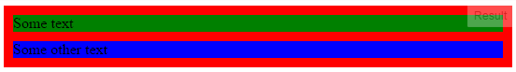
Here are the relevant points from the W3C spec:

8.3.1 Collapsing margins
In CSS, the adjoining margins of two or more boxes (which might or might not be siblings) can combine to form a single margin. Margins that combine this way are said to collapse, and the resulting combined margin is called a collapsed margin.
Adjoining vertical margins collapse [...]
Two margins are adjoining if and only if:
- both belong to in-flow block-level boxes that participate in the same block formatting context
- no line boxes, no clearance, no padding and no border separate them
- both belong to vertically-adjacent box edges, i.e. form one of the following pairs:
  - top margin of a box and top margin of its first in-flow child
The reason why doing any of the following prevents the margin from collapsing:
- Floating either of your div elements
- Making either of your div elements inline blocks
- Setting overflow of #outer to auto (or any value other than visible)
Is because:
- Margins between a floated box and any other box do not collapse (not even between a float and its in-flow children).
- Margins of elements that establish new block formatting contexts (such as floats and elements with 'overflow' other than 'visible') do not collapse with their in-flow children.
- Margins of inline-block boxes do not collapse (not even with their in-flow children).
The left and right margins behave as you expect because:
Horizontal margins never collapse.

Q) When to use margin vs padding in CSS
A) To me the biggest difference between padding and margin is that margins auto-collapse, and padding doesn't. Consider two elements next to each other each with padding of 1em. This padding is considered to be part of the element, and is always preserved. So you will end up with the content of the first element, followed by the padding of the first element, followed by the padding of the second, followed by the content of the second element. Thus content of the two elements will end up being 2em apart.
Now replace that padding with 1em margin. Margins are considered to be outside of the element, and margins of adjacent items will overlap. So in this example you will end up with the content of the first element followed by 1em of combined margin followed by the content of the second element. So the content of the two elements is only 1em apart.
This can be really useful when you know that you want say 1em of spacing around an element, regardless of what element it is next to.
The other two big differences is that padding is included in the click region and background color/image, but not the margin.
By default I use margin everywhere, except when I have a border or background and want to increase the space inside that visible box.

Margin is on the outside of block elements while padding is on the inside.
- Use margin to separate the block from things outside it
- Use padding to move the contents away from the edges of the block.


By default,
Width of an element = (left border width + left padding width + content width + right padding width + right border width)
Height of an element = (top border height + top padding height + content height + bottom padding height + bottom border height)
Below is the diagram for the same.

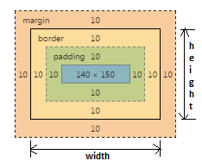
width of an element = (10+10+140+10+10)
height of an element = (10+10+150+10+10)

The box-sizing property is used to alter the default CSS box model used to calculate widths and heights of elements. It is possible to use this property to emulate the behavior of browsers that do not correctly support the CSS box model specification.

Syntax
box-sizing: content-box;
box-sizing: border-box;

box-sizing: inherit;

Values
content-box
This is the default style as specified by the CSS standard. The width and height properties are measured including only the content, but not the padding, border or margin. Note: Padding, border & margin will be outside of the box e.g. IF .box {width: 350px}; THEN you apply {border: 10px solid black;} RESULT {rendered in the browser} .box {width: 370px;}

border-box
The width and height properties include the padding and border, but not the margin. This is the box model used by Internet Explorer when the document is in Quirks mode. Note that padding and border will be inside of the box e.g. .box {width: 350px; border: 10px solid black;} lead to a box rendered in the browser of width: 350px. The content box can't be negative and is floored to 0 making it impossible to use border-box to make the element disappear.
Border and padding goes within the box, when this values is applied.

Borders
You can use borders to decorate elements with lines or boxes.
To specify the same border all around an element, use the border property. Specify the width (usually in pixels for display on a screen), the style, and the color.
The styles are:
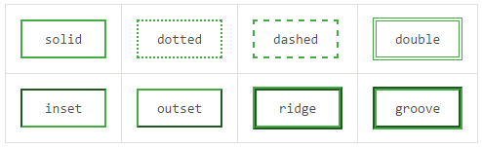
You can also set the border style to none or hidden to explicitly remove the border, or set the color to transparent to make the content invisible without changing the layout.

To specify borders one side at a time, use the properties: border-top, border-right, border-bottom, border-left. You can use these to specify a border on only one side, or different borders on different sides.
This rule sets the background color and the top border of heading elements:
h3 {
border-top: 4px solid #7c7; /* mid green */
background-color: #efe; /* pale green */
color: #050; /* dark green */
}
<h3>Stylish heading</h3>
The result looks like:
Stylish heading

Margins and padding
Use margins and padding to adjust elements' positions and to create space around them.
Use the margin property or the padding property to set the margin or padding widths respectively.
If you specify one width, it applies all around the element (top, right, bottom and left).
If you specify two widths, the first applies to the top and bottom, the second to the right and left.
You can specify all four widths in the order: top, right, bottom, left.

Example
This rule marks out paragraphs with the class remark by giving them a red border all round.
Padding all round separates the border from the text a little.
A left margin indents the paragraph relative to the rest of the text:
p.remark {
border: 2px solid red;
padding: 4px;
margin-left: 24px;
}
<p class="remark">Here is a remark.</p>



More details
When you use margins and padding to adjust the way elements are laid out, your style rules interact with the browser's defaults in ways that can be complex.
Different browsers lay elements out differently. The results might look similar until your stylesheet changes things. Sometimes this can make your stylesheet give surprising results.
To get the result you want, you might have to change your document's markup.

the box model
While we're talking about width, we should talk about width's big caveat: the box model. When you set the width of an element, the element can actually appear bigger than what you set: the element's border and padding will stretch out the element beyond the specified width. Look at the following example, where two elements with the same width value end up different sizes in the result.
simple {
width: 500px;
margin: 20px auto;
}

.fancy {
width: 500px;
margin: 20px auto;
padding: 50px;
border-width: 10px;
}
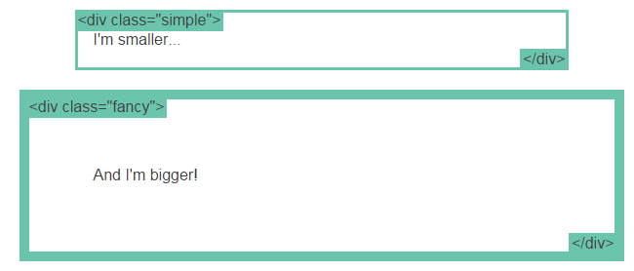
For generations, the solution to this problem has been math. CSS authors have always just written a smaller width value than what they wanted, subtracting out the padding and border. Thankfully, you don't have to do that anymore...

