box-sizing
Over the generations, people realized that math is not fun, so a new CSS property called box-sizing was created. When you set box-sizing: border-box; on an element, the padding and border of that element no longer increase its width. Here is the example with box-sizing: border-box; on both elements:
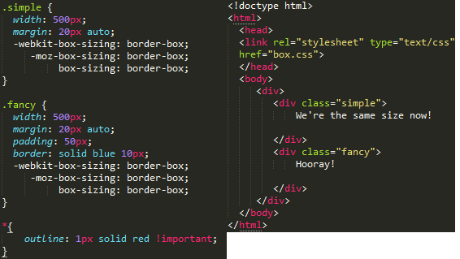
Since this is so much better, some authors want all elements on all their pages to always work this way. Such authors put the following CSS on their pages:
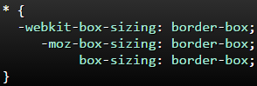
This ensures that all elements are always sized in this more intuitive way.
Since box-sizing is pretty new, you should use the -webkit- and -moz- prefixes for now, as I have in these examples. This technique enables experimental features in specific browsers. Also, keep in mind that this one is IE8+.

box-sizing
Over the generations, people realized that math is not fun, so a new CSS property called box-sizing was created. When you set box-sizing: border-box; on an element, the padding and border of that element no longer increase its width. Here is the same example as the previous page, but with box-sizing: border-box; on both elements:
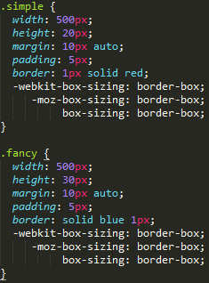
<div class="simple"></div>
<div class="fancy"></div>
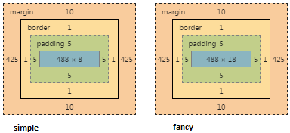
Since this is so much better, some authors want all elements on all their pages to always work this way. Such authors put the following CSS on their pages:
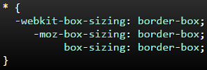
This ensures that all elements are always sized in this more intuitive way.
Since box-sizing is pretty new, you should use the -webkit- and -moz- prefixes for now, as I have in these examples. This technique enables experimental features in specific browsers. Also, keep in mind that this one is IE8+.

