There are two tools built into Firefox that are useful for experimenting with JavaScript: the Web Console and Scratchpad.

The Web Console
The Web Console shows you information about the currently loaded Web page, and also includes a command line that you can use to execute JavaScript expressions in the current page.
To open the Web Console (Ctrl+Shift+K on Windows and Linux or Cmd-Option-K on Mac), select "Web Console" from the "Developer" menu, which is under the "Tools" menu in Firefox. It appears at the bottom of the browser window. Along the bottom of the console is a command line that you can use to enter JavaScript, and the output appears in the pane above:
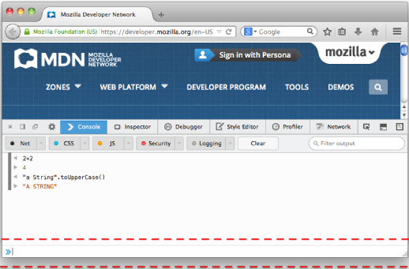

Scratchpad
The Web Console is great for executing single lines of JavaScript, but although you can execute multiple lines, it's not very convenient for that, and you can't save your code samples using the Web Console. So for more complex examples Scratchpad is a better tool.
To open Scratchpad (Shift+F4), select "Scratchpad" from the "Developer" menu, which is under the menu in Firefox. It opens in a separate window and is an editor that you can use to write and execute JavaScript in the browser. You can also save scripts to disk and load them from disk.

